Teaching Financial Literacy
OSCA 2013
Key Concepts:
The biggest stumbling blocks about not teaching financial literacy, can summed up into two main thoughts: lack of time and lack of expertise. Many teachers express concern in an already packed curriculum, how to do I find the time? Others are unsure of whether they possess the skills necessary to teach financial literacy.

Teaching Financial Literacy does not require full lessons (but you could) but rather a change of mindset. It is looking at your curriculum through a financial lens and changing examples and minds-on activities to relate to financial literacy elements.

Some ideas that have worked to promote Financial Thinking in your class include:
- Stories with financial themes
- Acting out financial stories
- News stories
- Short videos
- Activities and games related back to financial literacy
- Creating children’s stories and books (for use in elementary feeder schools)
Whether you have the opportunity for traditional lessons or only a few moments a day or week you can make financial literacy part of any course.
Jeff Balch
j.balch@tvdsb.on.ca
Presentation Website: http://bit.ly/XWCs136
http://teaching-financial-literacy4.webnode.com/

Quick Reference Links
http://www.fcac-acfc.gc.ca
http://www.getsmarteraboutmoney.ca
http://www.canlearn.ca
http://www.edugains.ca/newsite/financialLiteracy/index.html

Website Signup:  http://bit.ly/hNoLfr | THE CITY engages youth by using an imaginative and interactive hands-on approach to learning, providing practice in real-life skills and making financial concepts easy to understand. As each topic is introduced, students learn through eight “life stage characters”, each of whom faces different financial circumstances  The resource blends the use of fictional characters in THE CITY with real-life financial activities and decisions, which are organized in a hands-on, activity-based format. Students can be assigned parts of a module, the full module or entire resource. The entire resource takes 22 hours to complete in-class.  THE CITY is also available in an on-line web based format that mirrors the teacher-led versions. A student’s progress can be assessed online when a class is setup.  This eleven module program is available in both French and English in both print and web format. The materials are available at no cost.

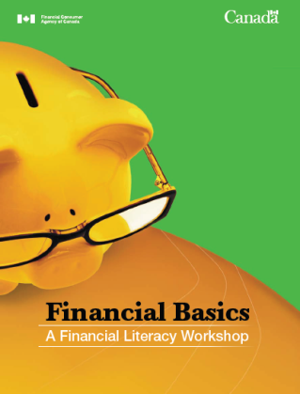  To Order:  http://bit.ly/Zbk4A9 | Financial Basics is an engaging hands-on workshop to help participants learn how to make a budget, manage expenses, understand credit and debt management, protect themselves from fraud and save for their future.  Financial Basics provides a workbook for each participant or teachers can download and create their own booklets from the topics provided.  Financial Basics workshop materials are easy to use will help facilitate the teaching of basic financial concepts and will engage all learners. The material combines instructor lead, videos and websites to engage and instruct. These materials are available at no cost.  The workshop materials are available in both English and French and include the following resources:

http://bit.ly/QC06av | Your Financial Toolkit has been designed to help Canadians manage their personal finances. The Toolkit provides reliable, unbiased and easy-to-use information and tools that people can use to become more capable and confident financial consumers.  It is not necessary to teach the modules in order or in their entirety. They are designed so they may be taught independently of each other. You may teach an entire module, one or more mini-modules, or selected activities, depending on your audience and the time available. If you select the modules or mini-modules relevant to the topics your audience wants to learn about, you will have a simple, straightforward package of resources to support your presentation with minimal preparation. PowerPoint lessons, videos and worksheets are available at no cost.

