Lesson 1

Topic Goal: Metric System Length – Estimating and Measuring

Discuss and describe applications from everyday life and the workplace that would involve the measurement of length using the metric system.

Visit the following youtube video for a brief description on the Metric System.
https://www.youtube.com/watch?v=U04nHNUMfPA

Canada formally adopted the modern metric 1970.
There are four main units of measurement that are used when answering questions; such as How long is is? How wide is it? What is the circumference?
1. Millimetres (mm)
2. Centimetres (cm)
3. Metres (m)
4. Kilometres (km)

Example(s):
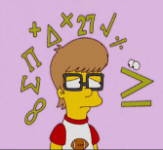

1. Here are some examples of what each measurement might look like:
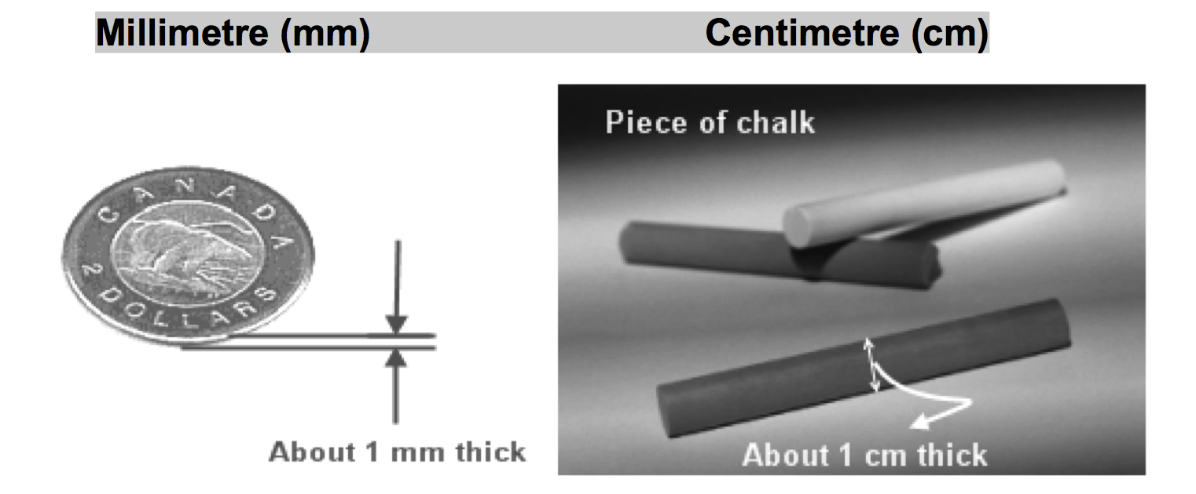
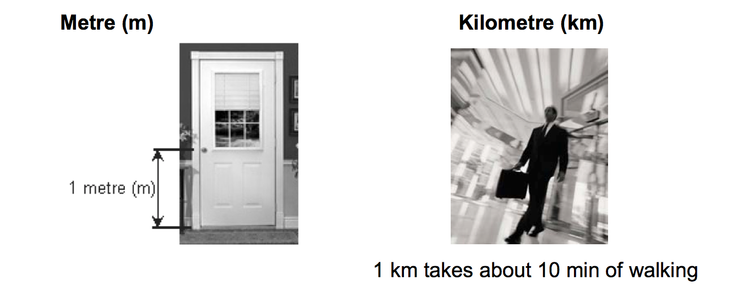

2. Key Conversions lengths and the Metric System
There are 10 mm in  1 cm | 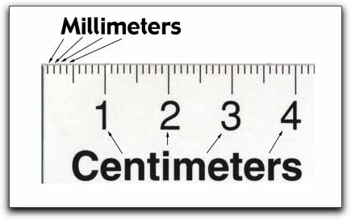
There are 100 cm in  1 metre | 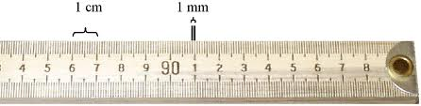
There are 1000 mm in 1 metre
There are 1000 m in 1 kilometre | 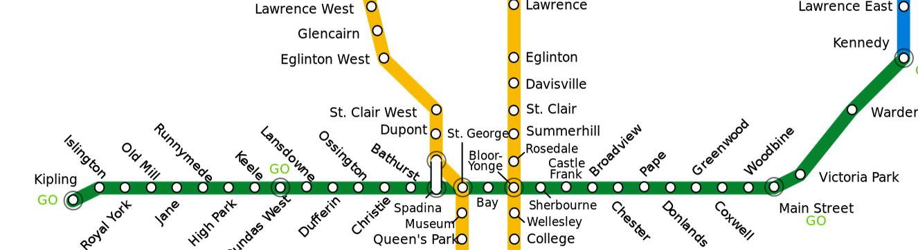  The Bloor Danforth subway line is 26.2 km which is 26200 m

3. Identify, in centimeters and millimeters, the location of each arrow.
a b c d

Answers:
a. 1.3 cm, 13 mm b. 3 cm, 30 mm
c. 4.6 cm, 46 mm d. 6.5 cm, 65 mm
4. Choose the best measure for each of the following objects:
- The length of a pencil
  - 20 mm
  - 20 cm
  - 20 m Answer: b. 20 cm

- The height of a basketball rim
  - 1.8 m
  - 3.1 m
  - 5.8 m Answer: b. 3.1 m

- The height of a car
  - 2.5 m
  - 2.5 cm
  - 2.5 km Answer: a. 2.5 m

Practice Questions:

- Choose the best measure:
a. Length of an iPhone | 12 cm | 12 mm | 12 m
b. Width of a math textbook | 20 cm | 20 m | 20 mm
c. Height of a mug | 10 mm | 10 cm | 10 m
d. Height of the CN tower | 553 cm | 553 m | 553 km
e. Width of a classroom computer monitor | 40 cm | 120 cm | 230 cm
f. Thickness of a lipstick | 30 mm | 40 mm | 12 mm
g. Height of a student’s chair above the ground | 0.6 m | 1.6 m | 2.0 m
h. Diameter (width) of a DVD movie | 18 cm | 12 cm | 24 cm

- Estimate each measure using appropriate units

  - Width of a binder __________
  - Length of a TTC bus __________
  - Distance from your home to school _____________
  - Thickness of an Oreo cookie __________
  - Height of a large Tim Horton’s Coffee __________
- Identify, in centimetres and millimetres, the location of each arrow.
a b c d

a. _______ cm, __________ mm
b. _______ cm, __________ mm
c. _______ cm, __________ mm
d. _______ cm, __________ mm

- With a ruler, measure each picture below to the nearest mm (no decimal places) and to the nearest tenth of a cm (one decimal place)
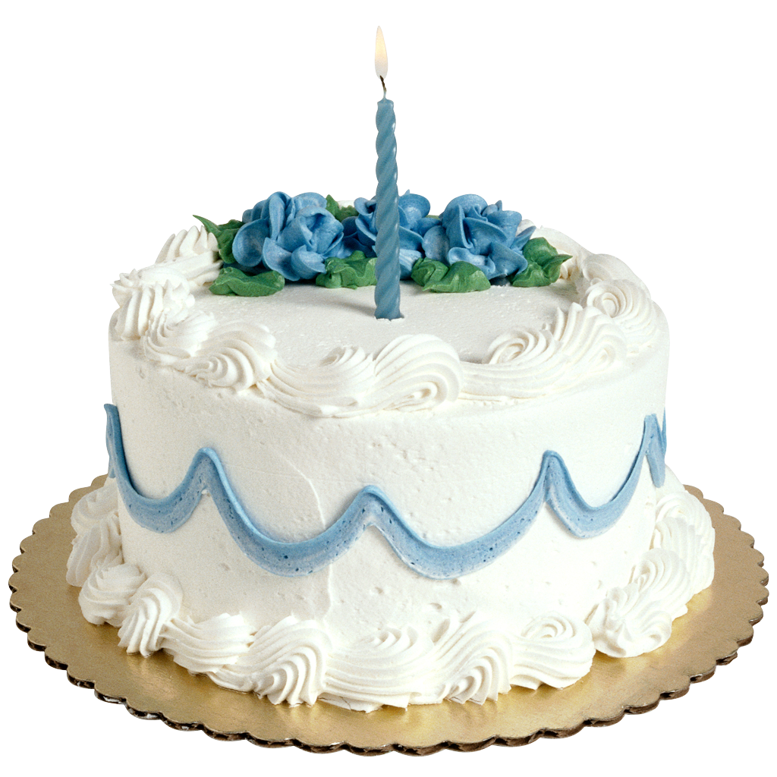
a.
______ mm
______ cm

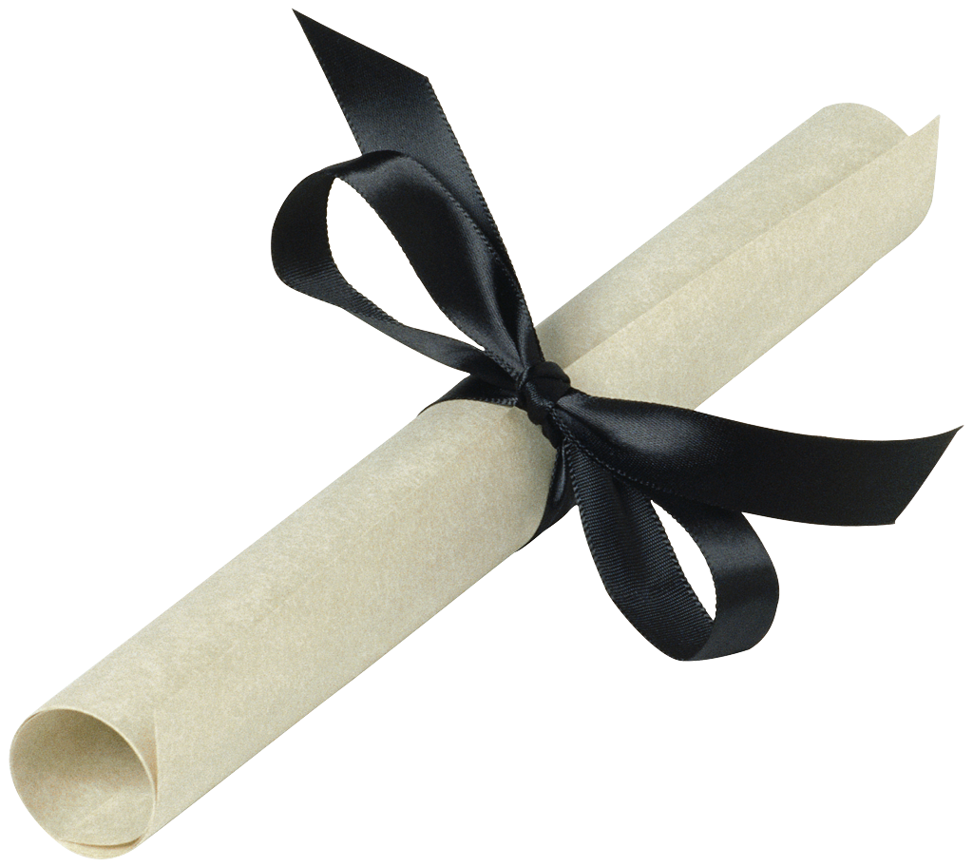
b.
______ mm
c.
______ cm
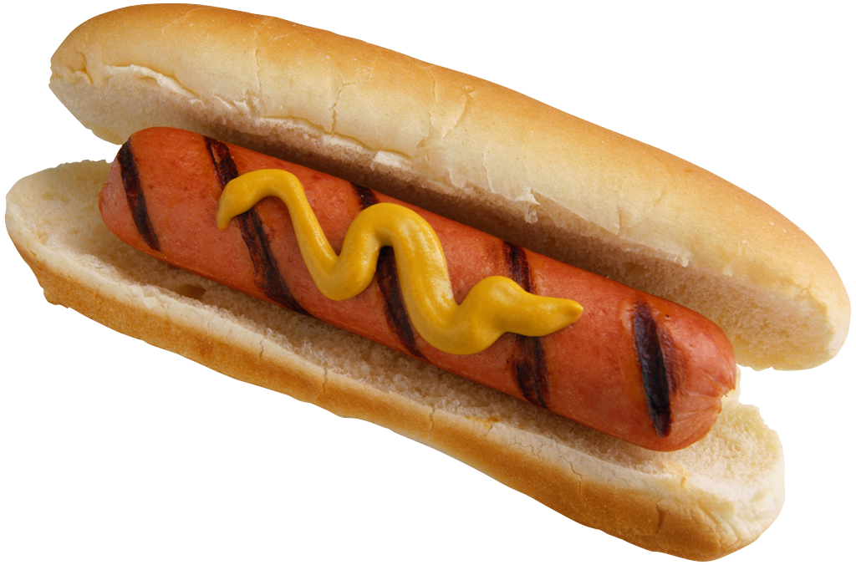
______ cm
______ mm

______ mm
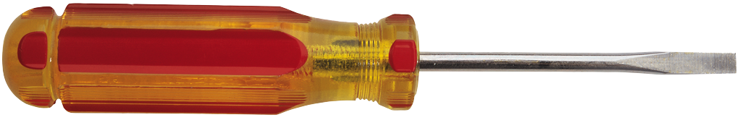
d.
______ cm

e. What do you notice about the difference between the length of each object in mm and in cm?

- If using the metric system, a person’s height is usually measured in centimetres. Explain why millimetres, metres, and kilometres, are not typically used.

Assessment:

- Choose the best measure:
a. Length of an cola can | 30 cm | 13 cm | 13 m
b. Width of a science textbook | 20 cm | 20 m | 20 mm
c. Height of classroom chalkboard | 1.25 m | 50 m | 125 mm
d. Height of a 32 storey apartment building | 992 m | 9090 m | 10 km
e. Diameter (width) of the bottom of a plastic water bottle | 60 cm | 6 m | 6 cm
f. Length of a stick of gum | 3 cm | 90 mm | 10 cm
g. Length of a bicycle | 20 cm | 2 m | 8 m
h. Length of a stamp | 20 mm | 20 cm | 2 m

- Estimate each measure using appropriate units.

  - Length of a pair of headphones __________
  - Length of one of your shoes __________
  - Distance from your home to the nearest mall ___________
  - Thickness of your thumb __________
  - Height of a Ketchup bottle __________
- Identify, in centimetres and millimetres, the location of each arrow.
a b c d

a. __________ cm, ____________ mm
b. __________ cm, ____________ mm
c. __________ cm, ____________ mm
d. __________ cm, ____________ mm

- With a ruler, measure each picture below to the nearest mm (no decimal places) and to the nearest tenth of a cm (one decimal place).
a.
______ mm
______ cm

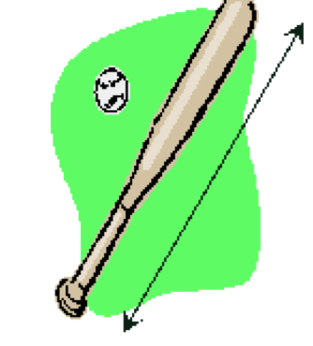
b.
______ mm
______ cm

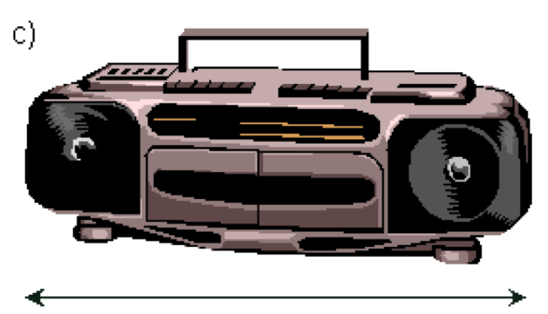
______ mm

______ cm

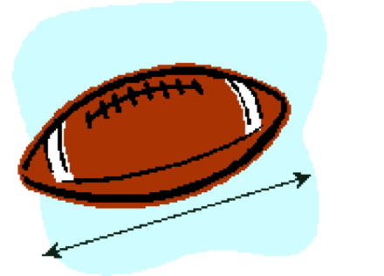
d.
______ mm

______ cm

- If using the metric system, kilometres are typically used to measure the distance between two cities. Explain why millimetres, metres, and metres are not used. Give an example to show your understanding.

