Lesson 1

Topic Goal: Money Into Words

Money can sometimes be written using numbers, but can also be written using words.
For example:
$25 000 | twenty five thousand dollars
$0.50 | fifty cents

Example(s):

a. Write nine thousand and fifteen dollars using numbers:
Answer: $9 015
You must have a dollar hundreds ones
sign in your answer
tens
thousands

b. Write three hundred and twenty thousand dollars using numbers:
Answer: $320 000
Thousands always have 3 numbers at the end
c. Write twenty three cents as a number:
Answer: $0.23
you still need to include the dollar sign and a zero if you are only working in cents, and don’t
forget your decimal!

Practice Questions:

- Write each in dollar form
a) | 25 cents |  | ___________________
b) | 49 thousand |  | ___________________
c) | 76 cents |  | ___________________
d) | 342 thousand |  | ___________________
e) | 9 thousand |  | ___________________
f) | 2 hundred |  | ___________________
g) | Four hundred and eleven |  | ___________________
h) | Seven hundred thirty six thousand four hundred |  | ___________________
i) | 15 cents |  | ___________________
- Write each dollar amount in words
a) | $45 100
b) | $457 | _______________________________________
c) | $839 000
d) | $3 000 | _______________________________________
e) | $17 | _______________________________________
f) | $0.09 | _______________________________________
g) | $0.84 | _______________________________________
h) | $3.08 | _______________________________________
j) | $18.03 | _______________________________________

- Write the value of the money shown below in words AND as a dollar amount

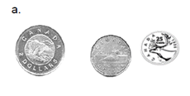
Dollar amount: ____________________
In words: ________________________

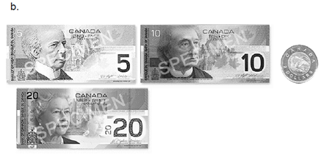

Dollar amount: ________________________
In words: ____________________________

- Why do you think it is important to know how to read and write values in both words and numbers?

Assessment:

- Write each in dollar form

a) | 55 cents | ___________________
b) | 78 thousand | ___________________
c) | 45 cents | ___________________
d) | 283 thousand | ___________________
e) | 1 thousand | ___________________
f) | 5 hundred | ___________________
g) | three hundred and twenty | ___________________
h) | Five hundred twenty two thousand four hundred | ___________________
i) | 45 cents | ___________________
j) | 7 hundred | ___________________

- Write each dollar amount in words
a) | $65 400 | _______________________________________
b) | $938 | _______________________________________
c) | $567 000 | _______________________________________
d) | $6 000 | _______________________________________
e) | $13 | _______________________________________
f) | $0.03 | _______________________________________
g) | $0.46 | _______________________________________
h) | $4.07 | _______________________________________
- Write the value of the money shown below in words AND as a dollar amount
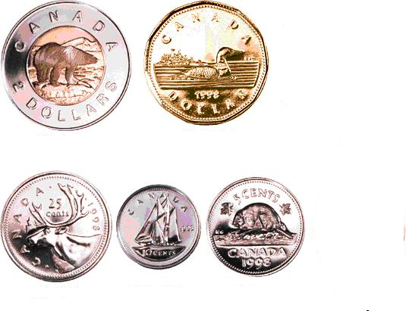

Dollar amount: ________________________
In words: ____________________________

Dollar amount: ________________________
In words: ____________________________

