**Lesson 2**

|  |
| --- |
| Topic Goal: Coin Combination and Change |

It is important to recognize bills and coins so that you are able to spend and save your money wisely.

When you buy something and you don’t have the exact combination of bill and coins, you pay with a larger amount and get the difference back. This is called **change**.

|  |
| --- |
| Example(s): |

|  |
| --- |
| 1. Calculate the total of each group of cash:     $5+ $5+ $10+ $2 + $1= $23.00   1. Find the change for each amount below. Show all your work   I had $60 I spent $15.35    Change: $60-$15.35 = $44.65  SUBTRACT BIGGEST FROM SMALLEST! |

|  |
| --- |
| Practice Questions: |

1. Calculate the total of each group of cash:

|  |  |
| --- | --- |
| Total: | b)    Total: |
|  |  |

1. Make up each amount below using bills and coins in **two** different ways.
2. 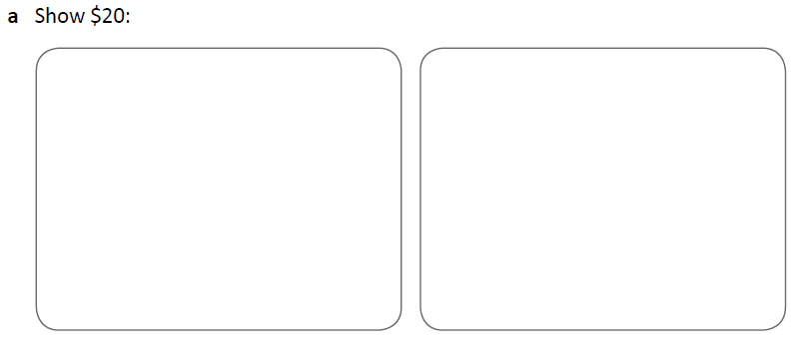

a. Show $10.80

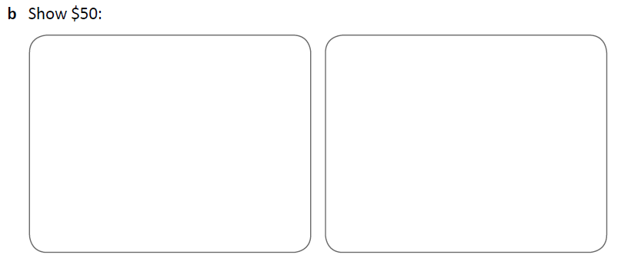

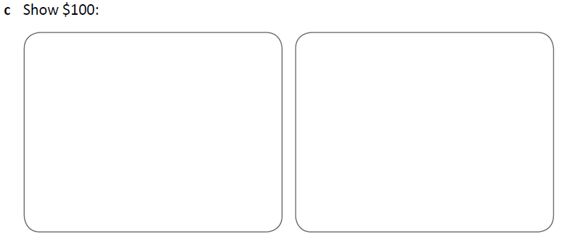

c. Show $75.75

1. Find the change for each amount below. Show all your work

I had $140.53 and I spent $125.63

CHANGE:

I had $30.50 and I spent $17

CHANGE:



I had $250.99 and I spent $234.34

CHANGE:

I had $20 and I spent $12.76

CHANGE:

1. Calculate the amount of change you would get back for each of these purchases

|  |  |  |
| --- | --- | --- |
| **Amount of Bill** | **Amount you Give to Cashier** | **Change you Expect** |
| 1. $5.43 | $10.00 |  |
| 1. $16.34 | $20.00 |  |
| 1. $33.65 | $40.00 |  |
| 1. $23.45 | $25.00 |  |

|  |
| --- |
| Assessment: |

1. Calculate the total of each group of cash:

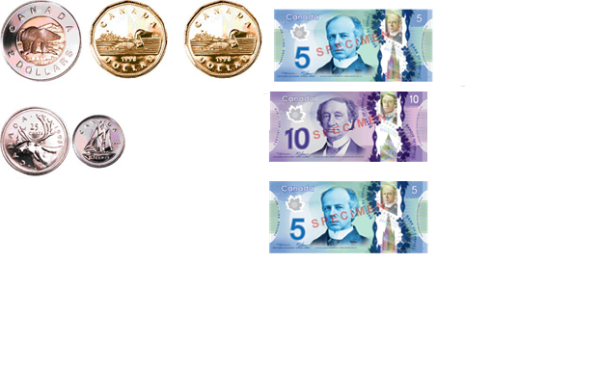

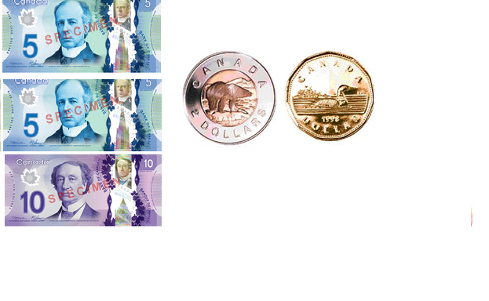

|  |  |
| --- | --- |
| Total: | b)  Total: |
|  |  |

1. Make up each amount below using bills and coins in **two** different ways.



b. Show $50.50

c. Show $80.35



1. Find the change for each amount below. Show all your work

I had $50.59 and I spent $43.20

CHANGE:

I had $243.75 and I spent $230.20

CHANGE:



I had $45.49 and I spent $15.99

CHANGE:

I had $120.58 and I spent $34.99

CHANGE:

4) Calculate the amount of change you would get back for each of these purchases

|  |  |  |
| --- | --- | --- |
| **Amount of Bill** | **Amount you Give to Cashier** | **Change you Expect** |
| 1. $6.54 | $10.00 |  |
| 1. $12.22 | $20.00 |  |
| 1. $22.54 | $40.00 |  |
| 1. $15.45 | $25.00 |  |