Lesson 3

Topic Goal: Budgeting

A budget is a plan of your future income and expenses so that you know how much to spend and save.

Practice Questions:

1) List 6 things you spend money on during the week. Estimate how much you spend on each item each week.
Item | How Much Do You Spend On This Item Each Week?
a)

b)

c)

d)

e)

2) Let’s pretend you are going out for lunch one day a week. When planning for lunch, you need to know how much money you have to spend and how much things cost.
YOUR MISSION:
You have $5.00 to spend on your lunch out. Use the list below to fill up your lunch tray. Write on the tray what you will be purchasing and make sure it is $5.00 or less!
PRICE LIST
Hamburger………$3.00 Cookies……….$0.50 Juice……….$1.00
Hotdog…………….$2.00 Chips…………..$0.75 Milk………..$1.50
Sushi Roll…………$2.00 Veggies……….$1.25 Apple…….$0.75

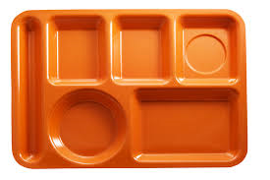
What can I
afford to eat for lunch?

Add your items:
ITEM | AMOUNT
TOTAL:

Can you afford to eat this lunch?
Your friend also wants to eat lunch with you but needs help spending her money. Can she afford the following items?
Can she afford this?
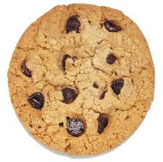
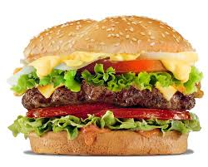
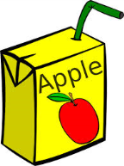
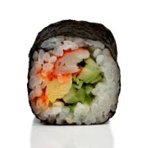

$_____ $______ $______ $_____ $____
Help your friend add up her lunch:
ITEM | AMOUNT
TOTAL:

Can your friend afford her lunch using only $5.00?

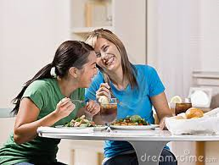
If not, what should she change?

ENJOY YOUR LUNCH!
3) When you plan a party, you usually buy things such as food, drink and party favours. It’s a good idea to set a budget before you go shopping so that you don’t spend too much.
Here is a list of party items:
Food |  | Drink |  | Party Favours
Sausage rolls | $2.75 | Coke | $3.99 | 10 party hats | $2.50
Pizza Slices | $3.00 | Lemonade | $2.50 | 10 balloons | $1.75
Burgers | $6.65 | Fruitopia | $4.50 | 4 game prizes | $6.99

a) Which two items of food and drink could you buy for less than $10.00? Show the change.

CHANGE:

b) Julie bought one of the food items for the party. She paid with a $10 bill and received $3.35 in change. Which food item did she buy?

c) Create a shopping list for the party if you have only $40 to spend. What would you buy?
MY PARTY SHOPPING LIST
ITEM | HOW MANY? | COST
TOTAL:

d) Do you have any change from your $40? Can you add anything else to your list?

Assessment:

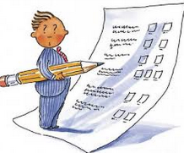

1) You all decide to wander around the mall before going home from school. You just got paid and have budgeted $40.
a) Write in this list what you will buy with your $40:
Day at the Mall!
Item | Cost
TOTAL:
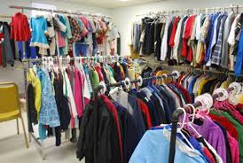
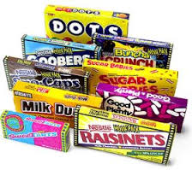
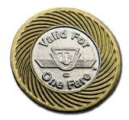

$2.10 $8.50 $4.00 $15.00
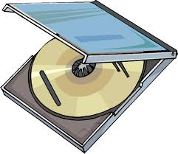
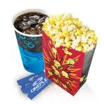
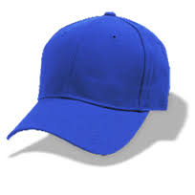

$7.00 $10.00 $5.00

b) Did you have any change?

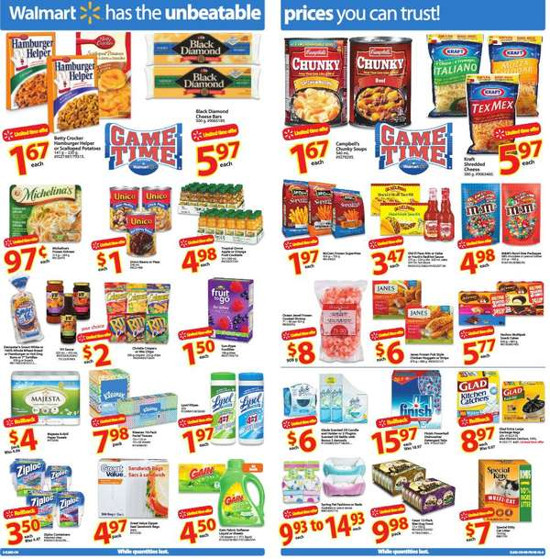
2) The grocery store flyer shows many items on sale.

Jesse buys some items at the grocery store. Complete Jesse’s bill.
Hamburger Helper | __________________________
Chunky Soup Can | __________________________
M&M’s | __________________________
Lysol Wipes | __________________________

- Calculate Jesse’s total.

- If Jesse gives the cashier $20, how much change does he get back

- Show the bills and coins the cashier would use to make the correct change.

