Lesson 3

Topic Goal: Imperial Length Units - Estimating and Measuring


You have learned about the metric system, now you will learn about another measuring system called Imperial.
In the imperial system there are four main units of measurement:
Unit | Abbreviation
Inch | in or “
Foot | ft or ‘
Yard | yd
Mile | mi

Most of the world has adopted the Metric System. What two countries use the imperial system? Look at the map below.
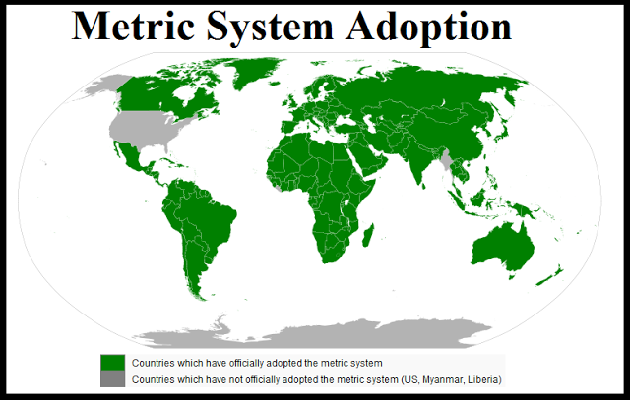
Although Canada has adopted the Metric system, we still use some imperial measures on our everyday lives. For example, when someone says,
- “I am 5 feet 4 inches tall”, or
- “My backpack weighs 20 pounds”,
they are using the Imperial System.

Source: Jensen, A. (2010, June 19). Know Justice. Living in the Past – The imperial System [Blog post]. Retrieved from http://onhech.blogspot.ca/2010/06/living-in-past-imperial-system.html

Example(s):
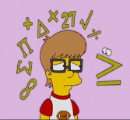

The following are some examples of what each measurement might look like.
An inch about equal to the distance from the tip of your thumb to its knuckle. | 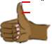
For the average sized teenager, one foot is a little bit longer than the distance from the tip of your elbow to your wrist. | 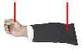
A lamb is about a yard tall | 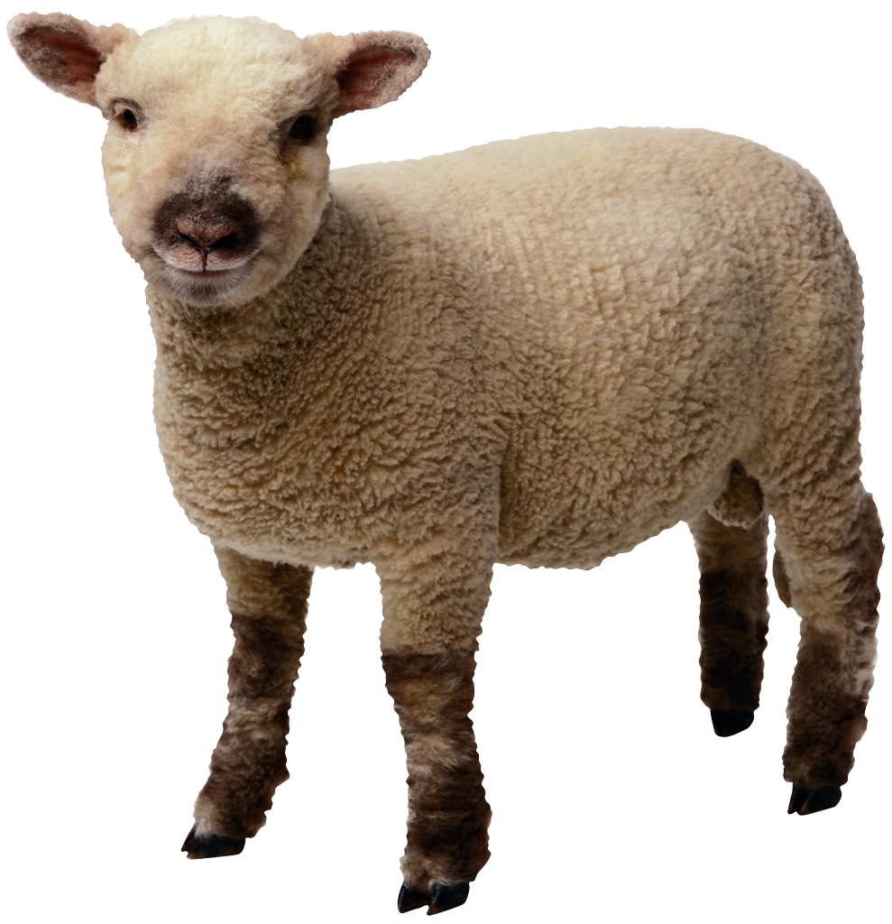
Five and a half times around soccer field is approximately a mile. | 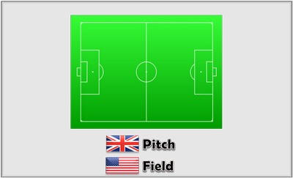

A - Key Conversions lengths and the Imperial system
- There are 12 inches in one foot
- There are 3 feet in one yard
- There are 1760 yards in one mile

1. Choose the best measure of the following objects:
- The length of a pen
  - 7 inches b. 16 inches c. 51 inches
Answer: The length of a pen is approximately 7 inches long.
- The height of the basketball rim
  - 5 feet b. 10 feet c. 100 feet
Answer: A basketball rim us 10 feet high
- The height of a toddler
  - 1 yard b. 6 yards c. 0.2 yards
Answer: A toddler is approximately 1 yard tall.

B - Using a ruler
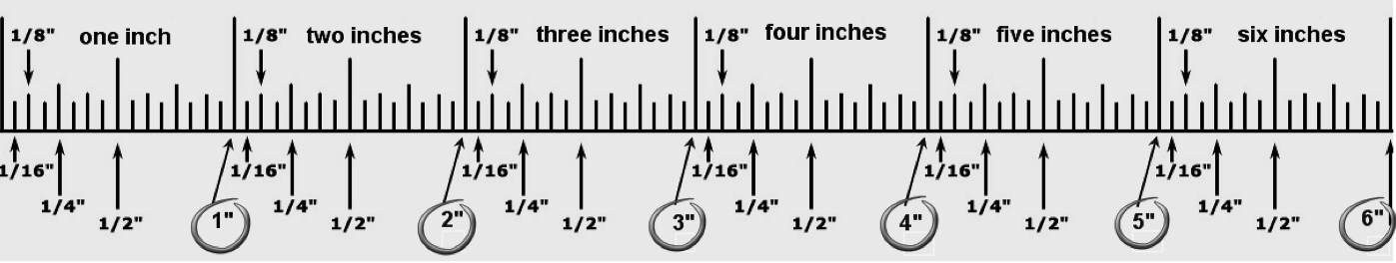
This is what one inch of an Imperial ruler looks like:

1. Name the fraction of an inch shown be each arrow
Answers:
- 1/8”
- 1/4”
- 1/2”
- 3/4”

d
c
b
a

2. Using a ruler, measure the length of the objects below as shown by the arrows
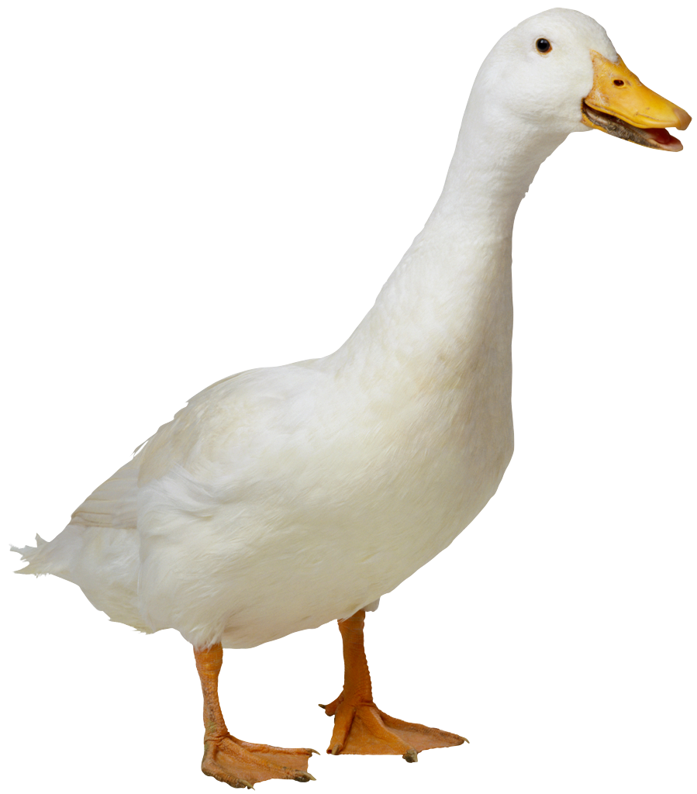
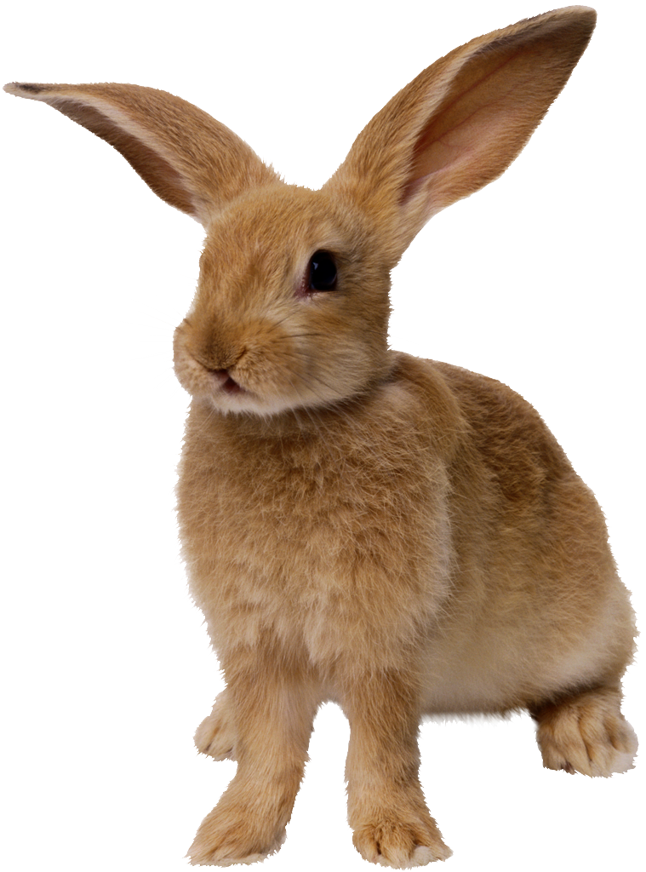
a. b.

________________________ ____________________________
Answer: 1 ½” Answer: 2 ¼”

Practice Questions:



- Choose the best measure for each of the following objects:
  - Length of an adult forearm 25 in 13 ft 1 mi
  - Width of a car 24 ft 150 ft 9ft
  - Length of a binder 3 in 11 in 52 in
  - Thickness of a pen 2 in 4 in 1/8 in
  - Distance of a marathon 26 mi 2 mi 2600 mi

- Write the fraction of an inch shown by each arrow.

c
b
a

  - ________
  - ________
  - ________

- Estimate, and then use a ruler to measure the length of the objects below as shown by the arrows.
Estimate ________
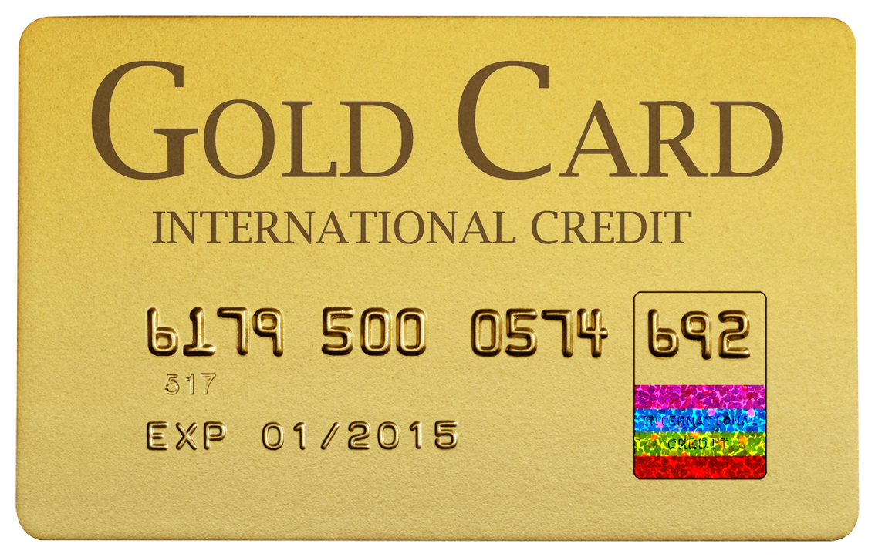
a.
Actual ________

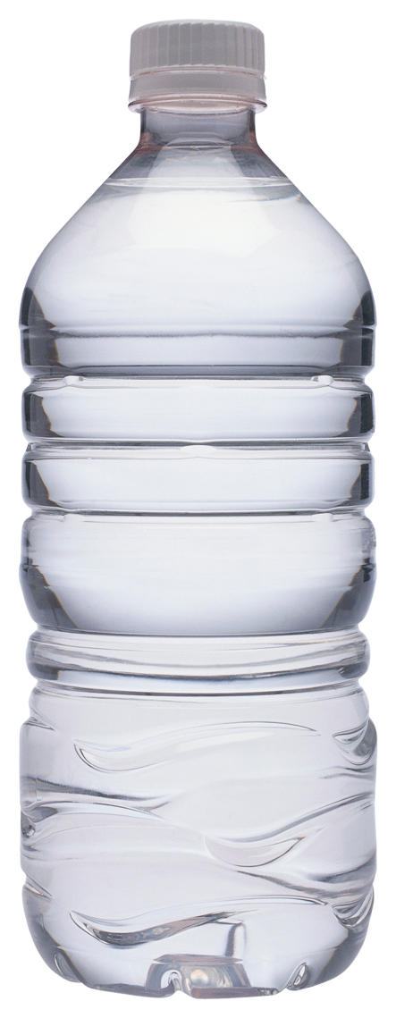
b.
Estimate ________
Actual ________

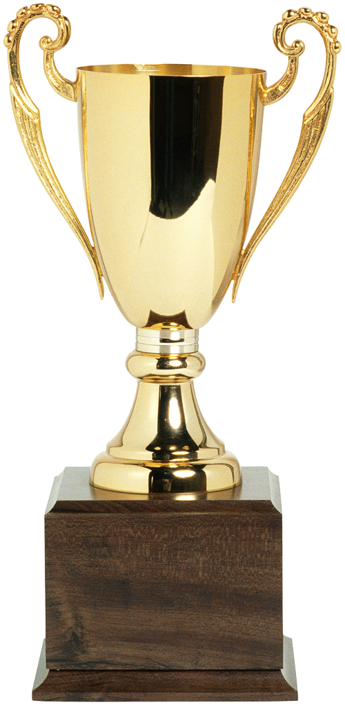
C.
Estimate ________

Actual ________

d.
Estimate ________
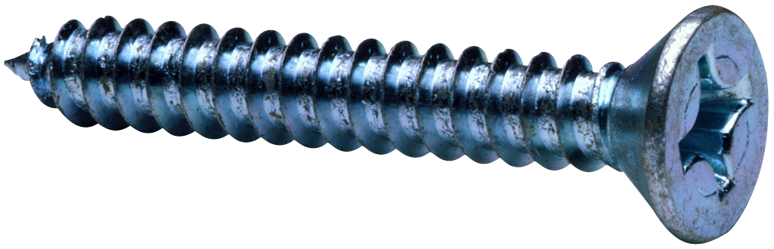
Actual ________

Assessment:



      - Choose the best measure for each of the following objects:
- Length of an adult foot 10 in 13 ft 1 mi
- Width of a door 36 ft 36 ft 36 yd
- Height of a toddler 3 in 1 ft 1 yd
- Length of a hockey stick 80 in 80 ft 80 yd
- Distance of your home to school 78 mi 3 mi 1390 mi

      - Write the fraction of an inch shown by each arrow.

c
b
a

- ________
- ________
- ________

      - Estimate, and then use a ruler to measure the length of the objects below as shown by the arrows.
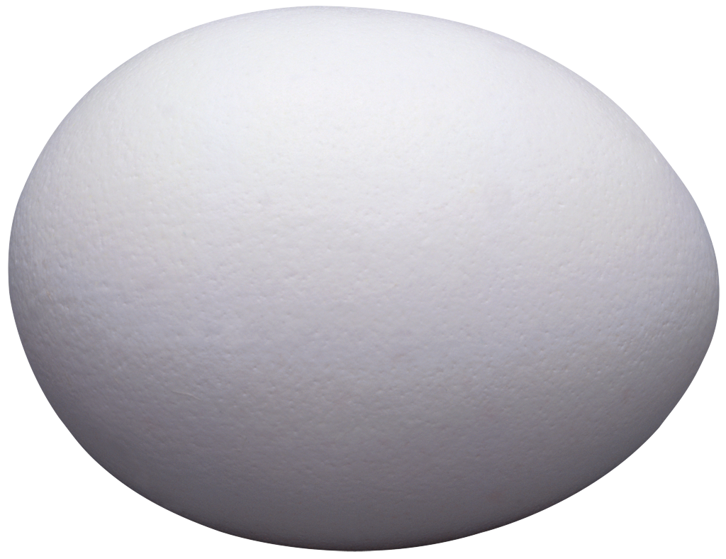
Estimate ________
a.
Actual ________

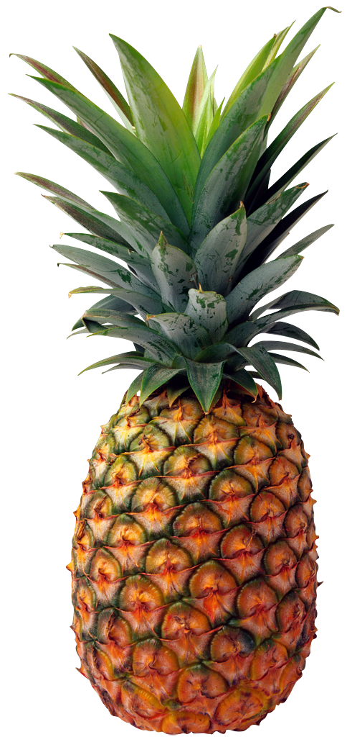
b.
Estimate ________
Actual ________

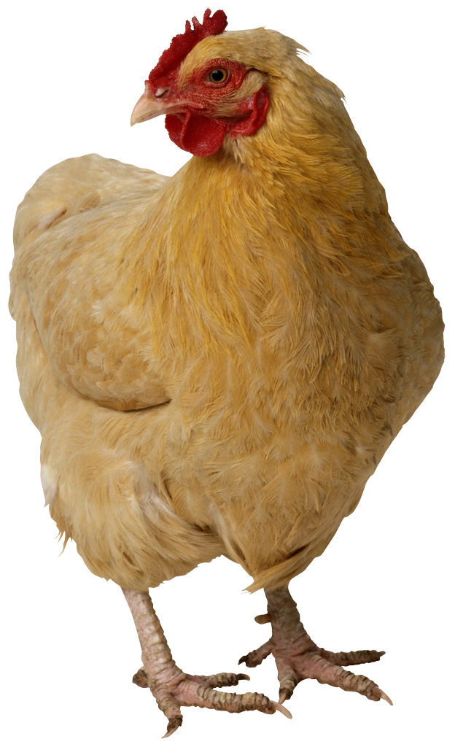
C.
Estimate ________

Actual ________

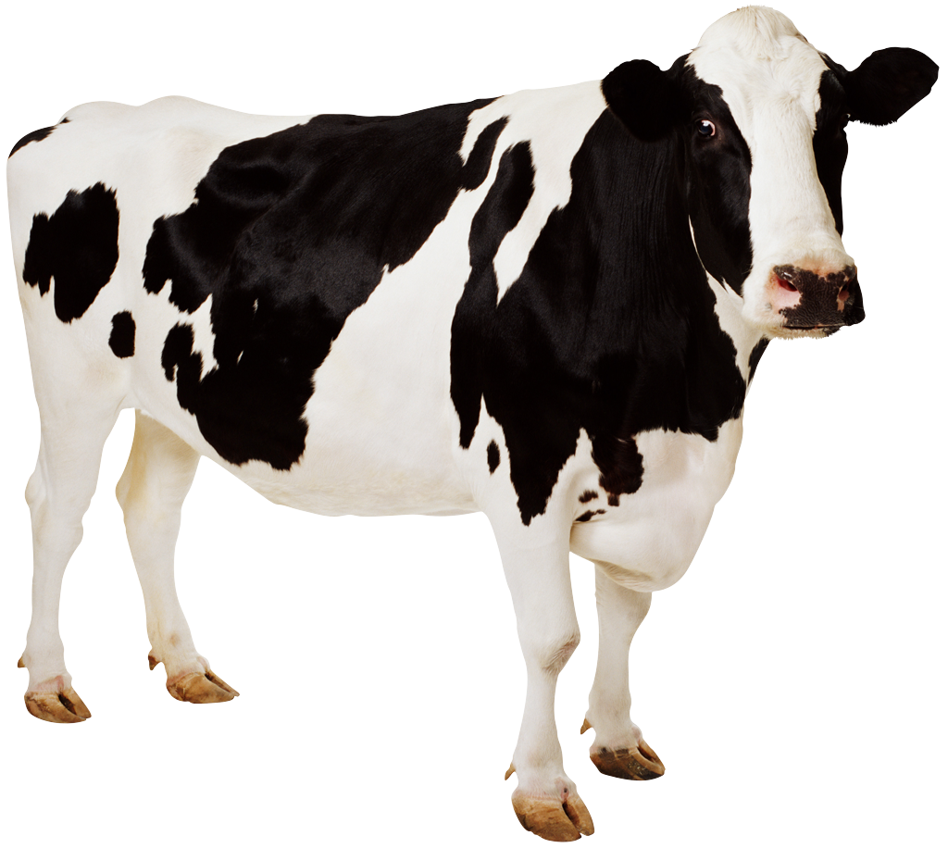
d.
Estimate ________
Actual ________

