Lesson 4

Topic Goal: Converting Imperial Units

We will convert between imperial units for length commonly used in everyday applications.

Example(s):

A. Converting from Large to Small
When converting from a larger unit to a smaller unit, multiplication is needed.

Miles

Inches
Feet
Yards
X by 1760
X by 12
X by 3

- Convert each measurement to the imperial unit given.
Miles | Yards | Feet | Inches
  - 4 yds = ________ ft

Multiply by 1760 by 3 by 12

To covert from yards to feet, you multiply by 3
Answer: 4 x 3 = 12 ft
b. 2 mi = ________ yds Answer: 2 x 1760 = 3520 yds
c. 3 yds = _______ ft Answer: 3 x 3 = 9 ft
d. 6 ft = _______ in Answer: 6 x 12 = 72 in

B. Converting from Small to Large

When converting from a smaller unit to a larger unit, division is needed.

Inches
÷ by 1760
÷ by 3
÷ by 12
Miles
Yards
Feet

- Convert each measurement to the imperial unit given.
Inches | Feet | Yards | Miles
  - 36 ft = ________ yds

Divide by 12 by 3 by 1760

To covert from feet to yards, you divide by 3
Answer: 36 ÷ 3 = 12 yds
b. 60 in = ________ ft Answer: 60 ÷ 12 = 5 ft
c. 90 ft = _______ yd Answer: 90 ÷ 3 = 30 yds
d. 2500 yds = _______ mi Answer: 2500 ÷ 1760 = 1.42 mi
2. Convert the following into feet and inches.
a. 15” = _____________
Answer: There are 12 inches in 1 foot. 15 ÷ 12 = 1 with three inches left over. Therefore, 15” = 1 foot an 3 inches (1’3”).
b. 17” = ________ Answer: 17 ÷ 12 = 1’ with 5” left over = 1’5”
c. 28” = ________ Answer: 28 ÷ 12 = 2’ with 4” left over = 2’4”
d. 70” = ________ Answer: 70 ÷ 12 = 5’ with 10” left over = 5’10”

C. Problems

1. Find the perimeter of the following basketball court. Remember the perimeter is the distance around an object, so you have to ADD all the sides together.
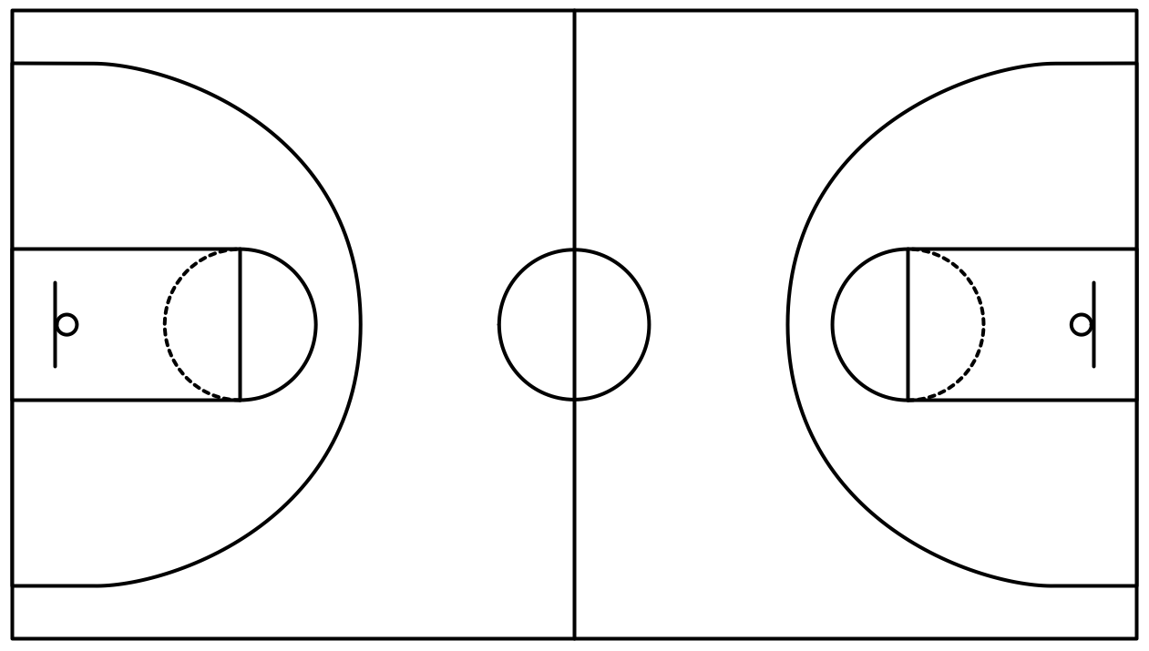
Notice that the units are different.

50 ft

1128 “
Step 1 – Convert to the same units.

50 ft

1128 “ = 94 ft

Converting inches to feet is the easier option, because you will be working with smaller numbers.
To convert from inches to feet => divide by 12 1128 ÷ 12 = 94 ft

Step 2 – Include the measurements of the other two sides.
94 ft

50 ft
50 ft

94 ft

Step 3 – Add of all the sides.
Perimeter = 50 + 50 + 94 + 94
= 288 ft
Therefore, the perimeter of the basketball court is 288 ft.
- Farah is at Canada’s Wonderland and wants to ride the Behemoth rollercoaster. The height allowance for the rollercoaster is 54” and Farah is 4’3”. Will she be able to go on the ride?
Convert Farah’s height into inches
Step 1 - Concert 4’ into inches. We are going from larger to smaller, so we need to multiply by 12.
4 x 12 = 48’
Step 2 – add 3” to 48”
3 + 48 = 51”
Therefore, Farah is 51” tall. She needs to be at least 54” tall to ride the rollercoaster.
Practice Questions:

- Convert each imperial measurement to the smaller imperial unit given
To convert from larger to smaller, you need to ____________
a. 4.5 mi = _________ yds
b. 16 ft = _________ in
c. 13 yds = _________ ft
d. 2 yds = _________ ft
e. 0.5 ft = _________ in
- Convert each imperial measurement to the smaller imperial unit given
To convert from larger to smaller, you need to ____________
a. 2 mi = _________ yds
b. 12 ft = _________ in
c. 3 yds = _________ ft
d. 4.7 yds = _________ ft
e. 0.9 ft = _________ in

- Convert each imperial measurement unit given
a. 2 mi = _________ yds
b. 12 yds = _________ ft
c. 27 ft = _________ in
d. 144 ft = _________ yds
e. 144 ft = _________ in
f. 32 in = ______ft______in
g. 13 in = ______ ft _____in
4. John needs to install baseboards along the bottom of the walls in his walk in closet. The following diagram shows the measurement of the walls. How much baseboard in feet and inches does he need to purchase?

P = _____ + ______ + ______ + ______ + _______ + _____
= _________”

Convert to feet and inches:
6’=_______in
7’6”=_______in
8’3”=_______in
12’7”=_______in

7’6”=_______in
18’9”=_______in

Assessment:

- Convert each imperial measurement to the smaller imperial unit given.

a. 2 mi = _________ yds
b. 12 ft = _________ in
c. 9 yds = _________ ft
d. 6 yds = _________ ft
e. 5.5 ft = _________ in
- Convert each imperial measurement to the smaller imperial unit given.

a. 2 mi = _________ yds
b. 12 ft = _________ in
c. 3 yds = _________ ft
d. 4.7 yds = _________ ft
e. 0.9 ft = _________ in

- Convert each imperial measurement unit given.
a. 0.07 mi = _________ yds
b. 48 yds = _________ ft
c. 90 ft = _________ in
d. 288 ft = _________ yds
e. 72 ft = _________ in
f. 52 in = ______ft______in
g. 19 in = ______ ft _____in
4. Elizabeth is on an exercise program where she needs to walk 1 mile a day. She chooses to walk around her park that is in a shape of a rectangle. The dimensions are on the rectangle below? Will Elizabeth reach her goal if she walks around the park once? Explain.
500 yds

300 yds
300 yds

500 yds

- David and Joe are having an argument about which basketball player is taller, Lebron James or Michael Jordan. David thinks Lebron James, who is 6’8” tall, is taller and Joe thinks Michael Jordan, who is 78” is taller. Who is correct? Explain using calculations and words.

