Lesson 4

Topic Goal: Estimation

Estimation: - a reasonable guess for a measurement
- an approximation that results from using rounded numbers in a calculation.
Example(s):

a) Estimate the cost of two items selling for $198.00 and $63.50
Therefore the estimated cost is:
$200 + $65 = $265.00
ANSWER $198 can be rounded to $200
$ 63.50 can be rounded to $65

b) Estimate the perimeter of an object that has sides: 12cm, 19.6cm and 9cm
Round to easy working numbers. In this instances we round 19.6 to the nearest whole number - 20
ANSWER 10 + 20 + 10 = 40cm

c) Estimate the cost of purchasing one of each item on the flyer below:
Estimation is very handy when you are grocery shopping
$8 + $2 + $2 + $3 + $6 + $5 + $6 + $6 = 38

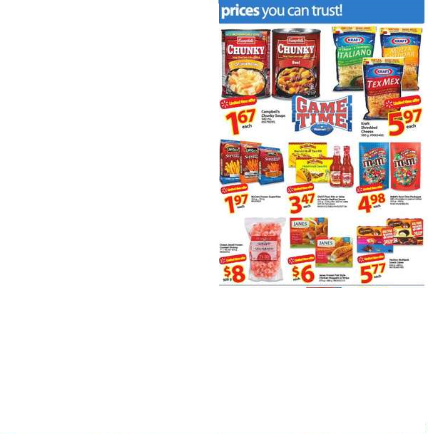

Practice Questions:

- Estimate the cost of two items selling for $243.00 and $67.59

- Estimate the cost of three items selling for $29.60, $7.50 and $3.75

- Estimate the cost two items selling for $23.87 and $14.99

- Estimate the cost of three items selling for $4.49, $3.89, and $18.77

- Estimate the perimeter of an object that has sides 7cm, 13.4cm and 16.5cm. (Hint: the perimeter is the distance around the object. To calculate perimeter you add up all the sides)

- Estimate the perimeter of an object that has sides 3.9m, 21.7m, 12.7m and 45.8m. (Hint: the perimeter is the distance around the object. To calculate perimeter you add up all the sides)

- Using the map below, estimate the distance between Toronto
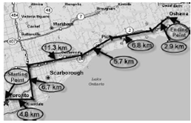
and Oshawa

Assessment:

- Estimate the cost of two items selling for $112.00 and $38.40

- Estimate the cost of three items selling for $34.45, $2.47 and $3.94

- Estimate the cost two items selling for $45.87 and $12.49

- Estimate the cost of three items selling for $8.40, $2.89, and $19.77

- Estimate the perimeter of an object that has sides 87cm, 11.4cm and 29.5cm.

- Estimate the perimeter of an object that has sides 2.6m, 41.3m, 11.9m and 55.8m.

7. Using the invoice below, estimate the amount owing
