Lesson 5

Topic Goal: Expenses

Expenses are anything you spend money on. For example, bus tickets or food.
In order to budget your money it is important to know how you spend your money. Keeping an expense report/invoice will help organize and budget money.

Example(s):

Below is an example of someones monthly expense report:

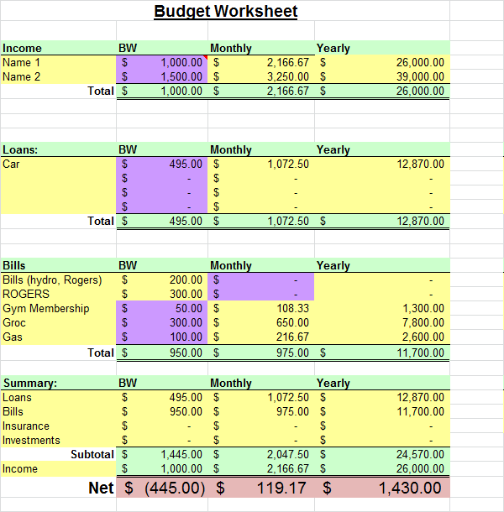

Here is an example of a basketball players monthly expenses (doesn’t include purchasing houses)
Expenses | Amount
Cars | $150 000
House (maintenance, tax, insurance etc.) | $80 000
Entertainment (restaurants, clubs, etc.) | $20 000
Groceries | $5 000
Clothes | $5000
Jewellery | $10 000
Total | $270 000

He earns $300 000 a month, and therefore has a savings of $30 000
Amount left over = Income – Expenses
= $300 000 – $270 000
= $30 000

Practice Questions:

- Complete the expense report below.

Jeff’s Supply Store Invoice # 4920
Date: December 1, 2015
Paid by: Credit Card
Ship To: Artimis School of the Arts

Item # | Quantity | Unit Price | Line Total
Pen | 4 | $0.50
Pencil sharpeners | 3 | $22.50
Calculator | 1 | $23.50
Binders | 5 | $5.50
Marker | 2 | $4.00
 |  | Total

- Explain how you found the total cost of pens in question 1.

- Explain how you found the total expenses in question 1.

- Explain why a person might want to keep an expense report.

  - How did this help Jeff?

  - How did this help Artimis?

- Describe a situation where a person might use estimation when grocery shopping.

- Using the table below to organize the expense report under the appropriate headings and calculate the totals.
Jan 3. | Groceries $36.71
Jan 18. | Paid phone bill $71.22
Jan 12. | Gas for vehicle $35.00
Jan 2. | Groceries $18.13
Jan 26 | Food for Super Bowl Party $36.61
Jan 21. | Paid electricity bill $78.45
Jan 31 | Rent $650.00
Jan 17 | Dinner at Pizza Hut $38.00
Jan 1 | Movie tickets $15.50
Feb 10 | Water bill $40.00
Feb 3 | McDonalds $15.00
Feb 23 | Gas for vehicle $30.00
Feb 14 | Starbucks drinks $12.40
Feb 28 | Rent $650.00

Date | Utilities | Gas | Rent | Food | Entertainment | Other
Total
Grand total of all expenses:

Assessment:

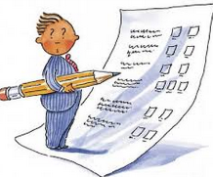

- a) You were given $500 to spend on month. Create your own expense report of what you would buy. Make sure you are realistic.

Month: __________________________
Date | Expenses (money going out)
Total

b) Do you have money left over at the end of the month or do you owe money? How much?

2) Why do you think making an expense statement is important? What can you do with left over money?

3) Fill in the invoice below:
Jeff’s Supply Store Invoice # 4920
Date: September 1, 2015
Paid by: Credit Card
Ship To: Erin’s Sports School

Item # | Quantity | Unit Price | Line Total
Pen | 6 | $1.50
Pencil sharpeners | 2 | $26.50
Calculator | 7 | $30.50
Binders | 3 | $7.50
Marker | 4 | $3.50
 |  | Total

4) Using the table below to organize the expense report under the appropriate headings and calculate the totals.
Dec 6 | Gas for vehicle $55.00
Dec 17 | Dinner at Chipotle $38.00
Dec 1 | Paid phone bill $67.22
Dec 7 | Groceries $56.71
Dec 3 | Clothes $200.30
Dec 23 | Paintballing $24.00
Dec 27 | Paid electricity bill $94.20
Dec 31 | Rent $750.00
Jan 18 | Gas for vehicle $40.00
Jan 3 | Movie snacks $16.00
Jan 28 | Water bill $40.00
Jan 6 | Lunch at Burger King $20.00
Jan 7 | Groceries $60.30
Jan 25 | Gas for vehicle $35.00
Jan 12 | Timmies $12.40
Jan 31 | Rent $750.00

Date | Utilities | Gas | Rent | Food | Entertainment | Other
Total
Grand total of all expenses:

