Lesson 6

Topic Goal: Expenses

Sales tax uses the percent of an amount to calculate the additional money that needs to be paid when purchasing an item. Sales tax can vary from province to province and can be called different things. Ontario’s tax is called harmonized sales tax (HST) and is 13%. Tax does not always apply to all items. For example, flour, sugar, bread, milk, eggs, fruits, vegetables are not taxed.
Province | Type | Total Tax
Alberta | GST | 5%
British Columbia | GST + PST | 12%
Manitoba | GST + PST | 13%
New Brunswick | HST | 13%
Newfoundland and Labrador | HST | 13%
Northwest Territories | GST | 5%
Ontario | HST | 13%
Prince Edward Island | HST | 14%
Quebec | GST + QST | 14.975%
Saskatchewan | GSTP + PST | 10%
Yukon | GST | 5%

Example(s):
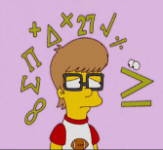
Sales tax =$\frac{rate of tax}{100}$ x cost of item
The formula for calculating tax is:

For example, if the tax rate was 9% and the item cost $24.99, you would write:
= 9% of $24.99
= ($\frac{9 }{100}$) x $24.99
= 0.09 x $24.99
= $2.249
= $2.25
- What is the total cost of shirt that sells for $13.99 if that tax is 6%
Sales tax = $\frac{6}{100}$ x $13.99
= 0.06 x $13.99
= $0.839
= $0.84

To then find the total item cost including the tax:
TOTAL COST = Tax + Cost of the item =

Total cost = $0.84 + $13.99
= $14.83

Practice Questions:

- Calculate the total HST (13%) for the following items

  - Soap costing $1.99

  - Earrings costing $34.50

  - Winter coat coasting $175.00

  - IPod costing $74.00

- Calculate the total cost of the following items including tax (13%)

  - CD costing $11.50

  - Truck costing $45 000

  - Pants costing $37.99

  - Shoes costing $65.97
- A baseball bat costs $65.99. How much are you saving when the store hosts a “no HST” event day? (hint HST = 13%)

- How much more HST are you paying on a laptop that costs $350 than on Ipad that costs $250? (hint HST = 13%)

- You have $30 to spend at a store. You know you cannot buy anything that costs $30.00 because of the tax that will be added to the price. Circle 5 items that you think you can afford.

DVD | $26.20 | Sweatshirt | $27.99
Webcam | $24.00 | T-shirt | $23.10
CD | $23.10 | Jeans | $29.85
Video game | $28.50 | Jacket | $27.10

- Record each item you circled and calculate the tax and total amount

Item | Price | Tax | Total

- What is the most expensive item you could afford to buy including tax?

- You have $100.00 to spend

  - You decide to buy two t-shirts at $15.45 each and a pair of pants for $32.00. Calculate the total price with tax.

  - If you give the cashier $100.00, how much change should you receive?

Assessment:

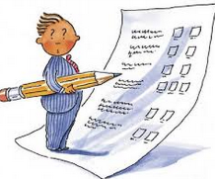

- Calculate the HST for the following items:
ITEM | COST | HST AMOUNT
Shampoo | $4.75
Toilet Paper | $8.99
TV | $650.00
Boots | $75.99

- Using the same items, now calculate the total cost which includes HST (13%):
ITEM | COST | HST AMOUNT (13%) | TOTAL COST
Shampoo | $4.75
Toilet Paper | $8.99
TV | $650.00
Boots | $75.99

- You are going to the mall with your friends and you have $40.00 to spend on whatever you want. Circle which items you can afford to purchase after calculating the HST amounts on each. Complete the table below
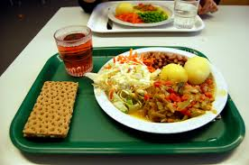
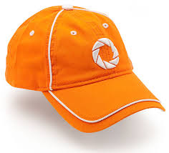
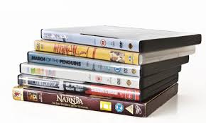
Lunch: $5.00
Hat: $15.00
DVD: $10.99

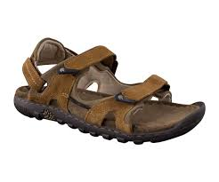
Sandals: $25.99
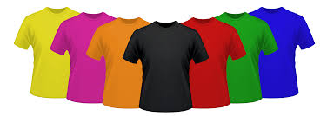
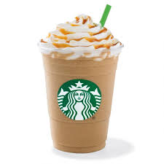
T-Shirt: $25.75
Frappacino: $4.50

Item | Price | Tax | Total

