Strand- Geometry |  |  | Grade  8 | Assessment FOR Learning Observation & Interview |  |  | Date  March 2015
Mathematics Lesson Task/Problem-  Learning Goal- We are learning data can be REpresented in many ways.  Lesson from TIPS4RM Unit 4, Lesson 1, Retrieved from www.edugains.ca  Activation- Have students draw two intersecting lines. Use another colour to connect the lines to create a quadrilateral. Have students turn and talk to a partner and discuss many different ways to describe their shape.  During- With math partner, students create and describe quadrilaterals.  After- Math Congress- Select 2/3 work samples that draw out different properties including diagonals  Create Highlights/Summary Chart- see reverse  Individual Practice- Individually, in math notebooks, TIPS4RM 4.1.3 |  |  |  | Learning Goal/Curriculum Expectations  Learning Goal: We are learning to construct and classify quadrilaterals by their diagonals.  (post and share with students prior to lesson)  – sort and classify quadrilaterals by geometric properties, including those based on diagonals, through investigation using a variety of tools (e.g., concrete materials, dynamic geometry software) (Sample problem: Which quadrilaterals have diagonals that bisect each other perpendicularly?)
Students | Math Thinking Notes: |  |  |  |  | 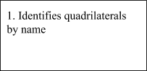  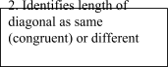  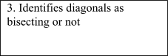  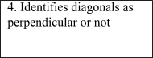
Questions About Students’ Mathematics Learning  - How is this solution the same as someone else’s solution?  - How are these two solutions different?  - What could have been done in this solution to help them become unstuck  - Can someone summarize this group’s method of solving the problem? |  |  |  |  | Students’ Mathematical Errors
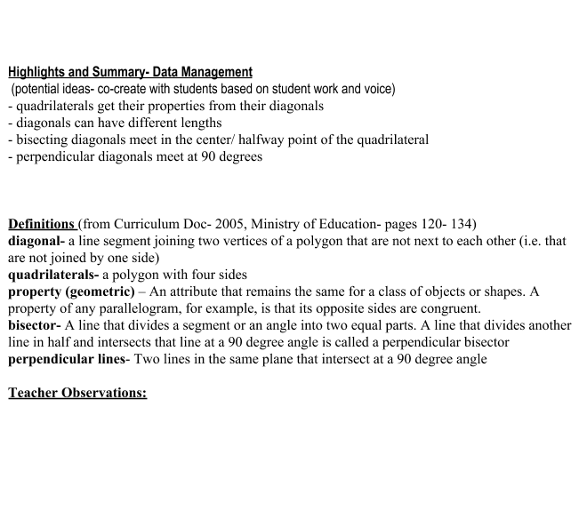

What mathematics did the students learn? Explain your ideas using the evidence you gathered. | What mathematics for teaching did you learn today?

Continue your professional learning … co-teaching, learning mathematics for teaching, teacher inquiry/study … View The Literacy and Numeracy Secretariat webcasts at http://www.curriculum.org (Archived Webcasts): November 2005 – Learning Mathematics for Teaching; March 2007 – Making Mathematics Accessible for All Students; June 2007 – Coaching for Student Success in Mathematics; March 2008 – High Yield Strategies for Improving Mathematics Instruction and Student Learning

