Lesson #1: Golden Ratio – Ratios in the Real World
Lesson Title: Golden Ratio - Ratios in the Real World (80 minutes) |  | Date:  JM
Overall Expectations  • solve problems by using proportional reasoning in a variety of meaningful contexts.  • demonstrate an understanding of proportional relationships using percent, ratio, and rate.  Learning Goals  - Identify ratios in real world context  - Identify examples of Golden Ratio  Success Criteria  - Students will see ratios in real world and understand the importance of ratios in art, science, math, geography, etc. | Assessment for/as Learning Opportunities:  - As students are working on the minds on make anecdotal notes about their progress.  - Listening and recording observations of student conversations during whole class task.  Assessment of Learning:  Prior Knowledge/Readiness  Learning Skills  Responsibility, Organization, Independent Work, Collaboration, Self-regulation
Lesson Plan

Minds –On - Draw a few rectangles. Choose the one you think is the most visually pleasing. Compare your favourite with others in your group. As a group choose the most pleasing? Did you have a similar rectangle? Find the ratio of the length: width in fraction form. Put this fraction into a decimal. Compare the decimals around the room. Record decimals on board.
Have students construct a golden rectangle. Have them construct 1: 1.618. Also Double and half.

Action
- Divide students into groups. Have them work through the 3 activities:
    - Ratios in the Human Body
    - Fibonacci Ratios
    - Golden Rectangle
Consolidation
Video Clip - Donald in Mathematic Land Start at 7:21 – 13:45

Resources:
Video Clip - Donald in Mathematic Land
Three Activities: Ratios in the Human Body, Fibonacci Ratios, Golden Rectangle
Homework Assignment:  Find an example of the Golden Ratio in nature. | Next Steps/Reminders:
Reflection:

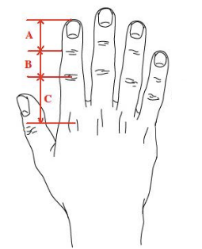
Ratios in the Human Body

Part 1: Ratio in the Human Body
Measure and record the following:
- Distance from the ground to your belly button _______
- Distance from your belly button to the top of your head _____________
- Distance from the ground to your knees ________________
- Distances A, B and C (see hand)
- Length of your hand ________________
- Distance from your wrist to your elbow _______________
Now calculate the following ratios:
Ratio 1: Distance from the ground to your belly button / Distance from your belly button to the top of your head
Ratio 2: Distance from the ground to your belly button / Distance from the ground to your knees
Ratio 3: Distance C / Distance B
Ratio 4: Distance B / Distance A
Ratio 5: Distance from your wrist to your elbow / Length of your hand
Record all your results on the following table:

Student name | Ratio 1 | Ratio 2 | Ratio 3 | Ratio 4 | Ratio 5
Average
Can you see anything special about these ratios?

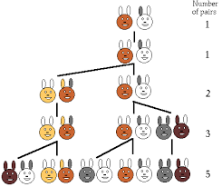
B. The Fibonacci Sequence
Now look at the following sequence of numbers:
1, 1, 2, 3, 5, 8, 13, 21, 34, 55, 89...
The following number is the sum of the previous two. This is Fibonacci's sequence.
Compare the ratios between the numbers. How do they change. Now do the following ratios on a calculator and give answers in decimal numbers:
1/1 =
1/2 =
3/2 =
5/3 =
8/5 =
13/8 =
21/13 =
34/21 =
55/34 =
89/55 =
144/89 =
233/144 =
377/233 =
610/377 =
987/610 =

What pattern do you see? Graph your results.
The Golden Rectangle (Open Ended)
Draw a rectangle with the Fibonacci number's ratio. From this rectangle we can then derive interesting shapes.
- First colour in two 1x1 squares on a piece of squared paper in the middle of the graph paper.
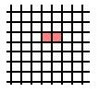

- Then draw a 2x2 square on top of this one. 3. Then draw a 3x3 square to the right.
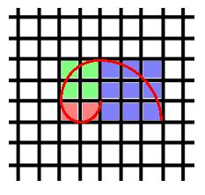
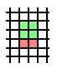

- Continue adding squares around the shape.

- What observations can you make?

- Let's try making a more interesting shape, going back to our first 1x1 squares and using a compass, place the compass tip on the top right hand corner of the right hand square and draw a semi-circle like this:
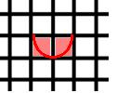

Then place the compass tip on the bottom left corner of the 2x2 square and draw an arc like this:
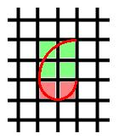

Continue. What do you observe? This shape is widely found in nature, can you find any other examples?
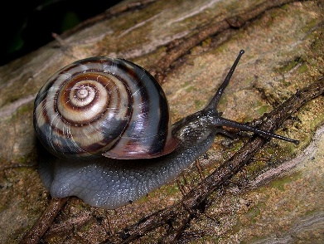

The Golden Rectangle (Guided)
Draw a rectangle with the Fibonacci number's ratio. From this rectangle we can then derive interesting shapes.
- First colour in two 1x1 squares on a piece of squared paper in the middle of the graph paper.

- Then draw a 2x2 square on top of this one. 3. Then draw a 3x3 square to the right

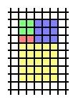
- Then draw a 5x5 square under these: 5. Then draw a 8x8 square to the left of these:
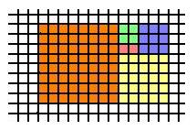

- Then draw a 13x13 square on top of these:
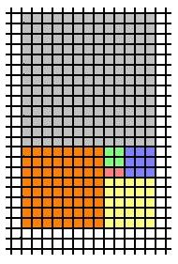
Let's try making a more interesting shape, going back to our first 1x1 squares and using a compass, place the compass tip on the top right hand corner of the right hand square and draw a semi-circle like this:

Then place the compass tip on the bottom left corner of the 2x2 square and draw an arc like this:

Then place the compass tip on the left hand, top corner of the 3x3 square and do the same:

Do the same for the other three squares to obtain:
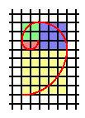

This shape is widely found in nature, can you find any other examples?
The Golden Rectangle (Open Ended)
Draw a rectangle with the Fibonacci number's ratio. From this rectangle we can then derive interesting shapes.
- First colour in two 1x1 squares on a piece of squared paper in the middle of the graph paper.

- Then draw a 2x2 square on top of this one. 3. Then draw a 3x3 square to the right.

- Continue adding squares around the shape.

- What observations can you make?

- Let's try making a more interesting shape, going back to our first 1x1 squares and using a compass, place the compass tip on the top right hand corner of the right hand square and draw a semi-circle like this:

Then place the compass tip on the bottom left corner of the 2x2 square and draw an arc like this:

Continue. What do you observe? This shape is widely found in nature, can you find any other examples?

Lesson #2 – Which is Proportional? Understanding Difference Between Additive, Multiplicative and Constants
Lesson Title: Which is Proportional? Understanding Difference Between Additive, Multiplicative and Constants |  | Date:  JM
Overall Expectations  • solve problems by using proportional reasoning in a variety of meaningful contexts.  • demonstrate an understanding of proportional relationships using percent, ratio, and rate.  Learning Goals:  - Understand the difference between additive and multiplicative relationships.  Success Criteria  - Can identify in real life contexts. | Assessment for/as Learning Opportunities:  - As students are working on the minds on make anecdotal notes about their progress.  - Listening and recording observations of student conversations during whole class task.  Assessment of Learning:  - Looking at the finished product and full solutions. Are the students able to communicate their understanding?  Learning Skills  Responsibility, Organization, Independent Work, Collaboration, Self-regulation
Lesson Plan

Minds –On
- Which is more? The ambiguity is the key. If students recognize and understand the difference between the additive and multiplicative approaches, this is the start to being able to reason proportionally. (See attached)
- Justify your reasoning.

Action
- Three arguments Activity – Give out the World’s Most Successful Dieter data.
- In groups, make three different arguments for each of the dieters.
- Choose your group’s champion and be prepared to defend your choice.

Consolidation
- Present their champion and explain their reasoning.
- Explain the difference between additive, multiplicative and constants.

Homework Assignment: | Next Steps/Reminders:
Reflections:

Which is More?

Look at these situations:

- Which set has more circles?

- Which dog gained more weight?

- kilograms 8 kilograms 3 kilograms 6 kilograms
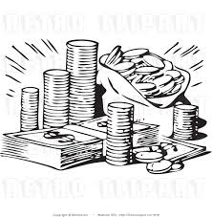
The World Most Successful Dieter

The World Most Successful Dieter program is about to award a $100 000 prize to the winner.

Data

Week | Max (kg) | Moe (kg) | Minnie (kg)
0 | 95 | 71 | 51
2 | 91 | 69 | 49
4 | 85 | 67 | 45

Max, Moe and Minnie are each on a diet and have recorded their weight in kilograms at the start of their diet and at 2 week intervals. After four weeks, which person is the most successful dieter?

The task is to make three different arguments – one that would favour each of the 3 dieters?

Choose your champion and be prepared to defend your choice.

Lesson #3:
What are the Strategies for Solving Proportional Problems?
Part I- Intuitive Strategies

Lesson Title: What are the Strategies for Solving Proportional Problems – Part #1 – Intuitive Strategies |  | Date:  JM
Overall Expectations  • solve problems by using proportional reasoning in a variety of meaningful contexts.  • demonstrate an understanding of proportional relationships using percent, ratio, and rate.  Learning Goals  - Identify intuitive strategies for solving proportional reasoning.  Success Criteria  - Students can articulate and explain the strategies. | Assessment for/as Learning Opportunities:  - As students are working on the minds on make anecdotal notes about their progress.  - Listening and recording observations of student conversations during whole class task.  Assessment of Learning:  - Looking at the finished product and full solutions. Are the students able to communicate their understanding?  Learning Skills  Responsibility, Organization, Independent Work, Collaboration, Self-regulation
Lesson Plan

Minds –On
- Mr. Miller’s 25 students are asked if they are basketball fans (yes or no). Of these students, 20 say yes and 5 say no.
    - Describe as many relations as you can about this data.
    - Find at least one additive and 2 proportional relationships.
Students might describe:
- There are 15 more fans than nonfans. (additive)
- There are 4 times as many fans as nonfans (proportional)
- For every 4 students who like basketball, there is 1 who doesn’t (proportional)
Action
- Discuss the learning goal. Today as you solve the problem you will be making a list of the strategies you use to solve proportional problems. At the end of the period, we will congress these strategies.
- Divide students into groups of 2 or 3.
- Place the 4 problems in 4 locations around the room. Have the students go to each of the stations during the period and work on the problem.
- Identify the strategies used to solve these problems.

Consolidation
- Congress the strategies and how they used them.
Resources: Strategies
Proportional Reasoning involves comparing 2 ratios as well as identifying equivalent ratios. There are many methods of solving problems:
- Unit ratios (Unitizing) – Figure out the unit ratio
- Scaling up or down – (If 3 dozen cost 24.99, what would 6 dozen cost? You could use unit rate, but it would be easier to multiple the cost by 2. This is a build up or scale approach)
- Scale factors – Comparing the scale and using that factor to calculate the answer.
- Ratio tables
- Double line comparison
- Graphs
- Cross products

All these methods are useful in particular situations and all should be understood. The first three are the most intuitive, therefore the students might be able to discover them independently. These problems will allow them to explore some of these strategies.

Have the students try to find 2 or 3 different methods for solving these problems

Homework Assignment: | Next Steps/Reminders:
Reflection:

4 Problem Circuit: Identify some strategies for solving proportional reasoning questions.

Proportional Reasoning involves comparing 2 ratios as well as identifying equivalent ratios. There are many methods of solving problems:
- Unit ratios (Unitizing) – Figure out the unit ratio
- Scaling up or down – (If 3 dozen cost 24.99, what would 6 dozen cost? You could use unit rate, but it would be easier to multiple the cost by 2. This is a build up or scale approach)
- Scale factors – Comparing the scale and using that factor to calculate the answer.
- Ratio tables
- Double line comparison
- Graphs
- Cross products

All these methods are useful in particular situations and all should be understood. The first three are the most intuitive, therefore the students might be able to discover them independently. These problems will allow them to explore some of these strategies.

Have the students try to find 2 or 3 different methods for solving these problems.

How Will They Taste?
Task: Will they taste the same?
Bowl #1 2 grape: 3 ginger ale Bowl #2 3 grape: 4 ginger ale
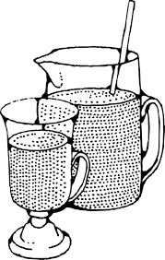

---------------------------------------------------------------------------------------------------------------------
Note to Teacher - Same Taste Argument: Some may argue that they are the same. There is one more ginger ale in each case, so they will be the same. Although incorrect, your class may have a good discussion.
Van de Walle, Elementary and Middle School Mathematics, p. 367

Who Gets More Pizza

Two groups of students, McDonald’s Gr. 7/8 and the Sampson’s Gr. 8 are having pizza parties. Mme McDonald ordered enough so that every 3 students will have 2 pizzas. Mme Sampson orders 3 pizzas for every 5 scouts. Assuming the same size of pizza, which groups of students had more pizza to eat?

---------------------------------------------------------------------------------------------------------------------
Best Price
- At the office superstore, you can buy 4 pencil for $0.59, or you can buy the same pencils in a large box of 5 dozen for $7.79. How much will you save per pencil if you buy the large box?

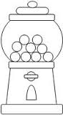
- The price of a box of 2 dozen gumballs is $4.80. Bridget wants to buy 5 gumballs. What will she have to pay?

Which Loads are the Same?
Which of the following loads have the same ratio of the trucks to boxes?

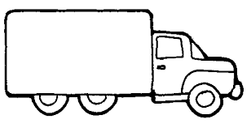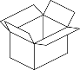

Mr. Miller’s 25 students are asked if they are basketball fans (yes or no). Of these students, 20 say yes and 5 say no.
    - Describe as many relations as you can about this data.
    - Find at least one additive and 2 proportional relationships.

What are the Strategies for Solving Proportional Problems?
Part 2- Direct Instruction

Lesson Title: What are the Strategies for Solving Proportional Problems – Part #2 – Direction Instruction |  | Date:  JM
Overall Expectations  • solve problems by using proportional reasoning in a variety of meaningful contexts.  • demonstrate an understanding of proportional relationships using percent, ratio, and rate.  Learning Goals  - Identify proportional vs non-proportional reasoning.  - Teach additional strategies for solving proportional reasoning.  Success Criteria  - Students can articulate and utilize the strategies. | Assessment for/as Learning Opportunities:  - As students are working on the minds on make anecdotal notes about their progress.  - Listening and recording observations of student conversations during whole class task.  Assessment of Learning:  - Exit Ticket  Learning Skills  Responsibility, Organization, Independent Work, Collaboration, Self-regulation
Lesson Plan

Minds –On – Proportional Reasoning or Not
- See document below. Which is proportionate reasoning?
Action
- Direct instruction of cross products strategy. (1 period)
- Demonstrate how to use Double Line Comparison to set up cross products strategy.
(1 period)
Resources
Homework Assignment: | Next Steps/Reminders:
Reflection:

Proportional Reasoning or Not

Warm Up: Read the following problems.
- Janet and Jeanette are walking to school, each at the same rate. Jeanette started first. When Jeanette has walked 6 blocks, Janet has walked 2 blocks. How far will Janet have walked when Jeanette is at 12 blocks?

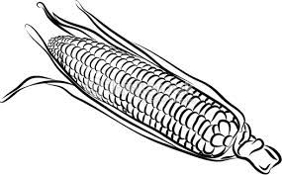
- Lisa and Linda are planting corn on the same farm. Linda pants 4 rows and Lisa plants 6 rows. If Linda’s corn is ready to pick in 8 weeks, how many weeks will it take for Lisa’s corn to be ready?

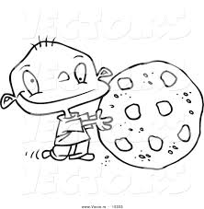
- Kendra and Kevin are using the same recipe to bake cookies. Kendra will make 6 dozen cookies, and Kevin will make 3 dozen cookies. If Kevin uses 6 ounces of chocolate chips, how many ounces will Kendra need?

Identify the type of problem and explain why.
Consider additive, multiplicative or constant.

Make up your own additive, multiplicative and constant problem.

Double Line Comparisons - Shared

- In 1960, U.S. railroads carried 327 million passengers. Over the next 20 years, there was a 14% decrease in passengers. How many passengers road the railroads in 1980?
327 Million

N
100%

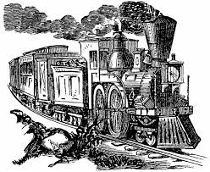
86% 14%

100%

Use double line chart to set up ratio.

$\frac{N of passengers in 1980}{327 passengers in 1960 }$ = $\frac{86\%}{100\%}$

- Sylvia’s new boat cost $8950. She made a down payment of $2000. What percent of the sales price was Sylvia’s down payment?

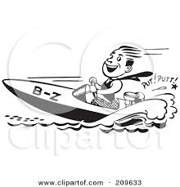
$8950

$2000

N

100%

$\frac{\$2000 downpayment}{\$8950 total cost}$ = $\frac{x \%}{100\%}$

Shared
- Jack can run an 8km race in 37 minutes. If he runs at the same rate, how long should it take him to run a 5 km race?

Set up ratio and solve:

- Feyi purchased a shirt for $18.50 at a 35% discount. What was the original price?

100%

Set up Ratio and Solve:

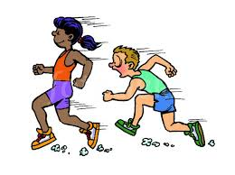
Exit Ticket

Name _______________________________

Set up a double line comparison and the ratio statement for this problem. Then solve this problem. Include a final statement.

A school has 280 students that participate in a walk for charity. This is 70% of the school population. How many students attend the school?

100%

Set up ratio and then solve. Include a final state

