Community Walk
Math Journal
Name: __________________

Community Map
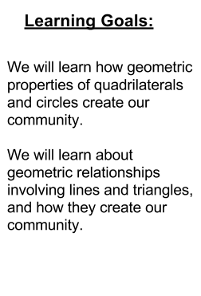
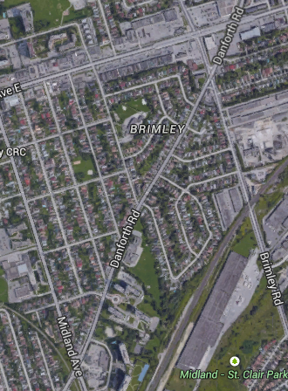

Accessed from: https://www.google.ca/maps/@43.7303968,-79.2571601,1952m/data=!3m1!1e3 (March 27,2015. 10:25am)

What geometry ideas do you see based on the maps shown and our community walk? (E.g. What types of shapes and lines do you mostly notice?)

_________________________________________________________________________________________________

What geometric shape does Robert Service P.S.’s property generally represent? How could you describe the angle-relationships? (E.g. interior/complementary angles, supplementary angles or opposite angles)

_________________________________________________________________________________________________

_________________________________________________________________________________________________

Sketch two polygons from the map, including one quadrilateral. Describe their properties, including those based on diagonals.

* Properties are attributes that remain the same for a class of shapes.
** Diagonals are line segments that join two vertices of a polygon that are not next to one another.
(Mathematics Curriculum Document: Glossary- Pages 120- 134)

Sketch two intersections from the community walk. Describe using geometry ideas and math vocabulary.

What geometry shape do you notice in the middle of Gordon Ridge Place? Why might this choice of shape be made within this community?

_________________________________________________________________________________________________

What did you learn about geometry and your community from today’s information and walk?

_________________________________________________________________________________________________

