Task 1: Building Towers with 10
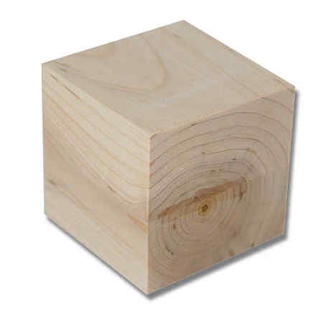
Materials Used:
- 20 1-inch cubes
- Device to take pictures of the towers
OR
- Pencil and paper to keep track of the towers already created
Procedure:
Working on It
- Select two students that can work well together
- If children are copying each other, place a binder between them

- Introduce cubes to students and say, “Using these 10 blocks, show me only 2 towers that stack 1 by 1.”
- Observe students as they are building the towers
- After they have created two towers, ask, “How did you make your towers?” Discuss the amount of blocks they used in each tower and record it with a picture or write the numeral combinations on paper.
- Ask, “Is there another way we can make 2 towers?”
- Continue making different combinations of towers until the student is unable to create any more combinations.
- If students repeat a combination, refer them to the pictures you’ve taken or the recording sheet to remind them that they have already created this combination

Document the Towers
Print out the pictures or drawings and label the combinations of 10 with the students to use for consolidation

Consolidation
Show the class the pictures or drawings of the different towers created.
- Ask, “How many ways did we make 10?”
- Ask, “Are there more ways to make 10?”
- Highlight the different combinations of towers created. “You made 10 with 5 and 5, you made 10 with 4 and 6”
Modifications:
Composers to 5
- If students are composers to 5, work with 5 cubes instead of 10
- You have 5 blocks, show me 2 towers

More cubes
- By having more cubes, students can save their towers and refer to them when creating different combinations of 10
Extensions:
Task 2:
- Using 10 hexalinks, ask the students to create something
- Discuss what parts they used to make their creation (i.e: two hexalinks for the head, two for the arms, etc)

Task 2: Part-Part-Whole to 10 with Hex-a-links 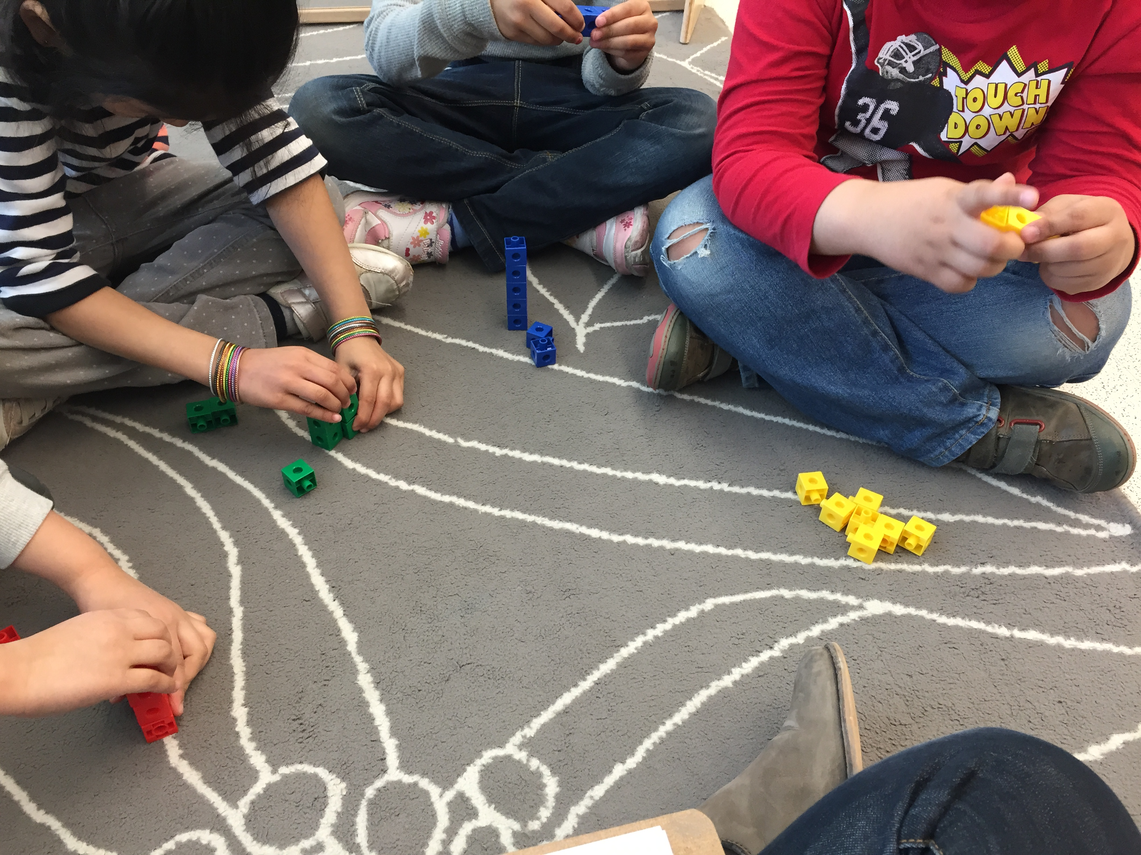
Materials Used:

Hex-a-links
Paper and Pencil for recording notes
Post it notes
Audio recording device
Camera
Procedure:

Work with a small group of children. Give the children 10 hex-a-links of the same colour and get them to check how many they have. Ask the children “What can you make with these 10 hex-a-links? Let the children create whatever they would like using all ten hex-a-links. Once the children are finished building, ask them questions to get them to share what they have created. For example, How many did you use on the side, the top, the bottom? What is holding it together? How many do you have? Once all of the children have made their creation, meet together as a large group. Model for the student how to break down your creation into part-part-whole and display the parts in a bansho. Have a couple students model for the group and then let the children independently create the part-part-whole of their creation. Get the children to identify where their part-part-whole should be place in the bansho. Before placing their parts, get the student to share how many parts they have and how many pieces in total they have. Once all student have placed their part-part-whole in the bansho have the students reflect on what they see. Ask “How did your friends show us 10?”
Modifications:

For children that are lower on the learning trajectories have them work with a smaller number of hex-a-links, like 5 or 7.
Extensions:

Have the students reflect on what they see in their class’ part-part-wholes. See if they are able to fill in the missing parts to find as many ways to decompose 10, ex. Part-part-whole from 1 to 10.

Task3: The Missing Number Game

Materials Used:
Paper plates
Double-sided counters
Plastic cup
5-frame/10-frame

Procedure:

- Number the plates with different number combinations to 10
- Set up a cup with 10 counters
- Present the game to a whole group
- Carry out the game with 1 student at a time

Educator: “We are going to play the Missing Number Game. We are going to make the number 10. Can you show me the number 10 on the plate? (pause) We are given a clue and our clue is the number _____. Can you find me the number ______? So, this missing number and this number ________ (point to each part) makes 10.

*Provide student with cup of 10 counters if necessary to decompose the number and find the missing addend

Modifications:

For students who do not understand the language:
We are given part of the number 10 and we need to find the other part to make 10 (point to each part). We already have ______. So, _____ and the missing number makes 10. How many more do we need to make the number 10? (Give student thinking time. If necessary, introduce the cup with counters.) The magic cup has 10 counters inside. You can use this to find the missing number.

For students who have challenges with the concept of part-part-whole:
- Instead of the plates, use a 10-frame.
- If students find it challenging to make 10, use the 5-plate (number combinations of 5)
- If students are confused with the plate, use a 5-frame.
- Note: Language used will depend on your students

Extensions:
Word problem
Eshal puts 5 grapes in her lunch box. Her mom gives her some more. Now Eshal has 7 grapes. How many did her mom give her?

Task 4: Problem Solving: FIND THE MISSING ADDEND

Eshal puts 5 grapes in her lunch box. Her mom gives her some more. Now Eshal has 7 grapes. How many did her mom give her?

