Lesson 1

Topic Goal: Perimeter of Square, Rectangle and Triangle

Perimeter means the distance around an object. This lesson discusses how to find the perimeter of various shapes.

Example(s):

To find the perimeter:
- Ensure all side lengths are given in the same units
- Add up all the sides.
Formulas:
P= Perimeter
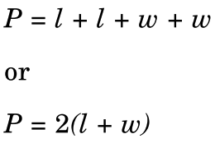
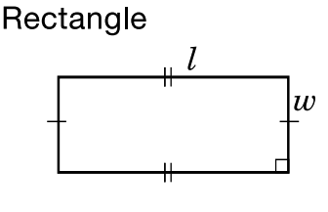
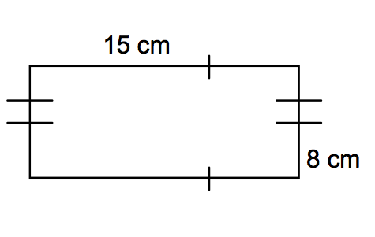
Find the perimeter of the following rectangle:

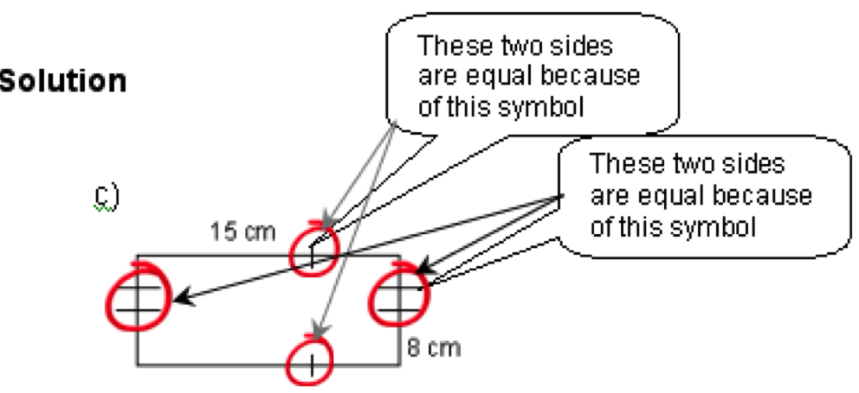

P = 15 + 15 + 8 + 8
= 46 cm
Because we know that a rectangle has two equal lengths and two equal widths, we can add one length and one width together and then multiply by two:
P = 2(l + w)
= 2(15 + 8)
= 2(23)
= 46 cm

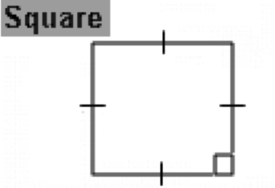
P = s + s + s + s
Or
P = 4s
s

Find the perimeter of the following:
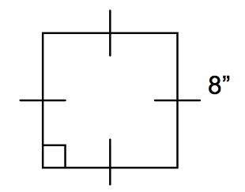
Solution:
P = 8 + 8 + 8 + 8
= 32”

Because we know that the sides of a square are all the same length, we can simply multiply one side length by 4.

P = 4s
= 4(8)
= 32”

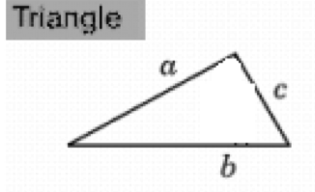
P = a + b + c

Find the perimeter of the following:
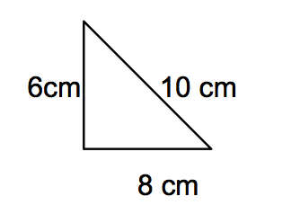
Solution:
P = 6 + 8 + 10
= 24 cm

Find the perimeter of the following:
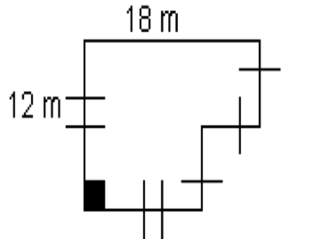
Solution:
Step 1 – Fill in all the unknown sides
6 m
This side is 18 m – 12 m (the top side minus the bottom side) = 6 m
6 m

12 m

Step 2 – Add up all the sides
P = 18 + 12 + 12 + 6 + 6 + 6
= 60 m

For some practice, play the perimeter game at this website:
http://www.bgfl.org/bgfl/custom/resources_ftp/client_ftp/ks2/maths/perimeter_and_area/index.html

Practice Questions:

1. Calculate the perimeter for each of the following objects:
Object | Perimeter
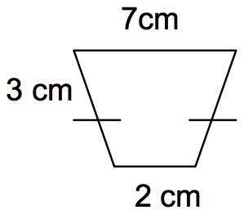
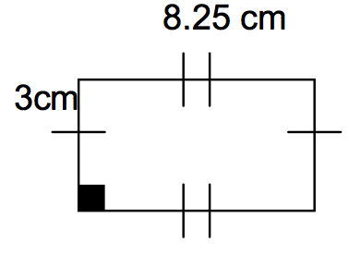
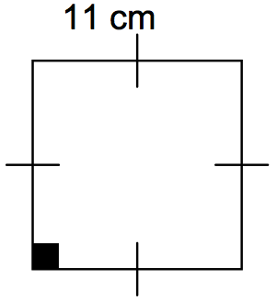
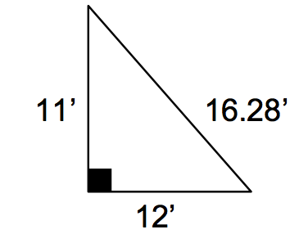
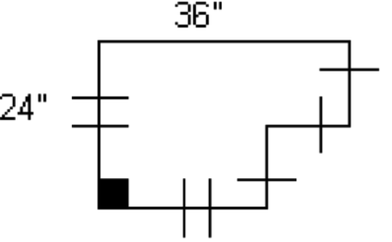
2. Complete the table below.
P = perimeter and a, b, and c, are lengths of sides of a triangle
P | a | b | c
 | 9 | 6 | 9
32 | 8 | 10
43.8 | 7.8 | 22.5

To find the length of a side when you are given the Perimeter – SUBTRACT the other side lengths from the Perimeter

Assessment:

