Lesson 2

Topic Goal: Area of a Square, Rectangle and Triangle

This lesson focuses on calculating the area of rectangles and triangles.

Example(s):
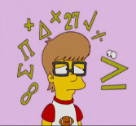

Area is the measure of how much space is in a flat surface.
Area of a Square
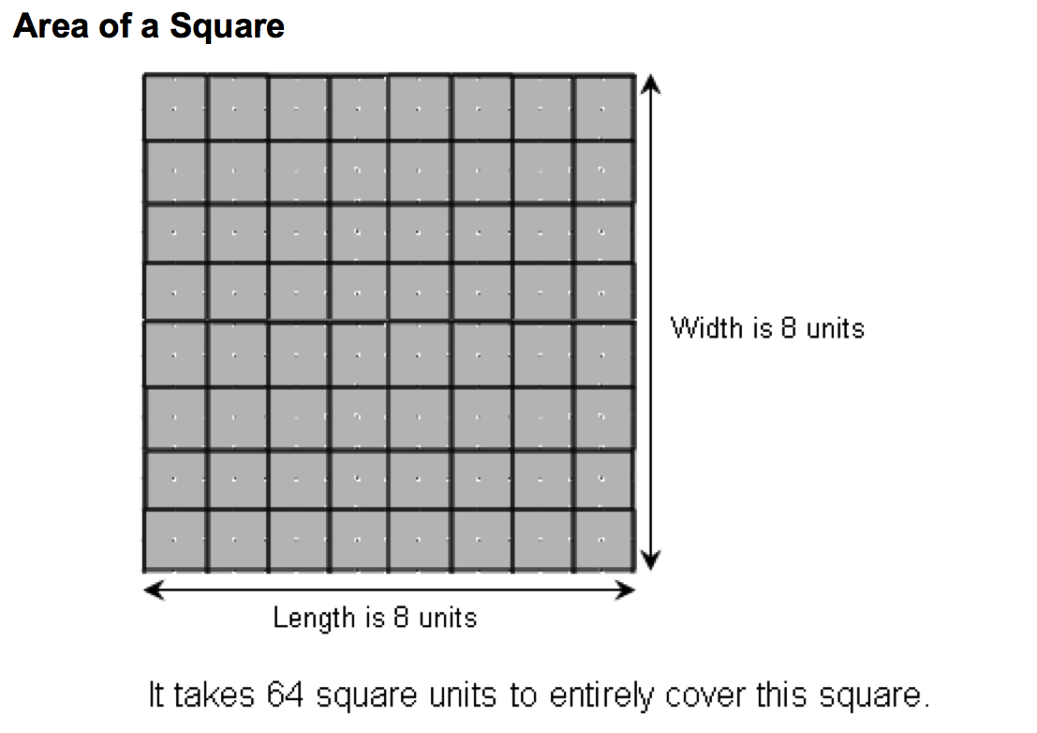

Formula:
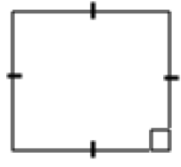
Area = length x width
Area = l x w
Find the area of the square below:
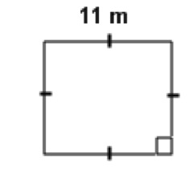
Remember that these marks mean that the sides are equal

Solution:

11 m
11 m

11 m

A = l x w
Notice that the units are squared, m²
= 11 x 11
= 121 m²
Area of a Rectangle
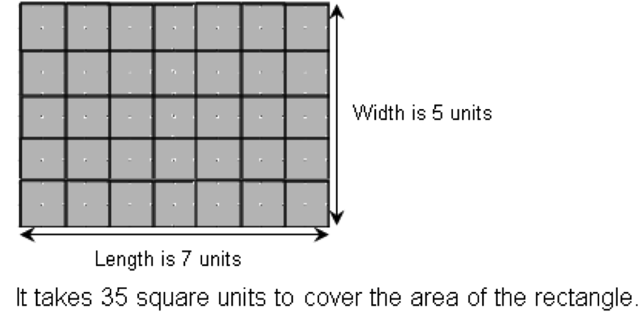
Formula:
w
Area = length x width
Area = l x w

l

Find the area of the rectangle below:
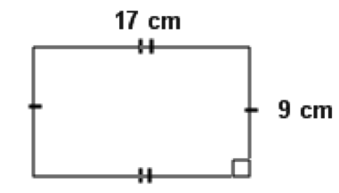

Solution:
A = l x w
= 17 x 9
= 153 cm²
Area of a Triangle
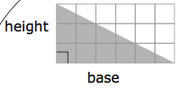
A = base x height
2

= 6 units x 3 units
2

= 18 units
2

It takes 9 square units to cover the area of the triangle.
h = height
b = base
Formula:
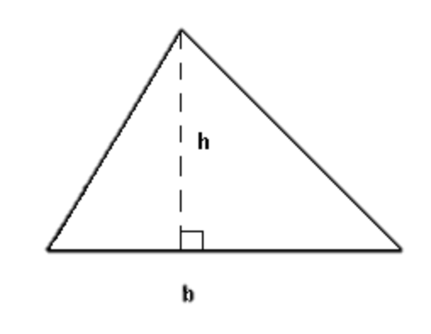
Area = base x height
2

$$A = \frac{bh}{2}$$

Find the area of the following triangle:
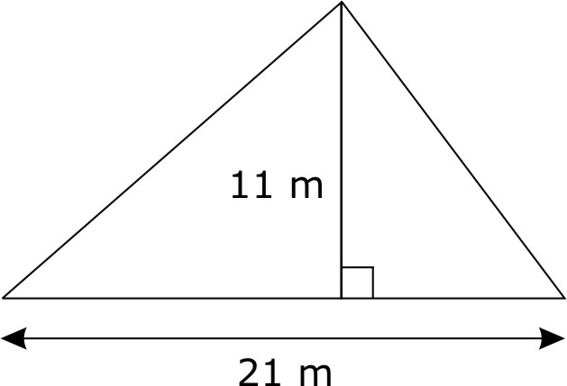

Solution:
b = 21 m
h = 11 m

Use the formula:

$$A = \frac{bh}{2}$$

Step 1 – multiply the base by the height

A = 11 x 21
2

A = 231
2

Step 2 – divide your answer by 2

A = 115.5
For some practice, play the area game at this website:
http://www.bgfl.org/bgfl/custom/resources_ftp/client_ftp/ks2/maths/perimeter_and_area/index.html

Step 3 – add the units

A = 115.5 m²

Problem:

The cost to lay down artificial turf at BMO field is $19.50/m². The dimensions of the playing area are 68 m x 105 m. How much does it cost to lay down the turf?

Solution:

Step 1 – draw and label a diagram
105 m

68 m

Step 2 – Use the formula for Area of a rectangle
A = l x w
= 105 x 68
= 7140 m²
The area of the field is 7140 m²
Step 3 – Find the cost of the turf.
Total cost = area of field x cost per m²
= 7140 x 19.50
= $139 230
Therefore, it costs $139 230 to put down artificial turf at BMO field.
Practice Questions:

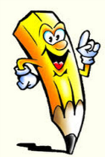

- Find the area of the following unshaded (white part) below. Each box represents 1 cm².

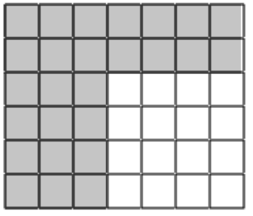

Area = _________

- Find the area of the following objects using the appropriate formula.
Shape –
Formula –
Length –
Width –
A = ______ x ______
=

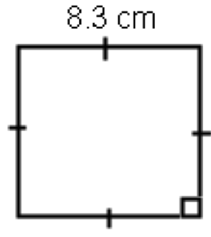
a.

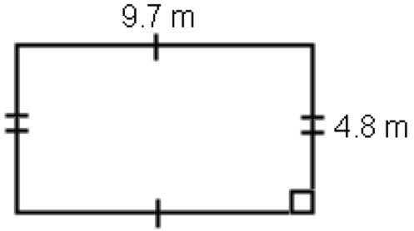
b.
Shape –
Formula –
Length –
Width –
A = ______ x ______
=

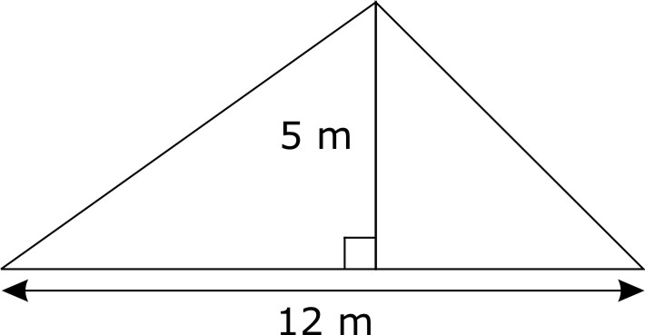
c.
Shape –
Formula –
Length –
Width –
A = x
2
=

3. A credit card measures 8.4 cm by 5.6 cm. Find the area of the card.

4. Sunfish sailboat is a personal size, beach sailboat. If it is 7.5 ft high and 10 long, how much material is needed to make the mast (sail)/
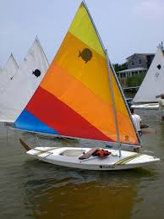
7.5 ‘

10 ‘

Assessment:

1. Write the formula or symbol from column B that matches the description in column A.
A | B
1. area of a square with length and width 1 cm: _________________________  2. formula for the area of a rectangle:  _________________________  3. formula for the area of a triangle:  _________________________ | a)  b) 1 cm²  c)

Write the word from column B that completes the explanation in column A
A | B
4. length from the base to the highest point of a triangle: _______________  5. the space covered by a  two-dimensional shape ___________  6. the shape that has an area of:  _________________  7. the shape of a door: ______________ | a) rectangle  b) triangle  c) height  d) area
- Find the area of the following unshaded (white part) below. Each box represents 1 cm².

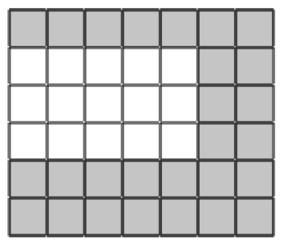

Area = _________

- Find the area of the following objects using the appropriate formula.
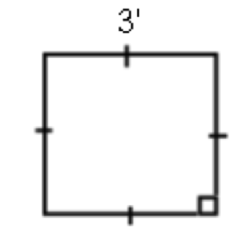
Shape –
Formula –
Length –
Width –
A = ______ x ______
=
a.

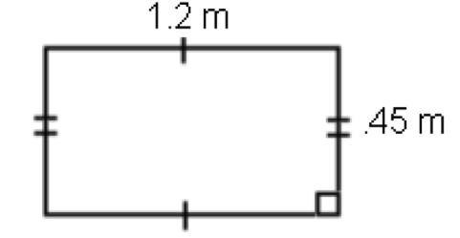
b.
Shape –
Formula –
Length –
Width –
A = ______ x ______
=

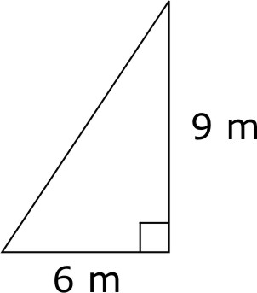
c.
Shape –
Formula –
Length –
Width –
A = x
2
=

- An average rectangular NHL rink is approximately 61 m long and 26 wide. A rectangular Olympic rink measures 61 m by 30.5 m.

  - Draw and label diagrams for both rinks.

  - Use the formula for area of rectangle to find the area of both rinks.

  - How much more playing surface do Olympic players have than NHL players?

- Mrs. Patel has a large garden that is in the shape of triangle. It is 23 feet high and 25 feet wide.
  - Draw and label a diagram of the garden.

  - She needs to cover the surface with soil. How much does she need?

  - The soil costs $1.25/square foot. How much will it cost her to cover the garden?

