Lesson 3

Topic Goal: Circumference of Circles
 | The distance around the circle is called the circumference. |  | 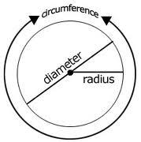
 | The diameter of a circle is any straight line that passes through the centre of the circle and whose endpoints lie on the circle
 | The radius of a circle is a line from the centre of the circle to the edge.
Example(s):
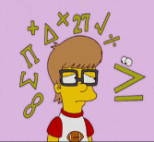

You need to know some abbreviations before you can use the formulas
r = radius
d = diameter
C = Circumference
∏ = pi = ≈ 3.14

There are two formulas you can use to find the circumference of a circle.
If you are given the diameter of the circle use  C = ∏d  C = 3.14 x diameter | If you are given the radius of the circle use  C = 2∏r  C = 2 x 3.14 x radius
Find the circumference of the given circle  6m  C = ∏d  C = 3.14 x diameter  C = 3.14 x 6m  C = 18.84 m  The circumference of the circle is 18.84m | Find the circumference of the given circle  4m  C = 2∏r  C = 2 x 3.14 x radius  C = 2 x 3.14 x 4m  C = 25.12m  The circumference of the circle is 25.12m.

Practice Questions:

- Which of the two formulas C = ∏d or C = 2∏r would be used to find the circumference of the given circle

7m
Formula:

14cm
Formula:

10cm
Formula:

8m
Formula:

- Calculate the circumference of each circle

- r = 7 cm

- d = 16 m

- r = 19 cm

- d = 5m

- Calculate the circumference of each circle

Circumference:
20cm

Circumference:
15cm

3m
Circumference:

Circumference:
30m

- Calculate the circumference of each circle

d = 10 cm
Circumference:
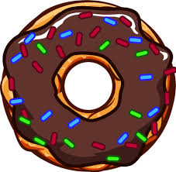

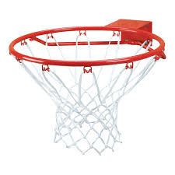
Circumference:
r = 45 cm

d = 55 cm
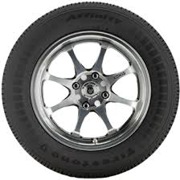
Circumference:

Circumference:

r = 12 cm

- Farah’s hoop earning has a radius of 1cm. What is the circumference of the earning?

- The radius of a Canadian quarter is 14.3 mm. What is the circumference of the coin?

Assessment:

- Which of the two formulas C = ∏d or C = 2∏r would be used to find the circumference of the given circle

9m
Formula:

15mm
Formula:

60cm
Formula:

5m
Formula:

- Calculate the circumference of each circle

- r = 49 m

- d = 6 m

- r = 30 mm

- d = 75 m

- Calculate the circumference of each circle

Circumference:
40cm

Circumference:
3mm

90cm
Circumference:

Circumference:
10m

- Calculate the circumference of each circle

d = 13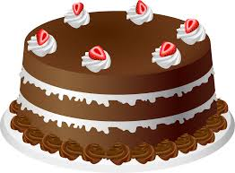 cm
Circumference:

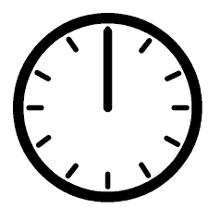
Circumference:
r = 50mm

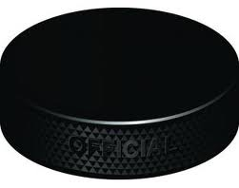
d = 3cm
Circumference:

Circumference:

r = 11 cm

- The radius of Jeff’s new car tire is 50 cm. What is the circumference of the tire?

- The rollercoaster loop has a diameter of 49m. What is the circumference of the loop?

