Lesson 4

Topic Goal: Area of a circle

The area is the number of square units needed to cover a region
The formula for the area of a circle is
A = ∏ r²

A stands for area
r² = r x r
∏ = pi ≈ 3.14

In order to find the area of a circle, we need to find the radius of the circle if we are given the diameter.
r = $\frac{d }{2}$
d = diameter
r = radius

Example(s):
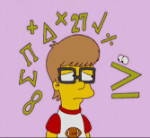

- Find the radius of the circle below
10cm

r = $\frac{d}{2}$
r = $\frac{10cm}{2}$
r = 5cm

The radius of the circle is 5cm.

- Find the area of the following circles

A = ∏ r²
A = 3.14 x r x r
A = 3.14 x 17m x 17m
A = 907.46 m²
The area of the circle of 907.46 m²

17mm

First you have to find the diameter
r = $\frac{d}{2}$
r = $\frac{15m}{2}$
r = 7.5m
Then you can find the area
A = ∏ r²
A = 3.14 x r x r
A = 3.14 x 15m x 15m
A = 706.5 m²
The area of the circle of 706.5 m²

15mm

Practice Questions:

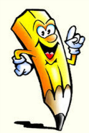

- Find the diameter of the following circles
26cm
radius:

radius:
9 m

radius:
6m

radius:
17mmm

- Find the area of the following circles

Area:

16m

Area:

9cm

Area:
70m

Area:
29cm

- Find the area of the following circles
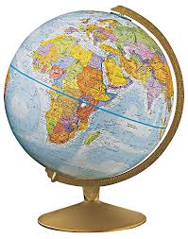
Area:
d= 18cm

Area:

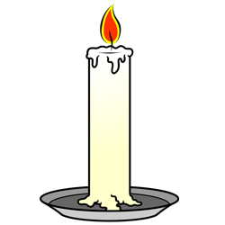

b)
r = 5mm
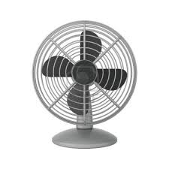
c)
Area:
r = 16cm

Area:
d= 2m
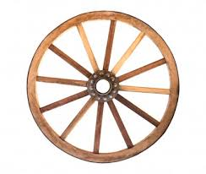
d)

- Kimesha measured the diameter of her plate to be 10cm.

a)What is the radius of her plate

- What is the area of her plate?

- What is the area of half her marble?

- Erin found the radius of a marble to be 8.4 mm. What is the area of her marble?

Assessment:

- Find the diameter of the following circles
28cm
radius:

radius:
39 m

radius:
18m

radius:
79m

- Find the area of the following circles

Area:

48m

Area:

31mm

Area:
17m

Area:
19cm

- Find the area of the following circles
Area:
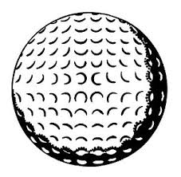
d= 29mm

Area:
r = 8cm
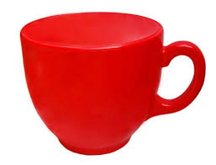
b)

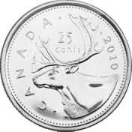
Area:
r = 26cm
c)

d= 2m
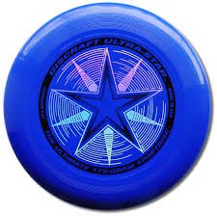
d)
Area:

- Michael’s DVD has a diameter of 5cm.

a)What is the radius of his DVD?

- What is the area of his DVD?

- What is the area of half the DVD?

- Stef found the radius hockey puck to be 7.5cm. What is the area of the hockey puck?

