Lesson 4

Topic Goal: Fractions

A fraction is a number that represents parts of a whole.

$$\frac{1 (number of equal part you have)}{2 (total number of equal parts)}$$

The top number is called the numerator and the bottom number is called the denominator.

Here is another way to look at fractions:
The line that separates the numerator and the denominator is another way of saying division.

Look at these four cats. We can say that $\frac{1}{2}$ of this group is 2. This is the same as dividing 4 by 2.

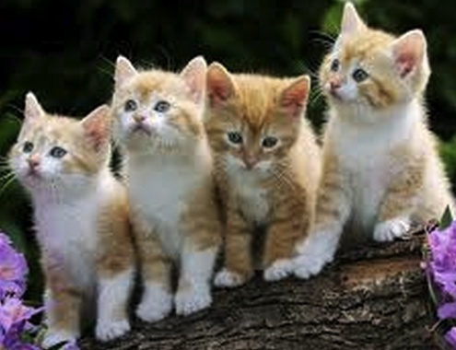
$$4 ÷2 =2$$
$$\frac{1}{2} of 4 =2$$

Example(s):

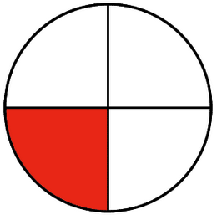
This circle is divided into 4 equal parts. One part is shaded. Therefore, $\frac{1}{4}$ of this circle is shaded.
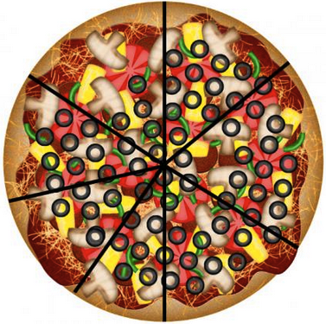
This pizza is divided into 7 equal slices. If you eat one slice you will have $\frac{6}{7}$ slices left.

You have 6 popsicles. If you want to divide the popsicles into 3 equal parts, then each part will have 2 popsicles.

$$6 ÷3 =2$$
$$\frac{1}{3} of 6 =2$$

Practice Questions:

1. Write the fraction of the shaded parts for each question.
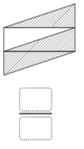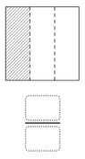
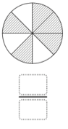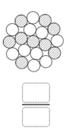

2. Shade each shape to match the fraction given:

$\frac{3}{12}$ $\frac{5}{7}$ $\frac{6}{16}$
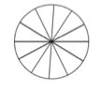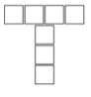

$\frac{2}{10}$ $\frac{1}{8}$
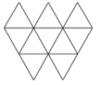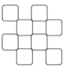

3. Draw any equal sized shape and shade to represent each fraction given:

$\frac{4}{8}$ $\frac{5}{5}$

4. Use a picture to show your answers to the following questions.
a) I have 8 gum balls and I have to share them equally with my sister. How many do we each get?

- There are 12 pens to be shared equally among 4 people. How many does each person get?

5. Find the following amounts.
Hint: remember that the line separating the numerator and the denominator means to divide.

- How many popsicles did each kid get if they were allowed $\frac{1}{3}$ of 6?

- How many pieces of pizza can each student have if they are allowed $\frac{1}{4}$ of 8?

- There are 25 kids in a class and $\frac{1}{5}$ of these students can hold their breath for 2 minutes. How many students can hold their breath?

Assessment:

- What is the fraction of the shaded area?

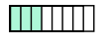

- Shade the figure with the indicated fraction.
 | $$\frac{2}{5}$$
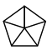 | $$\frac{1}{5}$$
 | $$\frac{3}{3}$$
 | $$\frac{5}{5}$$
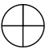 | $$\frac{1}{4}$$
 | $$\frac{5}{5}$$

3. Find the following amounts.
Hint: remember that the line separating the numerator and the denominator means to divide.

- How many popsicles did each kid get if they were allowed $\frac{1}{2}$ of 4?

- How many pieces of pizza can each student have if they are allowed $\frac{1}{4}$ of 12?

- There are 15 kids in a class and $\frac{1}{3}$ of these students can hold their breath for 2 minutes. How many students can hold their breath?

