Lesson 5

Topic Goal: Perimeter of composite shapes.

A composite shape is made up of two or more geometric shapes.
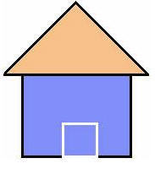
This house is a composite shape. It’s made up of a triangle and a square.
To calculate the perimeter of a composite shape you simply find the distance around the figure.

Example(s):

1. Kloe is putting a wallpaper border around her bedroom.
She must calculate the perimeter of her bedroom in order to buy the correct amount of wallpaper border.
4.5 ft
3 ft
7.5 ft
12 ft
9 ft
5 ft

Perimeter = 12 ft + 3 ft + 5 ft + 4.5 ft + 9 ft + 7.5 ft = 41 ft

Kloe needs 41 ft of wallpaper border for her room.

2. Mark wants to fence his garden. Lets help him find out how much material he needs to buy.
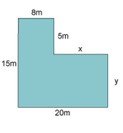

To help Mark first we must split the composite shape into simpler shapes. In this case we have two rectangles.
Now we can find the length of the missing sides.

To find the length “x” we can subtract 8m from 20m: 20 – 8 = 12m. This is because the opposite sides of rectangles are the same length.
To find the length “y” we can subtract 5m from 15m: 15 – 5 = 10m.

Now that we have all of the sides of this composite shape lets find its perimeter.

P = 8m + 5m + 12m + 10m + 20m + 15m = 70 m
Therefore, Mark will need 70m of fencing for his garden.

Practice Questions:

Find the missing dimensions and calculate the Perimeter of the following composite shapes.
a)
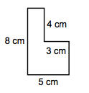

b)
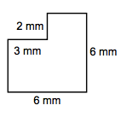

c)

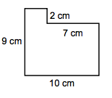

d)
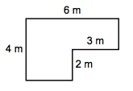

e)
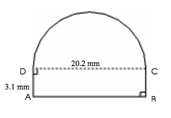

f)
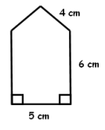

Assessment:

Calculate the perimeter of the following composite shapes.
a)
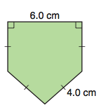

b)
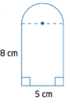

c)
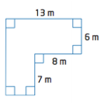

d)
