Lesson 5

Topic Goal: Equivalent Fractions

These are fractions with different numbers that represent the same amount.

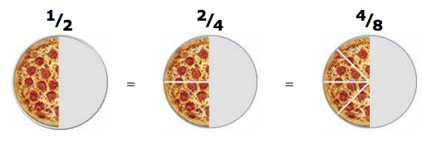

Example(s):

What do these fractions have in common?
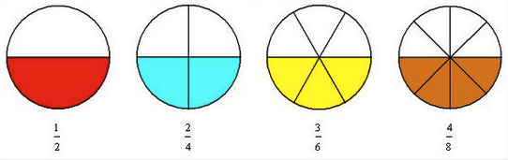

Answer:
These are fractions with different numbers that represent the same amount. Therefore, these are equivalent fractions.
Notice that although the group sizes change, the amount of un-shaded areas remains the same.

Practice Questions:

- Shade and write the equivalent fraction for each model.

a) 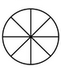

b) 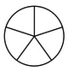 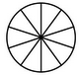

c) 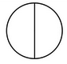 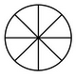

- Write the equivalent fraction for each fractions bar.

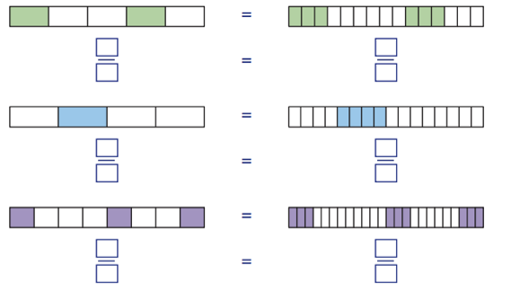

- Find and match the equivalent fractions. The first one is done for you.

$\frac{1}{5}$ | $$\frac{3}{5}$$
$$\frac{4}{8}$$ | $$\frac{2}{8}$$
$$\frac{2}{4}$$ | $$\frac{1}{2}$$
$$\frac{6}{10}$$ | $$\frac{2}{10}$$
$$\frac{ 3}{4}$$ | $$\frac{6}{8}$$
$$\frac{1}{4}$$ | $$\frac{1}{2}$$

Assessment:

- Write the equivalent fraction for each.
a)
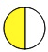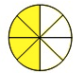

b)
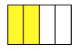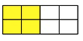

- Use a diagram to answer the following questions.
- Which fraction is the equivalent to ²/₄?

- ¹/₃
- ³/₇
- ¹/₂

- Which fraction is the same as ⁴/₁₆?

- ¹/₃
- ¹/₄
- ²/₅

- Which fraction is equivalent to ²/₆?

- ¹/₃
- ¹/₄
- ¹/₅

