**Lesson 6: Ionic Compounds**

* Metals and non-metals combine to form _______________________ by ________________________
* Metals: __________________ to form _______ (positive ion)
* Non-metals: ____________________ to form ________ (negative ion)



**+ ─**

* + Since ___________________________, metal and non-metal ions now attract each other
* the resulting ions all have stable, filled outer electron arrangements as the __________________________

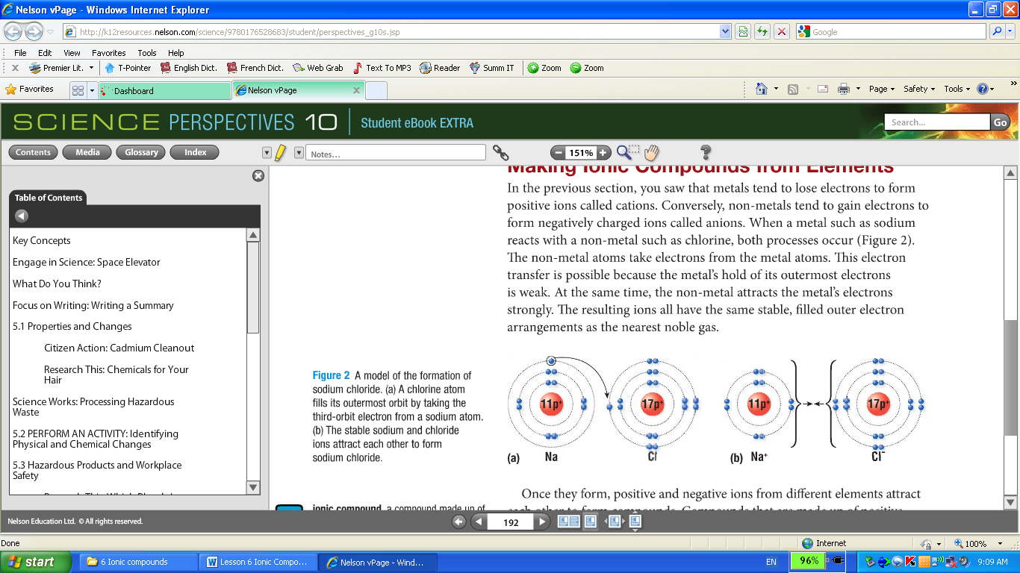

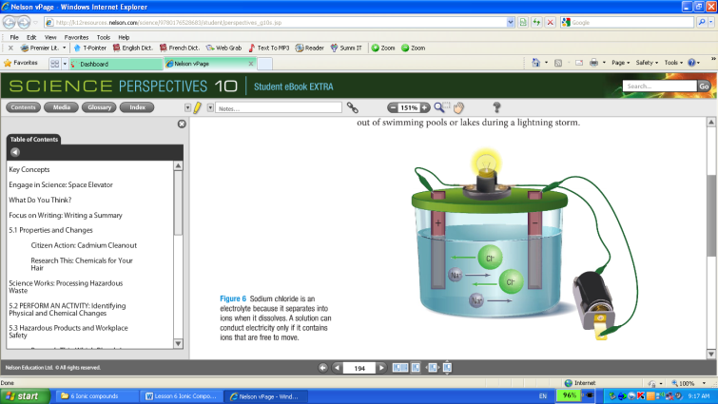**Ionic Compound**: compounds that are made up of _______________ ___________________________

**Ionic bond:** the simultaneous _________________________ of positive and negative ions in an ionic compound

**Properties of Ionic compound**

* ________, _____________ with ______________________
* Most ionic compounds are ______________ – _______ __________to produce a solution that _____________ _______________
  + Pure water is a __________________ of electricity but tap water, lake water, and seawater are good ____________________ because they contain ___________ from a variety of sources

**Naming Ionic Compounds:**

* The ____________________________________ in the compound and the _____________________________________
* Metal ion: name remains the __________
* Non-metal ion: ending changes to _____________
* e.g. _________________

**Chemical Formulas:**

* In a compound, the number of _______________________ must _________ the total number of _______________________

**e.g. Magnesium and Chlorine**

Step1: Write the symbol of the elements. Metal on the left, non-metal on the right

Step 2: Add ionic charge of each ion above the symbol

**Special Rules:**

* Do not write the subscript “1”
* Reduce subscript if there is a common factor

Step 3: **Crisscross Rule**: Crisscross the numbers of the ionic charges so that they now become subscripts for the opposite elements

Step 4: State the chemical formula and chemical name

e.g. Aluminum and oxygen

e.g. Magnesium and Sulfur

**Element with Multiple Ionic Charges**

* Some metals have two stable cations
* The Roman numerals in rounded brackets are used to indicate the ionic charge of the metal

|  |  |  |  |
| --- | --- | --- | --- |
| **Metal** | **Chemical symbol of element** | **Chemical symbols of ions** | **Names of ions** |
| Copper | Cu | Cu+  Cu2+ | Copper (I)  Copper (II) |
| Iron | Fe | Fe2+  Fe3+ | Iron (II)  Iron (III) |
| Lead | Pb | Pb2+  Pb4+ | Lead (II)  Lead (IV) |
| Mangenese | Mn | Mn2+  Mn4+ | Manganese (II)  Manganese (IV) |
| Tin | Sn | Sn2+  Sn4+ | Tin (II)  Tin (IV) |

e.g. Copper (II) Nitride

e.g. Determine the chemical name of PbO2

Step one: Reverse crisscross

Step two: Check the charge of the anion. If it has reduced, multiply the cation and anion’s charges by the reduced factor

e.g. CuBr2

***Read Section 5.6; answer questions # 1, 2, 3 on page 195.***

***Read Section 5.7; answer questions # 2, 3, 4, 7 on page 200.***