Lesson 6

Topic Goal: How to find equivalent fractions

To find an equivalent fraction you can:

Multiply the numerator and denominator by the SAME whole number.
$\frac{4 X3}{7X3}$ = $\frac{12}{21}$
$$\frac{4}{7} and \frac{12}{21} are now equivalent fractions$$

OR

Divide the numerator and denominator by the SAME greatest common factor (GCF).
Hint: The greatest common factor is the largest number that divides into the numerator and denominator exactly.

$$\frac{6÷6}{24÷6}= \frac{1}{4}$$

$\frac{6}{24} and \frac{1}{4}$ are now equivalent fractions.

Example(s):

Write 2 equivalent fractions for each of the following.
$$a) \frac{2}{3}$$
$\frac{2}{3}$ = $\frac{2 × 4}{3 × 4}= \frac{8}{12}$
$\frac{2}{3}$ = $\frac{2 × 5}{3 × 5}= \frac{10}{15}$

$$b) \frac{3}{9}$$
$$\frac{3÷3}{9÷3} = \frac{1}{3}$$
$$\frac{3 × 2}{9 × 2} = \frac{6}{18}$$

Practice Questions:

1. Write an equivalent fraction for each of these using the multiplication or division.
a. $\frac{1}{6} (×3)$

b. $\frac{2}{20 } (÷2)$

c. $\frac{9}{2} (×6)$

d. $\frac{5}{30} (÷5)$

2. What’s the pattern? Fill in the blanks.

$$\frac{5}{7} = \frac{10}{14} = \frac{15}{21} = \frac{20}{28} = \frac{}{}$$

$$\frac{1}{3} = \frac{}{} = \frac{5}{15} = \frac{7}{21} = \frac{9}{27}$$

$$\frac{9}{2} = \frac{18}{4} = \frac{27}{6} = \frac{36}{8} = \frac{}{}$$

$$\frac{8}{5} = \frac{16}{10} = \frac{24}{15} = \frac{}{}= \frac{40}{25}$$

$$\frac{1}{6} = \frac{}{} = \frac{3}{18} = \frac{4}{24} = \frac{5}{30}$$

3. Choose the correct equivalent fraction.

$$\frac{12}{18} = ? a) \frac{4}{9} b) \frac{1}{6} c) \frac{2}{3} d) \frac{3}{2}$$

$$\frac{5}{15} = ? a) \frac{10}{40} b) \frac{7}{21} c) \frac{13}{26} d) \frac{3}{18}$$

$$\frac{2}{3} = ? a) \frac{2}{12} b) \frac{4}{16} c) \frac{2}{20} d) \frac{4}{6}$$

$$\frac{14}{16} = ? a) \frac{3}{18} b) \frac{1}{8} c) \frac{7}{8} d) \frac{35}{25}$$

Extension: 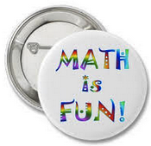

What happens if one of the values of your equivalent fractions is unknown? How would you solve for this value?

Let’s say that you have the following equivalent fractions:
$$\frac{5}{6}= \frac{n}{24}$$
How would you solve for “n”?

Because these fractions are equivalent, whatever happens to the denominator must also happen to the numerator.
That means that you must make the denominators of both fractions the same number.
Ask yourself, what can I multiply 6 by to get 24?
The answer? 4
Now, go ahead and multiply the numerator by 4 as well and see what happens?

$$\frac{5 × 4}{6 × 4 } = \frac{20}{24}$$

Therefore, “n” is 20. Because $\frac{5}{4} = \frac{20}{24}$

Let’ s practice our new skill.
Fill in the missing numbers.

$\frac{27}{36} = \frac{}{4}$ $\frac{16}{11} = \frac{}{22}$ $\frac{20}{} = \frac{5}{3}$

$\frac{2}{8} = \frac{20}{}$ $\frac{10}{9} = \frac{70}{}$ $\frac{2}{10} = \frac{}{20}$

Assessment:

- Shade in the second shape and complete the equivalent fraction.
Remember to make an equivalent fraction you can multiply OR divide the numerator and the denominator by the same number.

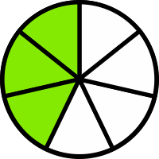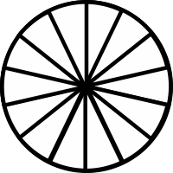

$$\frac{3}{7} = \frac{}{ 14}$$

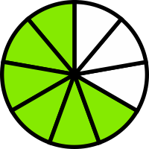

$$\frac{6}{9} = \frac{}{ 3}$$

2. Complete the equivalent fractions below by finding out which common number to multiply the numerator and denominator with.
- $\frac{1}{4} = \frac{4}{}$

- $\frac{1}{2} = \frac{}{6}$

- $\frac{6}{7} = \frac{12}{}$

- $\frac{5}{8} = \frac{}{16}$

- $\frac{2}{3} = \frac{}{15}$

- $\frac{4}{5} = \frac{8}{}$

- Shade in both shapes so that they are both equivalent. Don’t for get to also write the equivalent fraction.

