Lesson 5

Topic Goal: Area of Composite Shapes

To find the area of any composite shape you simply break it into smaller parts and add them up.

These smaller parts MUST be regular 2-D geometric shapes.

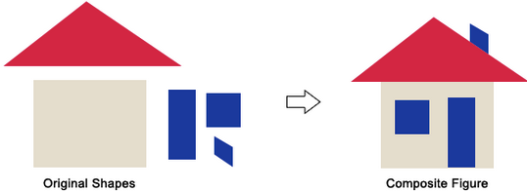

Example(s):

Find the area of this composite shape.

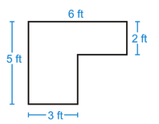
To find the area of this shape we must first break the shape into smaller parts. These smaller parts will be two rectangles.

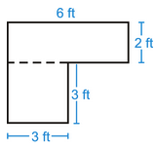
The area of the top rectangle is:
$$Atop =6 ×2=12 {ft}^{2}$$

The area of the bottom rectangle is:
$$Abottom=3 × 3 =9 {ft}^{2}$$

Now add up the areas to get the TOTAL area of this shape:
$${A total=12+9 =21 ft}^{2}$$

Practice Questions:

Calculate the total area of the following composite shapes.
a)
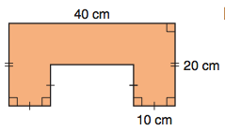

b)
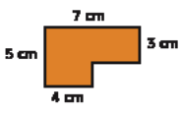

c)
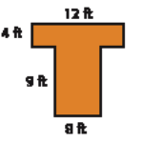

d)
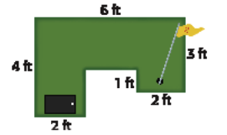

Assessment:

Find a composite shape in your classroom. Draw this shape and use a ruler to measure all the sides necessary to find its area.

