**PART A: Multiple Choice Questions [K: 13 marks, one make each]**

*Instructions:* Circle the correct response.

For questions 1 and 2, identify the following **angles** by circling the correct response.

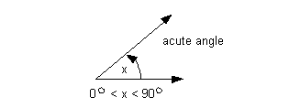

1. Angle x is a/an ________________ angle
   1. Acute
   2. Right
   3. Obtuse
   4. Straight

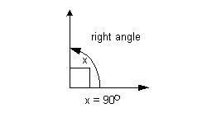

1. Angle x is a/an ________________ angle
   1. Acute
   2. Right
   3. Obtuse
   4. Straight

For questions 3 to 5, circle the most correct response

1. Complimentary angles are angles that add up to ________ degrees
   1. 45
   2. 90
   3. 180
   4. 360
2. All the angles in a triangle add up to ________ degrees
   1. 45
   2. 90
   3. 180
   4. 360

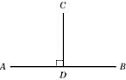

1. AB and CD are known as _______________ lines
   1. curved
   2. parallel
   3. perpendicular
   4. diagonal

For questions 6 and 7, classify the following **triangles** by circling the correct response

1. 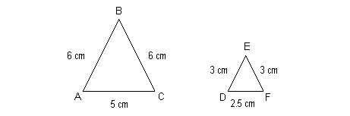Triangle ABC is a/an ________________ triangle
   1. Isosceles
   2. Scalene
   3. Equilateral
   4. Obtuse
   5. Right
2. Triangle CAT is a/an ________________ triangle
   1. 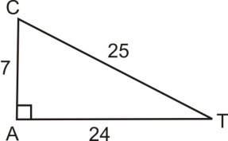Acute
   2. Scalene
   3. Equilateral
   4. Obtuse
   5. Right

For questions 8 and 9, define the following terms:

1. A **polygon** is a:
   1. A five sided figure
   2. A figure with four or more sides
   3. A figure with three or more sides
   4. A four-sided figure
   5. A three-sided figure
2. A **quadrilateral** is a:
   1. A five sided figure
   2. A figure with four or more sides
   3. A figure with three or more sides
   4. A four-sided figure
   5. A three-sided figure

For questions 10 to 13, pick the most correct response:

1. The **perimeter** of a **circle** is called the:
   1. Diameter
   2. Chord
   3. Composite
   4. Circumference
   5. Area
2. If the **radius** of a **circle** is 6cm, what is the **diameter**?
   1. 3 cm
   2. 12 cm
   3. 2 cm
   4. 6 cm
   5. Answer cannot be determined
3. The **hypotenuse** of a right triangle is always
   1. The shortest side
   2. The length of the other two sides added together
   3. The longest side
   4. Touching the right angle
   5. The subtraction of the two legs
4. If you wanted to build a rectangular fence around your backyard, you would need to know the:
   1. Area
   2. Perimeter
   3. Circumference
   4. Angles
   5. Volume

**PART B: Short Answer**

*Instructions:* Answer the following questions by **showing your work** or **providing a reason**.

1. Identify the missing angles **[T: 1 mark (answer); C: 1 mark (explanation)]**

a)

35°

a°

**Show your work or provide a written explanation:**

**_________________________________________________________________**

**a°** = _______________

b) **[T: 1 mark (answer); C: 1 mark (explanation)]**

b°

30°

**Show your work or provide a written explanation:**

**_________________________________________________________________**

**b°** = _______________

c) **[T: 1 mark (answer); C: 1 mark (explanation)]**

65°

c°

**Show your work or provide a written explanation:**

**_________________________________________________________________**

**c°** = _______________

2.Calculate the **perimeter** and **area** of each figure. Show your work by providing the correct formula and doing the math. Round your answers to the **nearest tenth** of a unit where applicable and write your final answer on the lines provided. **[T: 12 marks, 4 marks each; C: 3 marks for correct units and rounding]**

P= ________________ A= _________________



(a)

(b)



11.2 cm

9.6 cm

P= ________________ A= _________________

c)

C= ________________ A = _________________

**PART C:** Extended Responses **[C: 4 marks for correct units and concluding sentences in Part D]**

*Instructions:* Answer the following questions by showing your work and writing a concluding sentence.

1. You want to lean a ladder against the brick wall of your house so that you can clean the outside of your window. If the window is 5 feet above the ground and the ladder is 6 feet from the wall, how long is the ladder? Solve for the length of side c. *(****Hint: a2+b2=c2****).* **[A: 3 marks]**

**c = ___ ft**

**b = 3 ft**

**A = 4 ft**

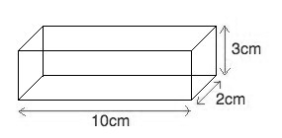2. Calculate the **volume** of the following 3D figures. Remember to write the correct formula and to include the correct units in your final answer. **[A: 5 marks; C: 2 marks (for correct formulas and units)]**

a) **[A: 2 marks]**

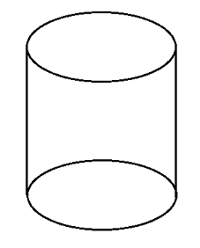

b)

3 cm

**[A: 3 marks]**

15 cm

|  |  |  |  |  |
| --- | --- | --- | --- | --- |
| **Marking Scheme** | | | | |
| **Knowledge** | **Thinking** | **Communication** | **Application** | **TOTAL** |
| **/13** | **/15** | **/8** | **/8** | **/44** |
| **Comments:** | | | | |