Math Centre #1
Vocabulary/Word Study & Dictionary

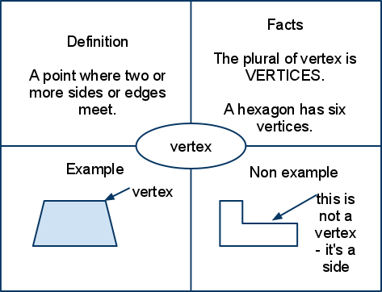
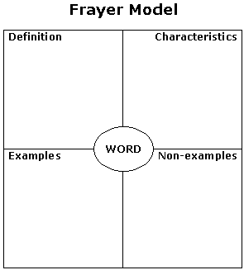
Materials:
- pencil & math notebook
- vocabulary chart
- Frayer model template or
blank paper to draw one
- math dictionary

Instructions:
- Write today's date and the title, "Vocabulary/Word Study". Underline the title neatly.

- Copy the list of math-relevant words into your notebook. Say the words quietly to yourself, or read them together with a partner.

- Choose ONE vocabulary word to dig deeper into. Copy this word in the centre of your Frayer model.

- Using a quiet voice, discuss the meaning and use of the word with others in your group. Think of facts or characteristics that define your word. Brainstorm examples and non-examples of your word.

- Consult a math dictionary to confirm and/or extend your thinking.

- Complete the remaining sections of your Frayer model.

- Tidy up the materials at your centre, thank your peers for their cooperation, and move to the next centre. (Or -- if time is up -- return to your table group.)

Math Centre #2
Manipulatives as Thinking Tools
Materials:
- coloured pencils & math notebook (or digital notebook & camera)
- one or more sets of math manipulatives
- online access to NLVM (google "virtual manipulatives" or visit http://nlvm.usu.edu/en/nav/vlibrary.html ) OR a comparable app that uses virtual manipulatives
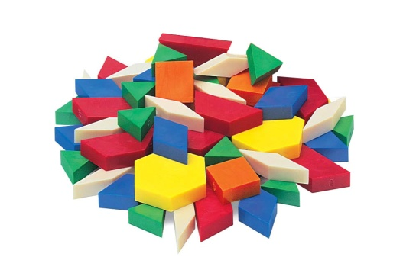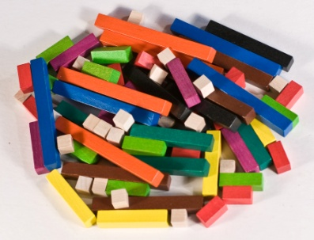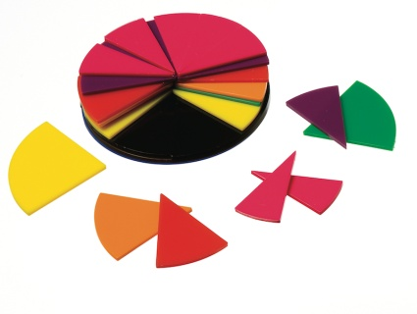
Instructions:
- Write the date and the name of the manipulatives you are using today as the title (e.g. "Pattern Blocks", or "Cuisinaire Rods"). Underline the title.

- Spend some time exploring your manipulatives. What do you notice about them? Sketch or take a photo of each manipulative and label it, describing colour, size, shape, side length, etc.

- Consider how your manipulatives fit together, and think about what they might be used for. What kind of problems could be generated or solved using these manipulatives? Record 2-3 ideas using complete sentences.

- Using the app or the Virtual Manipulatives Website, complete one or more learning activities. Summarize what you did; use mathematical vocab.

- Tidy up the materials at your centre, thank your peers for their cooperation, and move to the next centre. (Or -- if time is up -- return to your table group.)
Math Centre #3
CLIPS (max. 2 people per device)
Materials:
- pencil & math notebook
- flash-enabled device & headphones
- internet access
Instructions:
- Write today's date and the title "Math Clips". Underline the title neatly. Also record the name of your math partner for this activity.

- Visit the CLIPS website at www.mathclips.ca -- select a cluster to begin working on. (Your teacher may assign a specific cluster based on what you are currently studying in class.) Record the name in your notebook.

- Watch the video at the beginning of your cluster. Discuss the video with your partner. What math concepts does the video show?

- Choose a CLIP, and record the title. Then begin working through the activities for that clip. Stop and review activities as needed.

- After completing all the activities, choose one of the "Show What You Know" activities at the end of your clip. This activity should be done independently, and submitted to Ms. Teschow. You may print or take a screen shot, and glue or otherwise record it in your math notebook.

- Take some time to chat w/ your partner about how you worked together:

- Were you a good match for one another mathematically?
- Did you work well together as classmates? How do you know?
- Would you work with this person again? Why or why not?

Record your ideas in your math notebook.

- Tidy up the materials at your centre, thank your partner for working with you today, and move to the next centre. (Or -- if time is up -- return to your table group.)
Math Centre #4
Looking, Reading and Thinking
Materials:
- pencil & math notebook
- visuals: artworks, newspaper articles, photos or other images

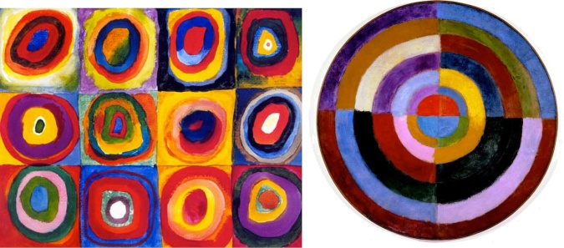

Instructions:
- Write today's date and leave space for a title. (You will write a title later.)

- At this centre, you will find a selection of images and/or newspaper articles. There might be an artwork, a photo, a graph from a pamphlet or some other visual. Take some time to peruse these items, then choose ONE artefact to work with.

- Decide on and record a title, and give a brief description of the image or article you looking at/reading.

- Think about what you see in your artefact. Where is the math? Is some sort of measurement involved? Geometry? Data? Are there fractions? Is proportional reasoning used? How? What patterns are there?

- Record your thoughts, ideas and observations, as well as any questions you may have. Use math vocabulary and complete sentences.

- Tidy up the materials at your centre, thank your peers for their cooperation, and move to the next centre. (Or -- if time is up -- return to your table group.)

Math Centre #5
Inquiry: Wondering About Math
Materials:
- pencil & math notebook
- inquiring mind!
- internet access and/or
math reference books

Instructions:
- Write today's date and the title "Math Inquiry". Underline the title neatly.

- Have you ever wondered how something works, or why a pattern is the way it is, mathematically speaking? This is your chance to ask, think about and begin to respond to a BIG question! Begin by brainstorming your ideas, and formulate a question. Once you have your inquiry question, write it out in your math notebook.

- Why is this question of interest to you? What do you already know about the topic/concept? What do you still need/want to find out? Jot your ideas down in your math notebook.

- Gather information by reading about your concept in a math textbook or other reference. You may also wish to use the Internet to find information. (Remember to consider the source: How do you know it's reliable?) Make notes of your discoveries, and organize or categorize them somehow.

- Pause to think about or discuss your findings with a partner. How has your thinking changed as you've found out more? Record your ideas.

- Find a way to share what you've discovered.

- Tidy up the materials at your centre, thank your peers for their cooperation, and move to the next centre. (Or -- if time is up -- return to your table group.)
Math Centre #6
Problem Choice
Materials:
- pencil & math notebook
- paper, markers (optional)
- problem solving folder

Instructions:
- Read through the math problems posted at this centre. Choose one to think about and solve either independently or with others at this centre.

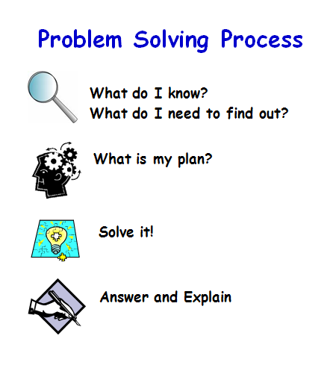
- Follow the steps in your math problem solving folder to think through and solve the problem.
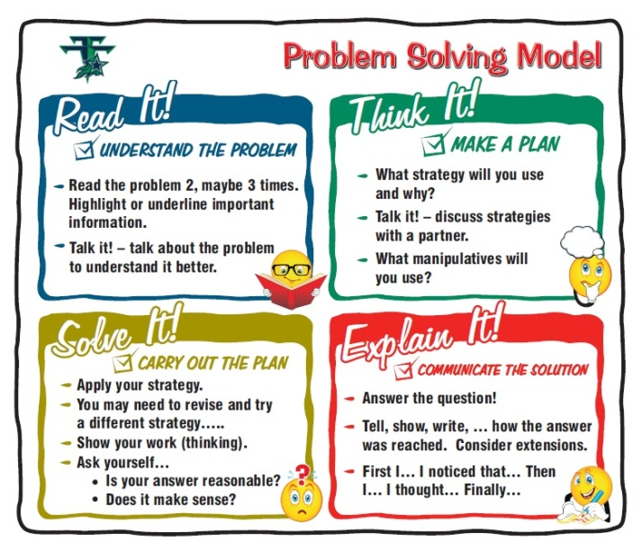

- Gather all your work, staple any loose pages together, and store it in your folder (if you worked with others, include their name on the work, and make sure they also have a record of having worked with you on this problem today.)

- Tidy up the materials at your centre, thank your peers for their cooperation, and move to the next centre. (Or -- if time is up -- return to your table group.)

Math Centre #7
Strategy Games
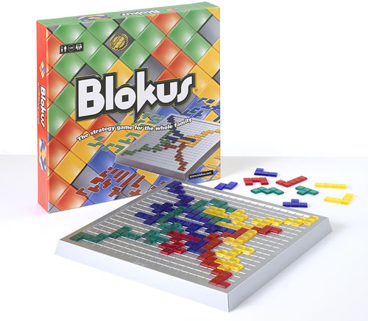
Materials:
- pencil & math notebook
- math related board game
- one or more partners to play with

Instructions:
- Write today's date and the name of the game you are playing. Underline your title neatly.

- Read through or review the rules of the game. Clarify any questions you may have before you begin playing.

- Play the game with the others at this centre. After you have played once or twice, take some time to talk about the math in the game. Also consider and discuss any strategies you can use to increase your chances of winning at this game.

- Record your group's thoughts, ideas and observations, as well as any questions you may have. Use math vocabulary and complete sentences.

- Play the game again, keeping in mind the things you and your partners talked/wrote about.

- Add any new ideas or observations to your write-up.

- Tidy up the materials at your centre, thank your peers for playing with you today, and move to the next centre. (Or -- if time is up -- return to your table group.)

Math Centre #8
Math Journal
Materials:
- pencil & math notebook or blog
- list of writing prompts

Instructions:
- Write today's date and the title "Math Journal Entry", along with a topic you want to write about. Underline the title neatly. (If you are typing a blog entry, be sure to include a relevant title.)

- You may choose to write about something specific you have been learning during this math unit, or you may choose one of the math journal writing prompts provided, and respond to that. Write in complete sentences, and remember to use:

- relevant math vocabulary
- examples to illustrate what you are writing about
- pictures, numbers, labelled diagrams
- strategies you used
- questions you may have
- feelings

- When you have completed your journal entry, reread it to make sure it makes sense and can be understood by someone else reading it.

- Read it once more to ensure you have used capitals and punctuation where needed. Make any changes as necessary. (If you are blogging, you may now press "publish".)

- Tidy up the materials at your centre, thank any partners you may have discussed your journal/blog with, and move to the next centre. (Or -- if time is up -- return to your table group.)

OTHER:
Skills Development (EDUGAINS Gap Closing e-practise?) epractice.ca
Math books/dictionary
Working with Ms Teschow

