Lesson Title:  Rate and Ration - Lesson #1 - Equivalent Ratios |  | Date:  PC
Overall Expectations:  Gr 7: demonstrate an understanding of proportional relationships using percent, ratio, and rate.  Gr 8 : solve problems by using proportional reasoning in a variety of meaningful contexts.  Learning Goals:  - Understand that ratios compare two quantities  Success Criteria: | Assessment for/as Learning Opportunities:  - As students are working on the minds on make anecdotal notes about their progress.  - Listening and recording observations of student conversations during whole class task.  Assessment of Learning:  - Looking at the finished product and full solutions. Are the students able to communicate their understanding?  Prior Knowledge/Readiness:  - equivalent Fractions  Learning Skills:  Responsibility, Organization, Independent Work, Collaboration, Self-regulation
Lesson Plan:

Minds On: Students will use ratios to describe their class in as many ways a possible. (The number of boys to the number of girls, brown eyes to other coloured eyes, blue jeans to not, etc). They should also be encouraged to create some part to whole rations. (The number of boys to whole class, girls to whole class, blue eyes to whole class etc).

Action/Problem: Distribute copies of Template 9.2.2 (Edugains). Have the students complete the page in small groups. Whole Group discussion about equivalent ratios. Discuss ways to record their thinking. Model the use of charts.
Whole class activity: Now That’s a Pencil! (See handout below)

Extensions: Can you show your results graphically.

Accommodations: Adapt the numbers in the both of the handouts to provide accommodations as necessary.

Consolidation: Sharing of results. Discussion of different approaches to solve the problem.

Resources:
http://www.edugains.ca/resources/LearningMaterials/TIPS/tips4rm/grade7/Unit9_Ratio&Rate.pdf
http://nrich.maths.org/6870

Homework Assignment:  Further practice of writing equivalent ratio. See 9.2.4 Edugains. | Next Steps/Reminders:  - Reminders about part to part and part to whole comparisons.
Reflection:

Lesson Title:  Rate and Ration - Lesson #2 |  | Date:  PC
Overall Expectations:  Gr 7: demonstrate an understanding of proportional relationships using percent, ratio, and rate.  Gr 8 : solve problems by using proportional reasoning in a variety of meaningful contexts.  Learning Goals:  - Connect rates to proportional relationships.  - Solve problems involving unit rates.  Success Criteria: | Assessment for/as Learning Opportunities:  - As students are working on the minds on make anecdotal notes about their progress.  - Listening and recording observations of student conversations during whole class task  Assessment of Learning:  - Looking at the finished product and full solutions. Are the students able to communicate their understanding?  Prior Knowledge/Readiness:  Learning Skills:  Responsibility, Organization, Independent Work, Collaboration, Self-regulation
Lesson Plan:

Minds On: Using a series of statements have the students decided whether they agree or disagree. (e.g People always get taller as they get older, if you buy 4 golf balls for $3.50 how much for 6?)

Action/Problem: Set up 6 different rate questions (See Below). Have the students work as a small group on one of the questions. After a set amount of time have the groups rotate. The students are to continue to work on their new problem, attempting to add to the solution or show it in a different way.

Extensions: For each question, ask the students to represent the rate graphically.

Accommodations: Use of differentiate friendly numbers.

Consolidation: Check for and highlight different approaches to solving the problems.

Resources:
http://www.edugains.ca/resources/LearningMaterials/TIPS/tips4rm/grade8/Unit8_ProportionalReasoning.pdf

Homework Assignment:  Real life connection - look through flyers for examples of ratio, find 5 and express the unit rate. | Next Steps/Reminders:
Reflection:

Mixing Lemonade 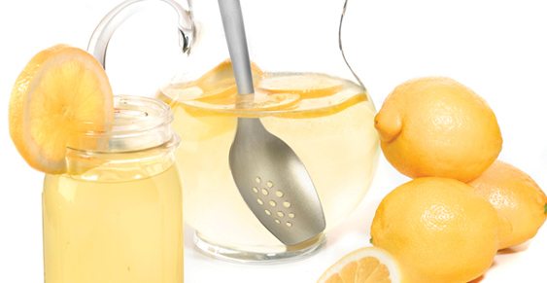

I mixed up some lemonade in two glasses.

The first glass had 200 ml of lemon juice and 300 ml of water.
The second glass had 100 ml of lemon juice and 200 ml of water.

Which mixture has the stronger tasting lemonade?
How do you know?

