TASK
In a grade 11 Stage band class (AMH 3M), the students will improvise a solo over the blues chord progression of C Jam Blues using iReal Pro ($12.99). Score Cloud (free) will then record and notate the solo for the students to listen to, view and discuss/analyse the improvisatory process
___________________________________________________________________________________
EXPECTATIONS
- Creating and Performing
A1. The Creative Process: apply the stages of the creative process when performing notated and/or improvised music and composing and/or arranging music;
A2. The Elements of Music: apply the elements of music when performing notated and improvised music and composing and/or arranging music
A.3 Techniques and Technologies: use a range of techniques and technological tools in a variety of applications relating to music
B. Reflecting, Responding, and Analysing
B3. Skills and Personal Growth: demonstrate and understanding of how performing, creating, and critically analysing music has affected their skills and personal development
_____________________________________________________________________________________
PRIOR KNOWLEDGE
- Jazz chords including M7, m7 and 7 chords
- Blues, pentatonic and major scales
- 12 bar blues structure
- Basic improvising skills including following the changes in a progression, creating a phrase using scale and chord notes, a bank of jazz rhythms, knowledge of how to build a solo
- C Jam Blues melody memorized in C concert
_____________________________________________________________________________________
MATERIALS
- Instrument
- Two iPads; one iPad with the iReal Pro app and one iPad with the ScoreCloud app
- Headphones for iPad
- Handouts on Five Steps in Creating a Strong Improvised Solo and the rubric
_____________________________________________________________________________________
LEARNING GOALS
I am:
- Learning to use technology on an iPad
- Applying my improvisation skills to a backing track
- Learning to analyse an improvisation

SUCCESS CRITERIA
I can:
- Operate the iReal Pro app on an iPad to play along over a progression
- Operate the SoundCloud app on an iPad to record notate a solo
- Improvise over the 12 bar blues progression in C Jam Blues using a blues, pentatonic or major scale, chord tones and various jazz rhythms
- Improvise with a plan to build a solo over several repetitions of a 12 bar blues
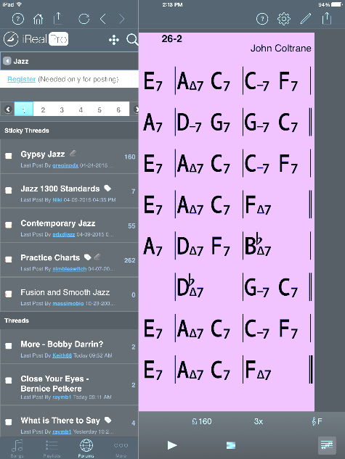
PROCESS FOR TEACHERS TO ACCESS PLAYLIST
- Bottom left go to forums which is at the bottom of screen and select

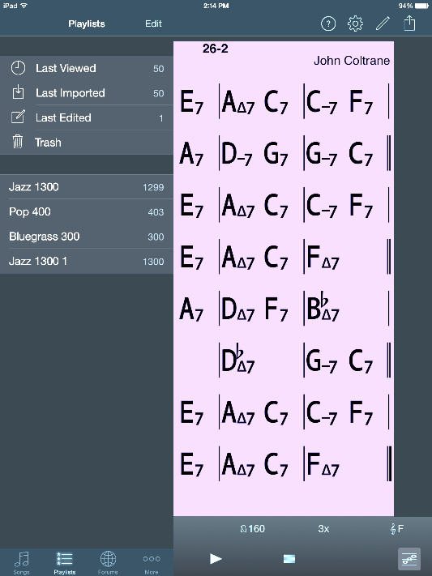
- A list of styles of songs appears
- Select

- Select jazz
- Select jazz standards
- Select jazz 1300
- It is loaded into the playlist
- Now choose jazz 1300 and the list of songs appears
PROCESS FOR STUDENTS TO FOLLOW
Students go off in pairs to improvise over the C Jam Blues progression.
Set up one iPad with the iReal Pro and select the app

- Select the three lines in the top left to access the playlists | 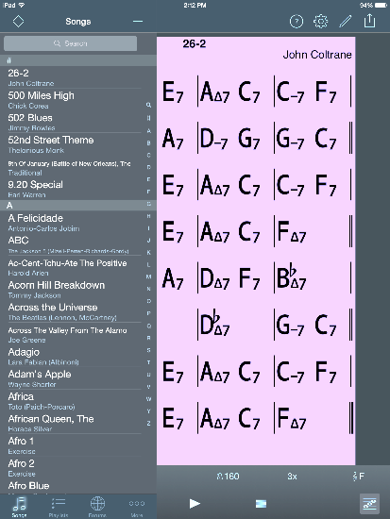  - Scroll through to find C Jam Blues and select
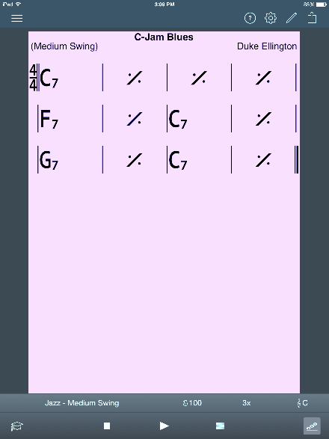  3 On the bottom of the screen, click on Jazz and choose Medium Swing | 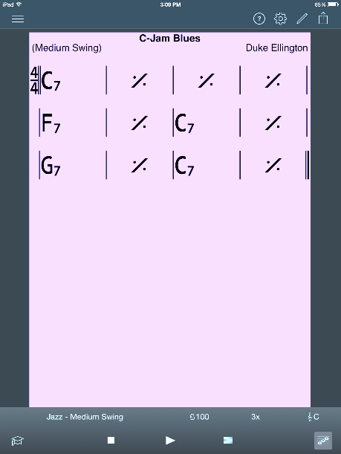  - Click on the metronome and set the tempo using the – and + signs
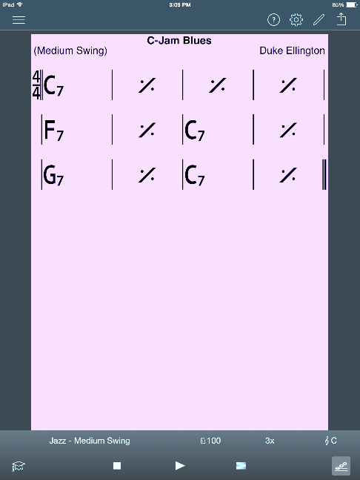  - Click on the 3x to set the number of desired repeats | 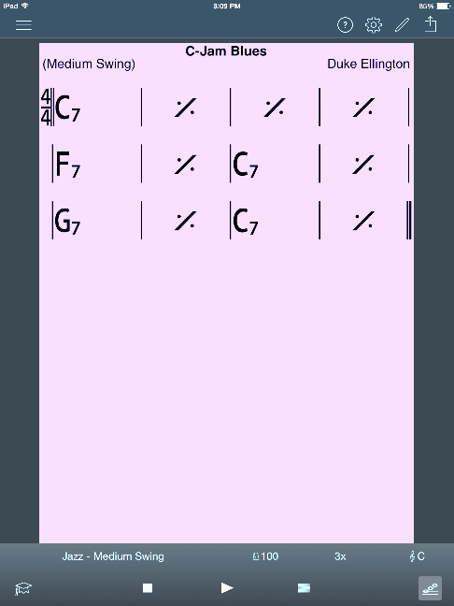  - Click on the clef sign to choose the key. Touch the top left if you need to choose the transposition screen (this allows the selection of transposition for wind instruments)
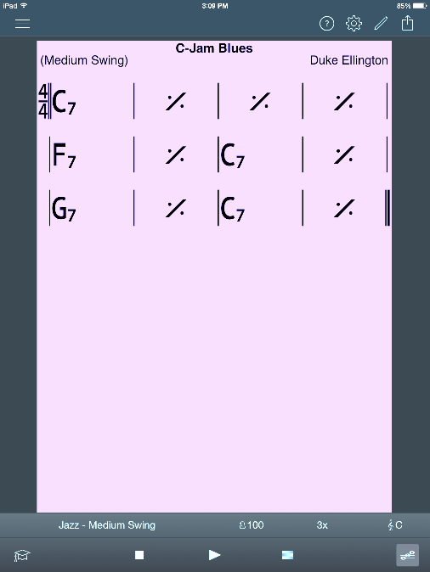  7 In the bottom right of the screen click on the bottom right symbol which is either guitar, piano or staff chord chart to choose the diagram of notes on the staff which will display the scales to accompany the chord changes when the piece plays | 8 Student playing plugs in earphones into iReal Pro
9 Set up one iPad with Score Cloud and select the app | 10 As one student prepares to perform, the second student presses record on the bottom left of Sound Cloud followed by play on iReal Pro
11 The metronome on iReal Pro counts one bar in | 12 The performing student records while playing through the C Jam Blues progression three times: 1) playing the melody 2) improvising 3) building the solo through at least one more time through the progression
13 The second student presses stop and the app notates the improvised solo | 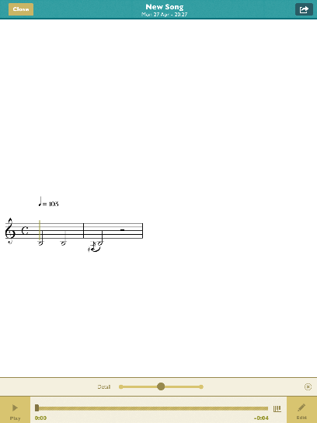  14 To title the solo with the performer’s name, the second student clicks the edit button in the bottom right of the screen
- On the top left touch title and on the keyboard type in the performing student’s name | 16 Touch the small keyboard diagram on the bottom right of the keyboard
17 Touch done on the right above the new title | 18 Touch done on the top right of the screen
19 Touch close on the top left of the screen | 20 Continue with the same process to record the second student
21 To access the improvised song and listen to it, touch My Songs in the bottom right and press play | 22 To delete a song, touch My Songs in the bottom left
23 Drag from the right of the screen to bring up the delete option

__________________________________________________________________________________
ASSESSMENT AND EVALUATION
ASSESSMENT AS LEARNING
- Students complete the chart Five Steps in Creating a Strong Improvised Solo before the performance
- Following their performance, they again look at the chart Five Steps in Creating a Strong Improvised Solo and review the Done and Details Following Performance columns
- Students complete a self evaluation of their improvised solo in the section provided below the chart

ASSESSMENT FOR LEARNING
- Peer assessment during the performance and recording of the improvised solo
- Following the recording, the teacher conferences with the student and their Sound Cloud recording on the iPad to analyse the improvisation and discuss the columns in Details Following Performance

SUMMATIVE EVALUATION
• With a live combo in the class, the student performs C Jam Blues in the same manner as the
iPads and will be evaluated on a rubric during performance

Teacher note:
Score Cloud does not quantize rhythms. Therefore, this exercise is focused more on the melodic and harmonic choices made in improvising.

STUDENT COMPLETED CHART AND SELF EVALUATION

 | Nine Steps in Creating an Improvised Solo | Done | Details Following Performance (complete after)
1
2
3
4
5
6
7

8

9

Self evaluation of your improvisation: ____________________________________________________

____________________________________________________________________________________

____________________________________________________________________________________

TEACHER RESOURCE

 | Nine Steps in Creating an Improvised Solo | Done | Details Following Performance (complete after)
1 | LISTEN TO GREAT PLAYERS PLAY THE SONG!
2 | KNOW THE MELODY! Play it over and over until it is memorized.
3 | KNOW THE FORM! Know how the piece is organized and know where you are in the form of the song.
4 | STUDY AND PLAY THE CHORDS AND SCALES. The better you know them, the better prepared you will be. Remember that the 3rd and 7th are the most important notes in the chord because they determine the type of chord it is. Know what scale works over the progression.
5 | CREATE SHORT RHYTHMIC IDEAS/RIFFS
6 | WORK TOWARDS A GOOD SOUND. It doesn’t matter how great your technique and ideas are if it doesn’t sound good.
7 | KEEP IT SIMPLE! A strong sense of melody is equally important as flashy technique.
8 | USE A VARIETY OF DEVICES. These include repetition, sequences, patterns, quotes from other songs
9 | BUILD THE SOLO IN REPEATS OF THE PROGRESSION THROUGH A VARIETY OF METHODS.  1st time through start simple, then move in subsequent repetitions of the progression to more complex rhythms or add more notes or change registers and so on to create interest.

Improvisation Performance Rubric

Criteria | Level 1 | Level 2 | Level 3 | Level 4
Sound quality | The improvisation is performed with a limited understanding of good sound quality. | The improvisation is performed with some understanding of good sound quality. | The improvisation is performed with a considerable understanding of good sound quality. | The improvisation is performed with an excellent understanding of good sound quality. thorough
Melody | The melody is performed with limited note and rhythmic accuracy | The melody is performed with some note and rhythmic accuracy | The melody is performed with considerable note and rhythmic accuracy | The melody is performed with excellent note and rhythmic accuracy
Chords | The improvisation is performed with limited accuracy in playing chord tones over the changes | The improvisation is performed with some accuracy in playing chord tones over the changes | The improvisation is performed with considerable accuracy in playing chord tones over the changes | The improvisation is performed with excellent accuracy in playing chord tones over the changes
Scales | The improvisation is performed with limited accuracy in playing appropriate scales over the changes | The improvisation is performed with some accuracy in playing appropriate scales over the changes | The improvisation is performed with considerable accuracy in playing appropriate scales over the changes | The improvisation is performed with excellent accuracy in playing appropriate scales over the changes
Rhythmic ideas/riffs | The improvisation has limited evidence of the creation of original rhythmic ideas/riffs | The improvisation has some evidence of the creation of original rhythmic ideas/riffs | The improvisation has considerable evidence of the creation of original rhythmic ideas/riffs | The improvisation has extensive evidence of the creation of original rhythmic ideas/riffs
Devices including repetition, sequences, patterns and/or quotes | The improvisation includes limited use of devices such as repetition, sequences, patterns and/or quotes | The improvisation includes some use of devices such as repetition, sequences, patterns and/or quotes | The improvisation includes considerable use of devices such as repetition, sequences, patterns and/or quotes | The improvisation includes excellent use of devices such as repetition, sequences, patterns and/or quotes
Building of the solo | The improvisation has limited evidence of building through repeats of the progression | The improvisation has some evidence of building through repeats of the progression | The improvisation has considerable evidence of building through repeats of the progression | The improvisation has extensive evidence of building through repeats of the progression
Overall effect of the performance | The improvisation is played with limited confidence and command of the performance | The improvisation is played with some confidence and command of the performance | The improvisation is played with considerable confidence and command of the performance | The improvisation is played with excellent confidence and command of the performance

