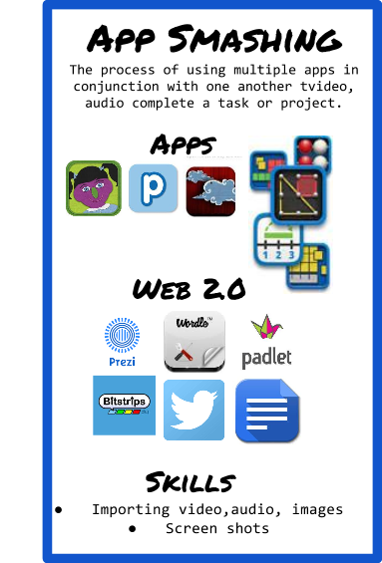  
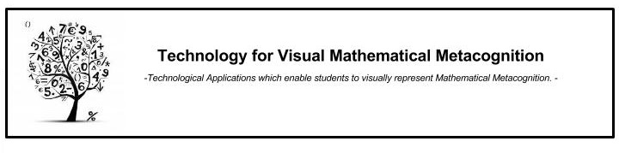

[Teaching Visual Mathematics](https://drive.google.com/file/d/0B8Uad-NcUbANc2pCMkprb0Q5TU0/view?usp=sharing)



[Book Creator Tutorial](https://www.youtube.com/watch?v=FnJ6jSeU8Pc)

https://docs.google.com/drawings/d/smy3kSm-S-PT7xVuXhwDU7Q/image?w=234&h=63&rev=18&ac=1

[Grade 3 Number Book](https://drive.google.com/file/d/0B8Uad-NcUbANRnlZM252V09GZWc/view?usp=sharing)

[Grade 3 Math Talk](https://drive.google.com/file/d/0B8Uad-NcUbANaHlfeEF0YmlmbU0/view?usp=sharing)

https://docs.google.com/drawings/d/sLACpfVIHek7rJaMeYVtlAg/image?w=224&h=63&rev=24&ac=1





[Measurement Book](https://drive.google.com/open?id=0B8Uad-NcUbANRERmRnJvSkVIU0E&authuser=0)







[Feltbook Math Book](https://drive.google.com/file/d/0B8Uad-NcUbANZDlwTWdUOWQyX1k/view?usp=sharing)

[Number Book Talk Video](https://drive.google.com/file/d/0B8Uad-NcUbANZTVyRUx0OTFyV0k/view?usp=sharing)

[Firehouse Problem](https://drive.google.com/open?id=0B8Uad-NcUbANTHBHS0RVb0gzQ1E&authuser=0)

**https://docs.google.com/drawings/d/smy3kSm-S-PT7xVuXhwDU7Q/image?w=234&h=63&rev=18&ac=1**https://docs.google.com/drawings/d/sBtMwhyNdXYLi3506nwkubQ/image?w=264&h=59&rev=40&ac=1

[How to export videos from Explain Everything](https://www.youtube.com/watch?v=gV1Cfm2fKxI​)

[Math Conversation](https://drive.google.com/file/d/0B8Uad-NcUbANaUE5MXhVM19VZmM/view?usp=sharing)

[Number Talk](https://drive.google.com/file/d/0B8Uad-NcUbANeS1YZTFVRW5GaUE/view?usp=sharing)

[Explain Everything Tutorial](https://www.youtube.com/watch?v=b00ZeszvjP4)