Name: Date:
1 Minute Challenge
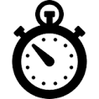
Activity | Estimate | Result
Squats
Sit ups
Frog jumps
Plank push ups
Arm circles
Push ups
Lunges
My discovery:

