The Creative Process: apply the stages of the creative process when performing notated and/or improvised music and composing and/or arranging music;

Image source: Ontario Curriculum, The Arts, 2010

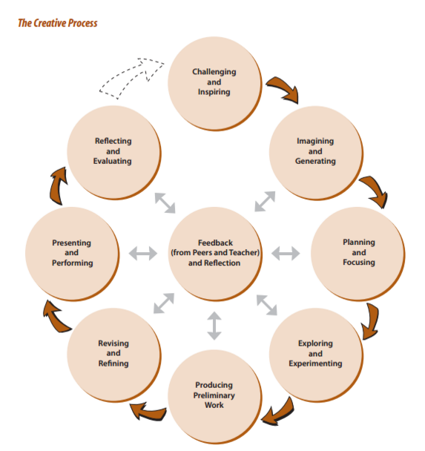

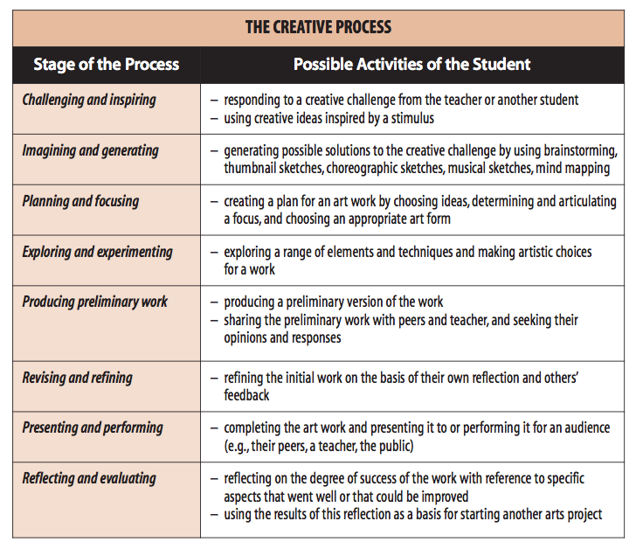
Source: Ontario Curriculum, The Arts, 2010

