The Critical Analysis Process: use the critical analysis process when responding to, analysing, reflecting on, and interpreting music;

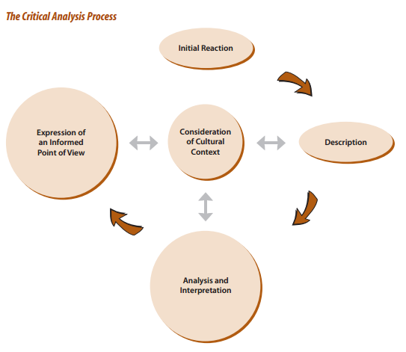
Image source: Ontario Curriculum, The Arts, 2010

