Book Creator for iPad Basics

Step 1: Choose your layout
To begin a new book click the + on the home page, select “New Book”
Choose how big you want your book to be – portrait, square or landscape

Step 2: Writing your story
To add TEXT to your book – select the + in the top right corner of the screen
You can use the pen to write with your finger
You can the T to type on the iPad keyboard
You can make your words bigger or smaller by taping on them and pulling the corner of the blue box

Step 3: Add pictures to your story
To add PICTURES to your story – select the + in the top right corner of the screen
You can press the PHOTO button to add pictures already on your ipad
You can press the CAMERA button to take a new picture
You can use the PEN to draw a picture
Make your pictures bigger or smaller by taping on them and pulling the corner of the blue box

Step 4: Saving your story
Your story will be saved automatically on Book Creator

Step 5: Reading your book
You can read your finished book in iBook
Press the box with the up arrow in the top right corner
Select “Open in iBook”

Fun Stuff to do in Book Creator
Adding Sound
Press the + button at the top right hand corner of the screen
Press the music note
You can press the big red button to record your own voice speaking or singing
You can also add music that is already on your iPad

Changing the page colour
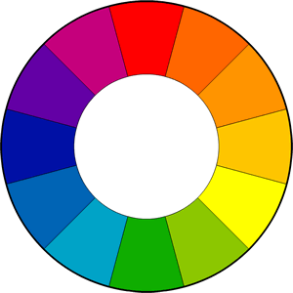
Press the “i” in a circle at the top right hand corner of the page
Press on PAGE COLOR and choose the colour you would like for your page

Changing the order of pages
Press PAGES at the top left of your screen
Hold you finger down on the page until it wiggles
Slide the page where you would like it to be
When you are finished press DONE in the top right of the screen
Double tap on a page to go back to your book

