Name: Date:
What is your favourite recess activity?
Tally Chart
Answers | Results
- Basketball

- Soccer

- Tag
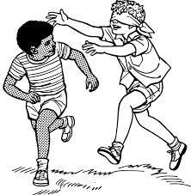

Number of people surveyed: ___________

What I learned from taking this survey:

Name: Date:
What time do you go to bed?
Tally Chart
Answers | Results
- 7:30-8:00 p.m.

- 8:00-8:30

- After 8:30

Number of people surveyed: ___________

What I learned from taking this survey:

Name: Date:
What is your favourite vegetables?
Tally Chart
Answers | Results
- broccoli
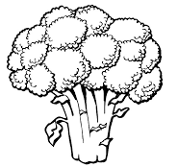

- cucumber
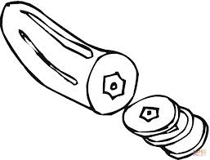

- salad
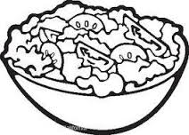

Number of people surveyed: ___________

What I learned from taking this survey:
Name: Date:
What is your favourite sport?
Tally Chart
Answers | Results
- basketball

- soccer

- hockey
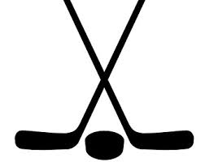

Number of people surveyed: ___________

What I learned from taking this survey:

Name: Date:
What colour are your eyes? 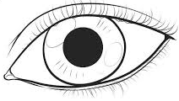
Tally Chart
Answers | Results
- brown

- blue

- hazel

Number of people surveyed: ___________

What I learned from taking this survey:

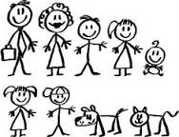
Name: Date:
How many people are in your family?
Tally Chart
Answers | Results
2 people

3 people

4 people

More than 4 people

Number of people surveyed: ___________
What I learned from taking this survey:
Name: Date:

________________________________________________________________________________________
(Bar Graph Title)

