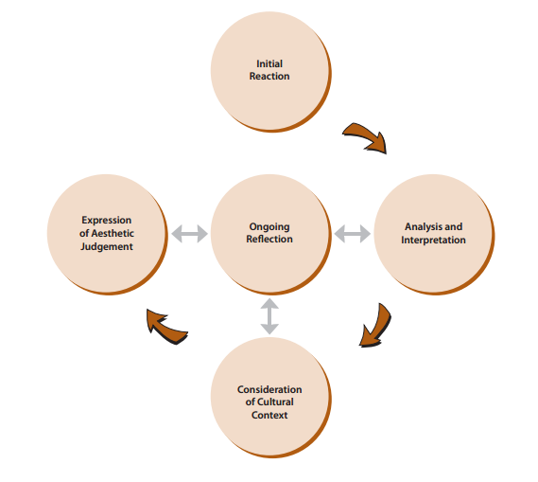
What is your evidence of learning?
The Creative Process: apply the stages of the creative process when performing notated and/or improvised music and composing and/or arranging music; | These two processes will be integrated into all learning throughout the semester and feedback provided regularly. They will be assessed at midterm and for the final portfolio project.
The Critical Analysis Process: use the critical analysis process when responding to, analysing, reflecting on, and interpreting music;
 | Level | Evidence | Reflection  What did you do well?  What are your next steps for improvement?
1 The Elements of Music: apply elements of music when performing notated and improvised music and composing and/or arranging music;

What is your evidence of learning?
Choose 3:
Rhythm
Melody
Harmony
Dynamics
Tone Colour
Form
Texture
2 Techniques and Technology: use a variety of techniques and technological tools when performing music and composing and/or arranging music.
3 Music and Society: demonstrate an understanding of how traditional, commercial, and art music reflect the society in which they were created and how they have affected communities or cultures;
4 Skills and Personal Growth: demonstrate an understanding of how performing, creating, and critically analysing music has affected their skills and personal development;
5 Connections Beyond the Classroom: identify and describe various opportunities for continued engagement in music.
6 Theory and Terminology: demonstrate an understanding of music theory with respect to concepts of notation and the elements and other components of music, and use appropriate terminology relating to them;
7 Characteristics and Development of Music: demonstrate an understanding of the history of some musical forms and of characteristics of types of music from around the world;
8 Conventions and Responsible Practices: demonstrate an understanding of responsible practices and performance conventions relating to music.

