Exit Ticket #6 Name: _______________________
Success Criteria:
I can rotate a shape clockwise or counterclockwise by 90 degrees.
I can rotate a shape with the centre of rotation inside the shape by 90 degrees.
I can rotate a shape with centre of rotation outside by 90 degree.
I can rotate a shape 180.
I can describe rotations clockwise/counter clockwise inside or outside of the shape by 90 & 180 degrees.

- The grid below shows a triangle that has been moved using transformations from position A to position B, then moved from position B to position C, and finally moved from position C to position D.
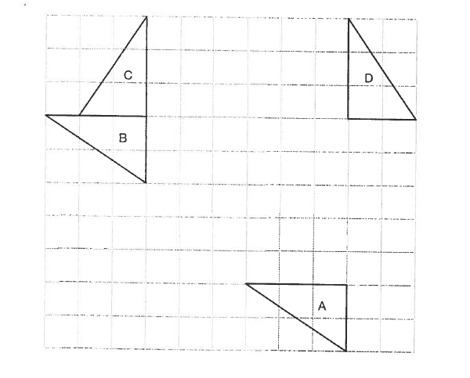
Complete the chart below with descriptions of the transformations needed to move the triangle. Be sure to include all units and directions in the chart. Show points of rotations and lines of reflection on the grid.
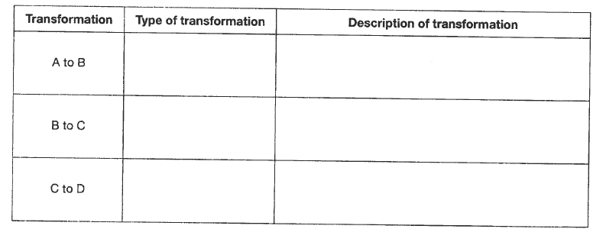

2. A shape is shown on the grid.

Which grid shows the image of the shape after a 180$∘$ rotation then a 90$∘$rotation counter-clockwise around Point “S”?

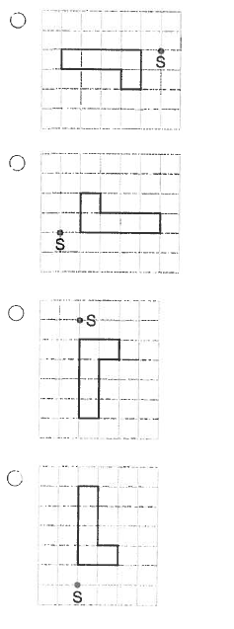

3. A pattern is created by rotating a rectangle 90$∘$clockwise about Point X. This rotation is repeated.
Which of the following shows the pattern created.
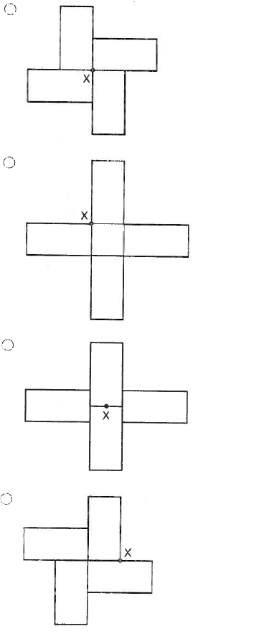

Exit Ticket #6 Name: _______________________
Success Criteria:
I can rotate a shape clockwise by 90 degrees.

The shape below needs to rotate 90$∘$ at Point A.
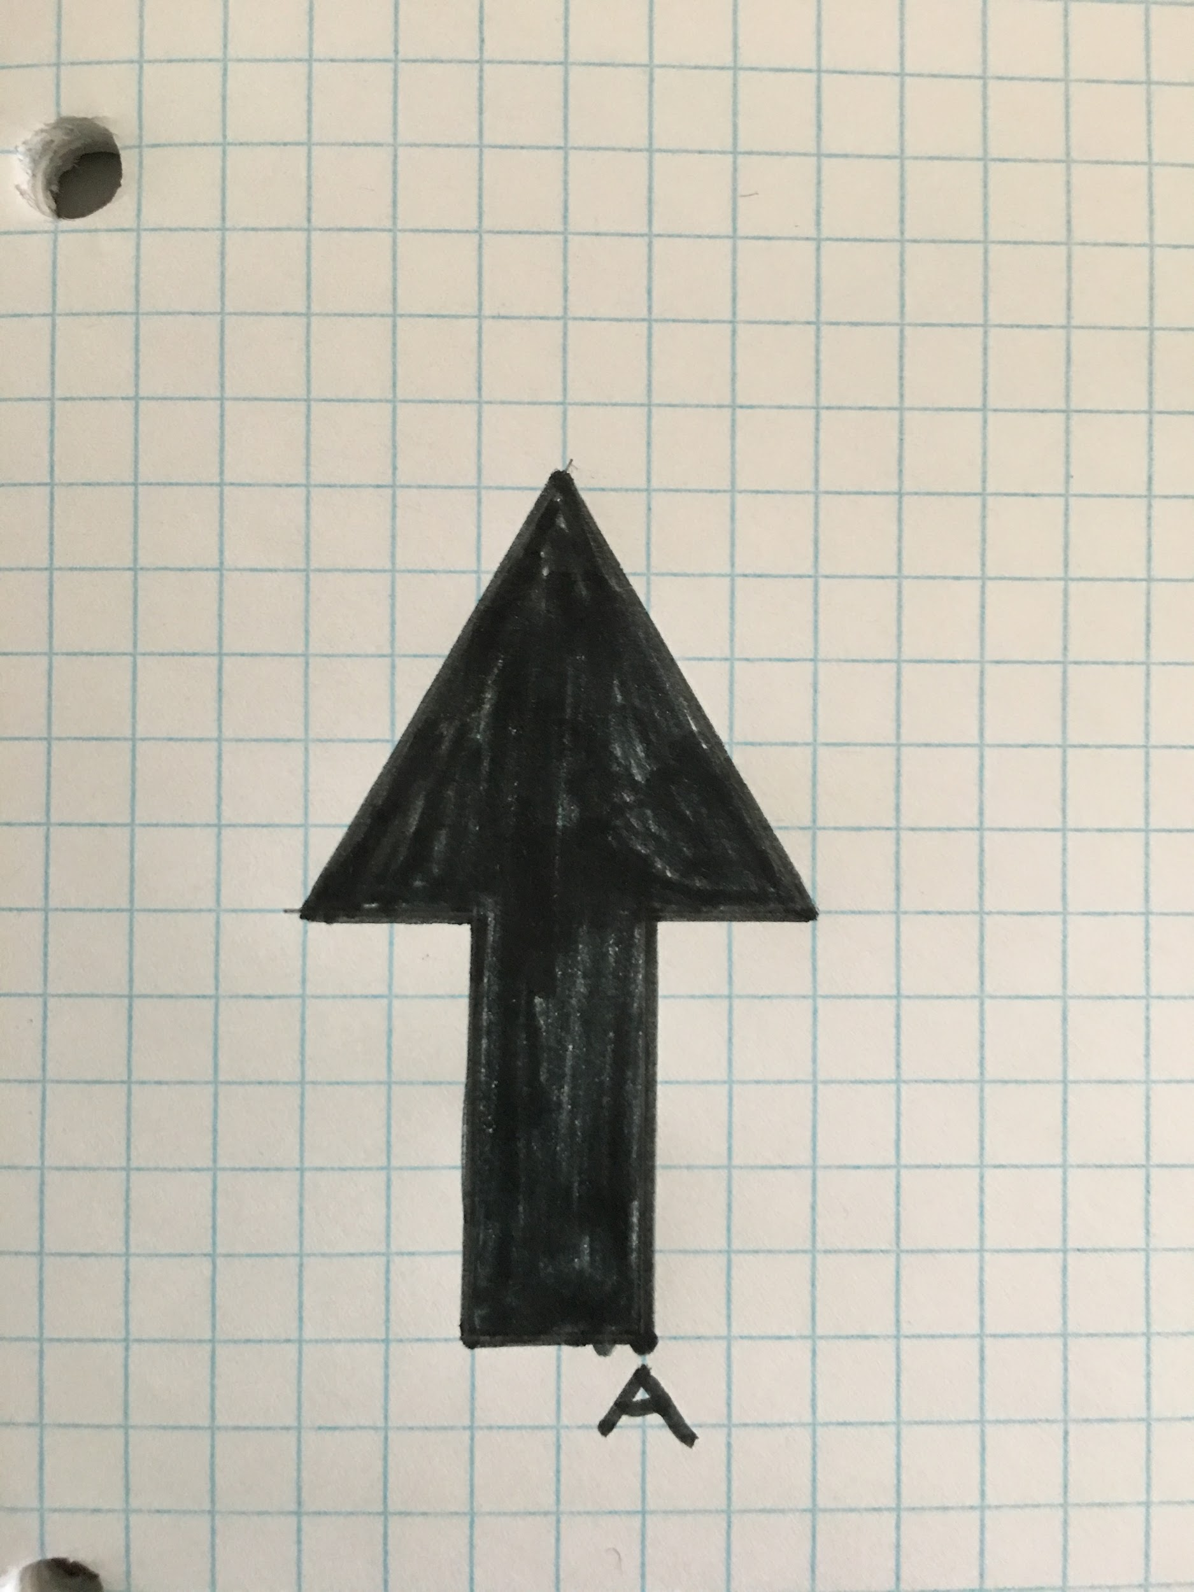
Using the grid below, draw the rotation of the arrow 90$∘$ at Point A.

2. A shape is shown on the grid.

Which grid shows the image of the shape after 90$∘$rotation clockwise around Point “S”?

