Community Walk Journal

Name(s):______________________________________________

Community Map
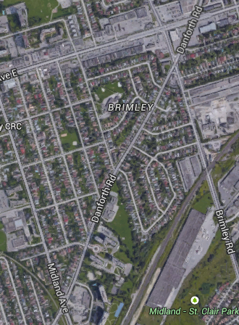
Learning Goals:

We will learn how geometric properties of quadrilaterals and circles create our community.
We will learn about geometric relationships involving lines and triangles, and how they create our community.

We will investigate issues related to the interrelationships between human settlement and sustainability from a geographic perspective.

Accessed from: https://www.google.ca/maps/@43.7303968,-79.2571601,1952m/data=!3m1!1e3 (March 27,2015. 10:25am)

MATH CONNECTIONS

- What geometry ideas do you see based on the maps shown and our community walk? (E.g. What types of shapes and lines do you mostly notice?)

_________________________________________________________________________________________________

_________________________________________________________________________________________________

2. What geometric shape does Robert Service PS’ property generally represent? How could you describe the angle-relationships? (E.g. interior/complementary angles, supplementary angles or opposite angles)

_________________________________________________________________________________________________

_________________________________________________________________________________________________

3. Sketch two polygons from the map, including one quadrilateral. Describe their properties, including those based on diagonals.

* Properties are attributes that remain the same for a class of shapes.
** Diagonals are line segments that join two vertices of a polygon that are not next to one another.
(Mathematics Curriculum Document: Glossary- Pages 120- 134)

4. Sketch two intersections from the community walk. Describe using geometry ideas and math vocabulary.

5. What geometric shape do you notice in the middle of Gordonridge Place? Why might this choice of shape be made within this community?

________________________________________________________________________________________________

_________________________________________________________________________________________________

_________________________________________________________________________________________________

________________________________________________________________________________________________

GEOGRAPHIC CONNECTIONS

- How would you describe the area that you explored on your walk? Is it urban/rural, describe the housing and industry, etc.?

_________________________________________________________________________________________________

_________________________________________________________________________________________________

_________________________________________________________________________________________________

_________________________________________________________________________________________________

2. What has changed in the community from when it was referred to as Scarborough Junction to now?

_________________________________________________________________________________________________

_________________________________________________________________________________________________

_________________________________________________________________________________________________

_________________________________________________________________________________________________

3. What evidence is there that this is/or isn’t a sustainable community? Explain your thinking?

_________________________________________________________________________________________________

_________________________________________________________________________________________________

_________________________________________________________________________________________________

_________________________________________________________________________________________________

