I’m lost

I’m a little confused

I mostly understand what’s going
on

I get it

What images came into your mind as you were reading?
Homelessness in Canada

Homelessness isn’t just what we see on the street—it takes many forms and affects many different people. People find themselves homeless for any number of reasons: they’ve lost their job, their health is deteriorating or they are fleeing domestic violence. Women and children are often part of the “hidden homeless”: people living in friends’ homes or temporary accommodations.
What are some words that you find confusing? Circle, underline or highlight them.
More than 235,000 Canadians experienced homelessness at some point in the past year. Homelessness costs the Canadian economy $7 billion annually. Per month, it costs $1,932 for a shelter bed or $10,900 for a hospital bed. And yet, none of these provide permanent solutions.
Why is homelessness an issue?

What is your opinion about homelessness?

That’s why many cities are turning to a model of help that provides housing stability as a first resort and then builds on that base with education, job training and aid for mental health challenges. So far, this method has been extremely effective at significantly reducing homelessness.
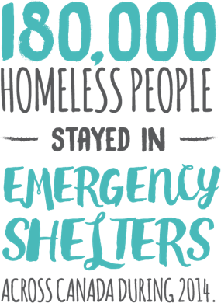
FAST FACTS
One study showed two in five homeless individuals had been assaulted in the previous year.
With an increased risk of illness or assault, homeless people are admitted to a hospital five times more often than the general population.
Vancouver reduced homelessness by 66% in five years by providing stable housing as a base for other social services.

HOMELESSNESS AND EMPLOYMENT
It’s a common misconception that homeless people don’t have jobs or sources of income. In the U.S., for example, 18 percent of homeless adults have a job, as do 42 percent of people seeking emergency food assistance. For many, a steady paycheck just isn’t enough to keep up with the climbing expenses of rent, food and bills.
How would you explain this article to a friend in one or two sentences?
Living in shelters or temporary housing adds an extra barrier to employment. Beyond the stigma of homelessness, applying for a job without a fixed address, rental history, reliable phone number or access to childcare adds an extra hurdle to an already difficult process.

"Local - Homelessness - WE". WE. N.p., 2016. Web. 22 Nov. 2016. URL: https://www.we.org/we-at-school/we-schools/issues-backgrounders/local-homelessness/
Name:
What is something that you don’t understand?

What is a question that you have?

What images came into your mind as you were reading?
What images came into your mind as you were reading?
What images came into your mind as you were reading?

