Sparkvue: Connecting PasPort AirLink to the tablet.

- Turn on the AirLink2. Turn it over and note the ID# on the back.
(e.g. AirLink2 ID# 20365)

` | - Turn on Tablet. On the top right corner, pick the user “Science 1” or “Science 2”, etc.  - Login using Password: _________
AirLink2-20365 | - Go to settings, turn on Bluetooth, and pair with AirLink2 (with the same ID# as the one you have).
- Open the “Sparkvue” app.

- Click on the Bluetooth icon and pick the same AirLink2 Wireless Device as step #4.
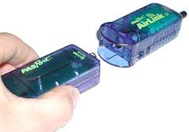 | - Follow your teacher’s instructions, connect other PASCO probes and conduct the experiment.

