Lesson 3: Credit and Credit Cards
Learning Goals:

- Explain what credit is and why we might use it
- Identify the parts of a credit card and explain how it works
- Identify the advantages and disadvantages of using credit cards
- Explain how to build good credit and avoid bad credit

Topic: Credit and Credit Cards

What is credit?
- Credit is a measure of how likely you are to pay something back.
  - If you have “good credit” it means banks and lending companies can trust you to pay back any money you borrow.
  - If you have “bad credit” the bank will find it harder to trust you and they may not let you borrow money.

- As you get older, some purchases will require you to use credit (house, car, loan, and school) so it is important to maintain good credit.

- For example, if you want to buy a car, you likely will not have $30,000 to spend up front in cash. In this case the car dealer will offer you an option of a monthly payment plan over a fixed number of years. They will also run a credit check on you before they agree to this arrangement because they need to trust that you will make your monthly payments.
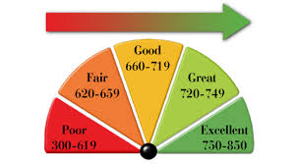
- Your credit is measured by a “credit score.” A credit score is like a mark you get in school. Scores range from 300 to 850. A higher score means you have better credit. Your score improves every time you make a payment on time and worsens if you miss a payment.

Practice Questions:
- What is credit?

- What is one item you can imagine wanting/needing to buy on credit?

- If you had a credit score of 325, would a company be willing to lend you money?

Building Good Credit
  - You will need good credit in order for banks and companies to give you a loan. To build good credit you need to find people that will trust you with a little bit of money AND you need to pay them back.

  - While you are under the age of 18, you will need a co-signer in order to get a loan. A co-signer is a person who puts their name on the loan with you, offering to make payments if you cannot do so. Parents, grandparents, anyone with a steady source of income would be acceptable as a co-signer.

  - To build good credit you could:
    - Make payments on a credit card
    - Make payments on a small loan
    - Make payments on a piece of furniture
    - Make payments on a car you purchased

What is bad credit?
  - If you don’t make your payments in FULL or are LATE with your payment, your credit score will be negatively affected.

  - You can have a lot of debt (ie. a $300,000 mortgage) and still have good credit if you make your payments on time.

  - Factors that can lead to bad credit include:
    - Missed payments
    - If too many people check your credit
    - Having a car repossessed
    - Paying a partial amount of your payment
    - Outstanding debts (loans you have not paid in a long time)

What does “No credit” mean?
  - When a person has no credit, it simply means they haven't had a chance to build their credit score yet.

  - Getting a credit card as a young adult is a common way people start to build credit.

Practice Questions:

- Explain one thing you could do to build good credit.

- What is a co-signer? Who could you ask to be a co-signer?

- What is the number one way people can develop bad credit?

What is a credit card?
- A credit card is a plastic card that represents an account that you can repeatedly borrow money from. The money is loaned to you by a credit card company like MasterCard, Visa, or American Express. A credit card is NOT a source of free money. Any money you borrow needs to be paid back.

Anatomy of a Credit Card
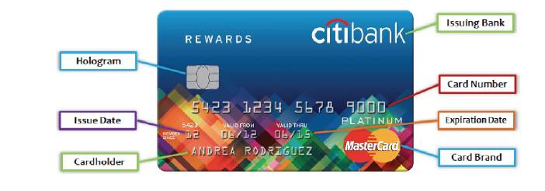

Hologram/Chip | 3D image that verifies a real card from a counterfeit.
Issue Date | The date the card was created.
Cardholder | The full name of the person that owns the card.
Issuing Bank | The bank that sponsors the card.
Card Number | A 16-19 digit number that represents the line of credit on the card. A form of ID.
Expiration Date | The date the card will no longer be valid or work.
Card Brand | This is the credit company that manages the card.

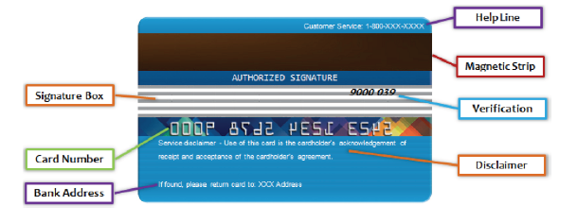
Signature Box | The space where you sign your name so no one else uses your card.
Card Number | The reverse of the 16-19 digit number on the front of the card.
Bank Address | Contact information for the bank that issues the card.
Help Line | The customer service number of the card that you call if you have questions or a lost/stolen card.
Magnetic Strip | A strip of information the card machine reads to identify one card from another.
Verification | A third level of security on a credit card. Sometimes called the CVV (card verification value). There are usually 3-4 numbers depending on the credit card company.
Disclaimer | A note from the issuing bank ensuring you know the agreement associated with the card.

Practice Questions:
- What is a credit card?
  - A plastic card with a magnetic strip
  - Something that represents a line of credit
  - A source of free money
  - Both A and B
- Which of these could be a credit card number?
  - 1122 3456 7489 345
  - 1111 4937 9773 9373 2758
  - 1028 4759 4957 3838
  - All of the above
- How many digits are in a standard credit card number?
  - 16
  - 17
  - 18
  - 19
  - A credit card number can be 16-19 digits long
- What happens after the expiration date on a credit card expires?
  - The card no longer works
  - The cardholder needs to get a new card
  - The card blows up
  - Both A and B
- How many numbers are in a CVV code?
  - 1
  - 2
  - 3
  - 4
  - 3 or 4

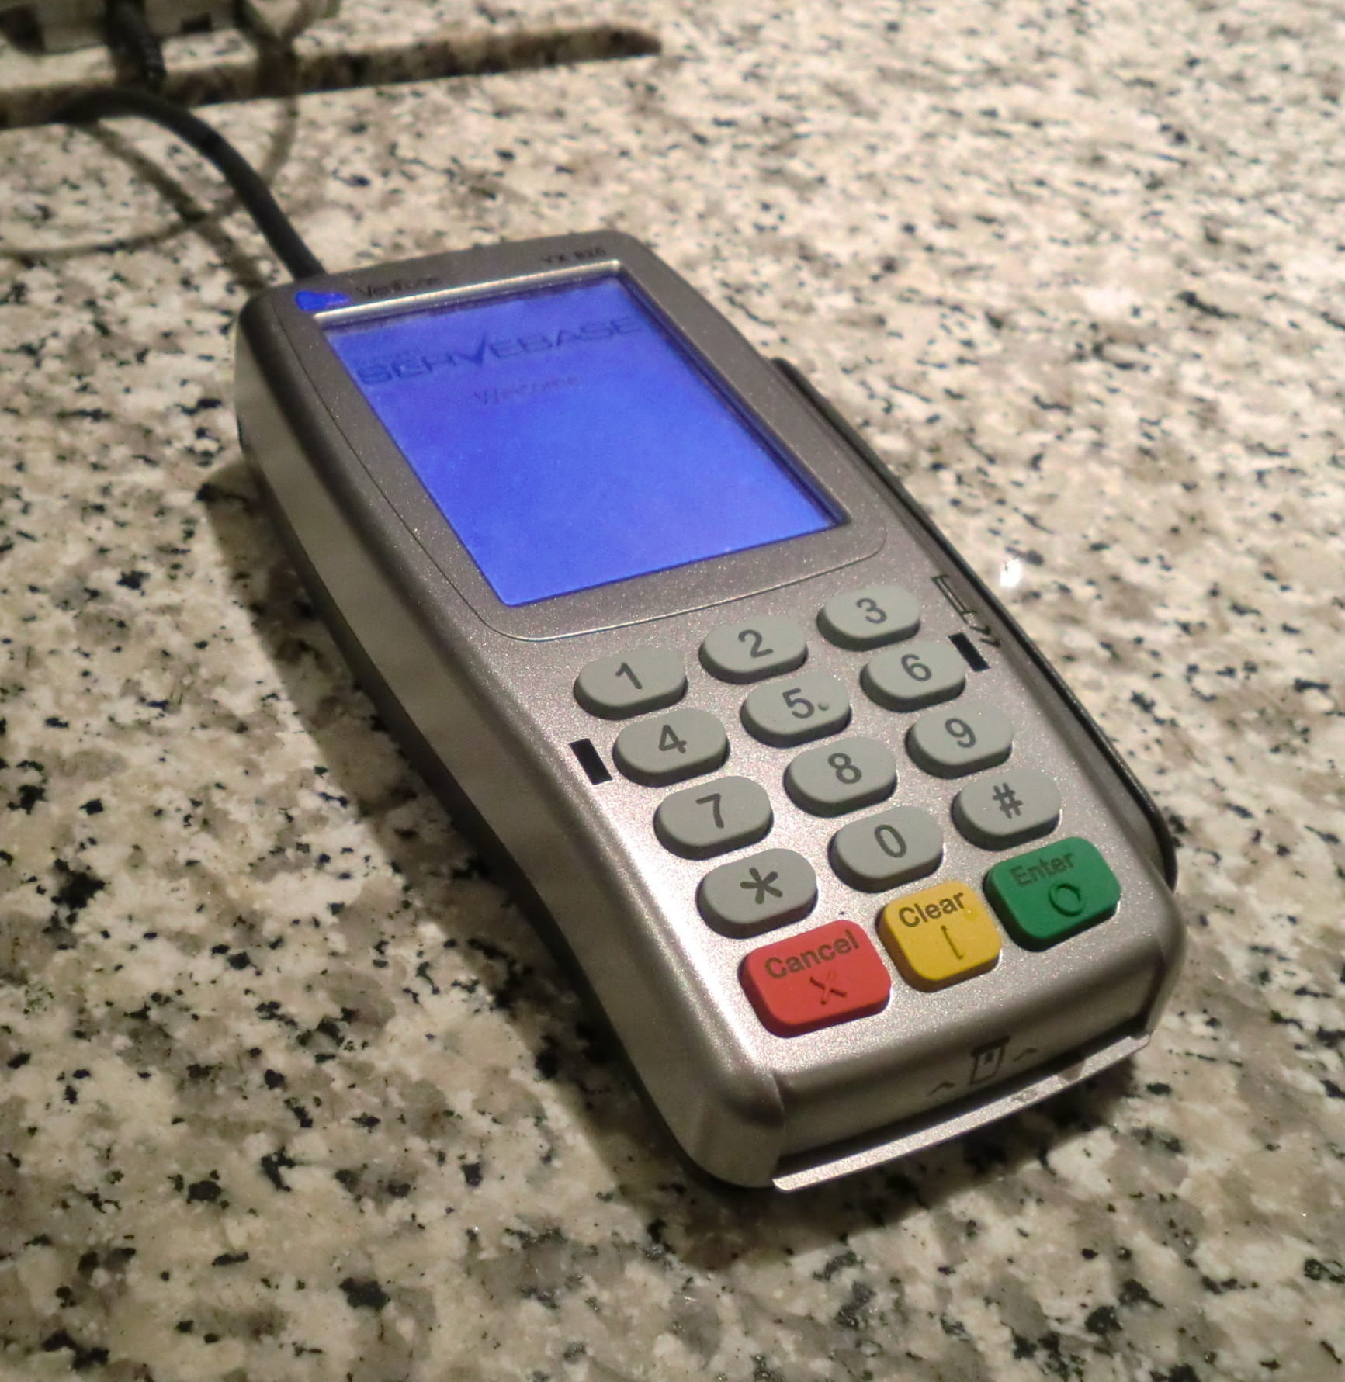
Using Credit Cards
To make a purchase using a credit card, you will need to either swipe the magnetic strip, tap the card to the card reader, or tell the retailer the information on your card. As you swipe or tap the card at the retailer (the store where you are buying items) your account information is passed through several different companies in quick succession. The basic steps are:
- Step 1: Authorization
  - The merchant you are making a purchase through asks the credit card company if your card is in good standing and can be used.

- Step 2: Batching
  - At the end of the day, the merchant collects all the credit card transactions and puts them in a ‘batch’ to send to the credit card company. The merchant does this so they can get money from the credit card company.

- Step 3: Clearing
  - The credit card company reviews the ‘batch’ and checks to make sure no fraudulent charges are being processed before sending the money to the merchant.

- Step 4: Funding
  - The merchant finally receives the money and your credit card is officially charged for the purchase. You will be able to see the charges on your statement.

Making Credit Card Payments
When processing is complete, you will get a charge on your credit card account that you will need to pay back. Your credit card statement can either be accessed online or will be sent in the mail to you each month. The statement is the ‘bill’ for your credit card and shows all the purchases you made in the month.
Credit companies offer many ways for you to make payments:
- Pay over the phone
- Pay online
- Pay through the mail (less common today)
- Pay at a bank
- Pay by auto-debit (you give the credit card company your banking information so they can deduct payments from your bank each month)

You need to at least make a minimum payments every month that you have a balance on your card (a balance is the money you owe on your card). If you don’t owe any money, you do not need to make a payment. If you fail to make your payments on time, you will have to pay extra fees. These fees can add up quickly and are a big reason it is hard to get out of credit card debt.

Practice Questions:
- True or False: You have to swipe a credit card to use it.
  - True
  - False

- What are the steps of credit card processing?
  - Authorization, batching, sorting, funding
  - Batching, acquiring, issuing, lending
  - Cleaning, funding, batching, selection
  - Authorization, batching, clearing, funding

- Which of the following is NOT a way to pay off a card?
  - At the bank
  - One the phone
  - Online
  - All of these are ways to pay off a credit card

Credit Card Statements
A credit card statement provides information such as how and when you’ve used your credit card, how much you owe, how much interest you are paying, how much your minimum payment is, and how much credit you have left. Knowing how to read your credit card statement can also help you catch unauthorized charges and/or billing errors.
Use the Credit Card Statement below to answer the questions about its different components.
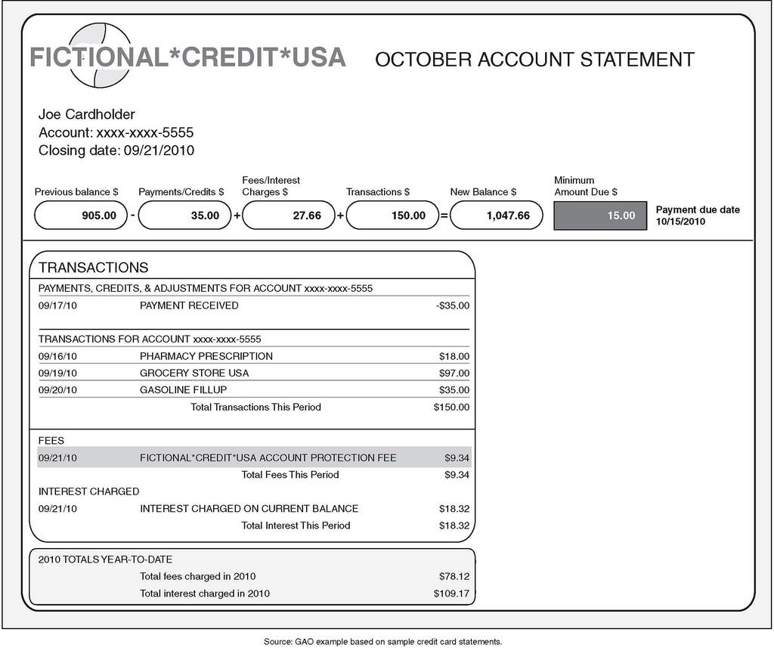
Practice Questions:
- What is the date of this statement? _______________________________
- What is minimum payment that must be made? ________________________
- Name two retailers where the account holder made purchases.

- What additional fees were charged to the card holder? __________________
- What is the total amount the cardholder owes? ________________________

Credit Card Fees
All credit cards will have some fees associated with them. When choosing a credit card it is important to be aware of these fees so you can select the ideal card for yourself. The most common fees are:
- Annual Fee: This is money you have to pay every year for using the credit card. It could be $0 or more than $250. Higher annual fees are usually for cards that offer really good rewards.

- APR: This is the Annual Percentage Rate, or the amount of interest that is charged on any unpaid balance on your card. If you pay back your balance within a certain timeframe (usually 25-30 days), you avoid this charge. This fee is usually 15-25% of the balance.

- Decline Fee: This fee is charged to your account when you try to make a payment for something you don’t have the money for. It is similar to an overdraft charge in your bank account.

- Late Fee: This is a fee for times when you do not make your payments on time.

Selecting the Right Credit Card
Applying for a credit card is surprisingly simple. All you need to do is fill out a form and hope you get approved. You must be 18 years old to apply. An application can be done online, through mail, or in a store depending on what you want to get. Every credit card is a little different, so it is important to search for one that has features/rewards you want (ie air miles, cash back). Credit card costs and features can vary greatly. This exercise will give you a chance to shop for and compare the costs and features of three credit cards. Use the form below to research the cost and features of 2 major credit cards and one credit card from a department store.

Credit Card Name
Bank Associated with the Credit Card
Annual Fee (if any)
Annual Percentage Rate (APR)
Credit Limit
Other Fees:
-late payment
-decline fee
Other Features:
-rewards (cash back, air miles…)

Practice Questions:
- Which credit card has the highest annual percentage rate and how much is it?

- Do any of the credit cards have annual fees? If so, which ones and how much are they? What is the advantage of having an annual fee?

- What is the benefit of comparing credit cards?

How to Avoid Credit Card Debt
Many students avoid getting credit cards because they don’t want to be in debt. Owning a credit card can be a great way to build up a good credit score, but you need to know how to manage a credit card correctly.
There are two main causes of credit card debt: bad spending and bad payments. You will either spend more money than you can pay back, or you will fail to pay a balance you owe. It can be tempting to buy yourself a new gaming system or the latest Jordan’s with your credit card, but if you get carried away with your spending, you place yourself in a dangerous situation.
Tips to Avoid Credit Card Debt:
- Don’t buy anything you don’t already have the money for.

- Always keep track of your balance. Know what you’ve already spent, what you can still spend, and when your payment is due.

- Avoid high interest rates or high annual fees. If it costs $90 for a credit card you rarely use, you should cancel it.

- Save your card for emergencies, train yourself not to use your card unless you need to.

Assessment Unit 1 Lesson 3

- List three new things that you learned today about credit cards and/or debt? In your opinion, which of these components is the most important to you?

- Do you think students should have a credit card? What is one advantage and one disadvantage?

- What costs are involved with credit cards?

- Why is it important to shop around for a credit card?

- How can you obtain a credit card?

- What are some important factors to consider when selecting a credit card?

Case Study: About six months after I started working I thought it was time for a holiday with my girlfriend I saw that I could apply to increase my credit card limit to five thousand dollars. I filled out a few forms online and then I got the credit increase. How easy was that!
So we took a holiday together to Los Angeles. We did all the touristy stuff. It was awesome! I used the card to pay for everything and planned to come back home and pay it off a bit each week. But I lost my job. And then I couldn't make the repayments. The interest was so high. I spoke with the lender as there was a change in my circumstances since I took out the credit card. I also saw a financial counsellor who helped with the repayment plan. I didn't want a bad credit rating to affect my ability to take out a loan in the future.
Anyhow now I don't sign anything unless I know what it means. I am also trying to build up a good savings buffer, so I don't have to rely so much on credit.

Questions:
- What is wrong with Steve’s decision to put an expensive trip on his credit card?

- What steps did Steve take to help manage his credit card debt and avoid a poor credit rating?

Case Study Answers should include:
Where Steve went wrong:
- Paid for his trip using a credit card and then couldn't meet the repayments
- Would have paid more for the trip by putting it on a credit card
- Had only been working for six months so no savings behind him in case something happened such as losing his job
- Had a credit card with a high interest rate
- Applied for the credit card online and didn't understand what he was signing up for

What Steve did to manage his debt?
- Talked to his credit provider to explain that his circumstances had changed and that he had lost his job
- Saw a financial counsellor and worked out a repayment plan
- Avoided a poor credit rating

Take Away:
- credit cards can be useful if used wisely and paid off within the interest free period
- always do your homework and 'shop around' before you sign up for any credit product.

