Lesson 4: Constructing Pie Graphs

Learning Goals:

- Learn how to construct a pie graph using a predetermined scenario from a table.

Topic: How to draw a pie graph

Pie Graph: a special graph that uses "pie slices" to show relative sizes of data.

Example(s):

Let’s construct a pie graph together. Let’s say you interview your class and ask which type of movie they liked the best. The table below is the result of your survey.
Add up all the values
Types of Movie
Comedy | Action | Romance | Drama | SciFi | Total
6 | 5 | 1 | 4 | 4 | 20

Next, divide each value by the total and multiply by 100 to get a percent:
Comedy | Action | Romance | Drama | SciFi | Total
6 | 5 | 1 | 4 | 4 | 20
6 ÷ 20 = 30% | 5 ÷ 20 = 25% | 1 ÷ 20 = 5% | 4 ÷ 20 = 20% | 4 ÷ 20 = 20% | 100%

Now to figure out how many degrees OR sectors for each "pie slice".
A Full Circle has 360 degrees, so we do this calculation:
Comedy | Action | Romance | Drama | SciFi | Total
6 | 5 | 1 | 4 | 4 | 20
30% | 25% | 5% | 20% | 20% | 100%
0.30 x 360º =108º | 0.25 x 360º =90º | 0.05 x 360º =18º | 0.20 x 360º =72º | 0.20 x 360º = 72º | 360º

Now you are ready to start drawing!
Draw a circle. Then use a protractor to measure the degrees of each sector.
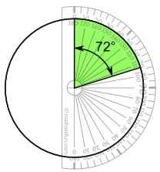
OR
If you have access to a computer ask your teacher to show you how to produce a pie graph on the computer. Don’t forget a title for your graph.
Your final product should look like this.

Practice Questions:

Show the following results in a pie graph.
Here is how many students got each grade in the recent test:
A | B | C | D | E
2 | 4 | 12 | 1 | 9

Strand 4 Lesson 4 Assessment:

Question 1:
The pie chart shows the amount of time Vicky spends on various activities each day.
- What percentage of her time does she spend eating?

- What percentage of her time does she spend sleeping?

- What does she spend the least amount of time on?

- What does she spend the most amount of time on?

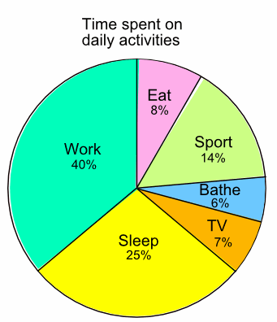
Question 2: Using the table below to construct a pie chart showing Marcia’s household expenses each month.
Marcia’s household expenses
Food | Clothes | Transportation | Phone | Leisure | Misc.
$120 | $55 | $90 | $40 | $60 | $20

