Lesson 5: Imperial Measurement
Learning Goals:

- To be able to use the imperial system to accurately measure length in feet and inches, to accuracies of ⅛ inch and $\frac{1}{16}$inch.

- To be able to use convert between feet and inches.

Topic: Imperial Measurement

- The Imperial System is mainly used in the United States. Canada uses the metric system and imperial system.

- The imperial system is used in some occupations such as construction.

- In the imperial system there are four main units of measurement that are used - inches (in) feet (ft.) yards (yd.) miles (mi)

- In the imperial system, inches are divided into half. Each half is then divided in half, etc.

- The smallest fraction of an inch that is generally used is$\frac{1}{16}$”.

- There are 12 inches in a foot.

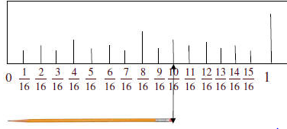
- There are two types of rules with inches. The first type of ruler has each inch split into 16 parts. The second type has each inch split into 8 parts.

Converting from a ruler with 16 parts ($\frac{1}{16}$”) to a ruler with 8 parts (⅛”)
- Take the denominator and multiply by 2

- Take the numerator and multiply by 2

- Keep the whole number as is if there is one

Converting from a ruler with 8 parts (⅛”) to a ruler with 16 parts($\frac{1}{16}$”)
- Take the denominator and divide by 2

- Take the numerator and divide by 2

- Keep the whole number as is if there is one

Converting Among Imperial Units - Converting Feet and Inches to Inches

- Multiply the feet by 12 and leave the inches alone

- Add the remaining inches to that answer you get above

Converting Among Imperial Units - Converting Inches to Feet and Inches

- Figure out how many whole feet you can remove by dividing the total amount of inches by 12
- Calculate any remaining inches by multiplying the whole number you get above by 12 and subtracting that from the total amount of inches

Example(s):

1) Identify the measurement indicated by each arrow
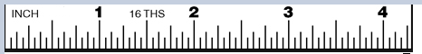

$\frac{3}{16}$”
2$\frac{5}{16}$”
This is a ruler where each inch is divided into 16 parts.

2) Use a ruler to draw a line of each length to the nearest ⅛”. Write the measurement below the line
Line up the ruler with the line. Accurately measure where the line ends
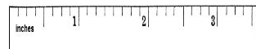

The line is 2$\frac{3}{8}$”.
If you had to convert it to the nearest$\frac{1}{16}$” you would multiply the denominator by 2 and the numerator by 2. You would leave the whole number as is.
2$\frac{2x3}{2x8}$” = 2$\frac{6}{16}$”

3) Calculate the length of each diagram as indicated with the arrows. Measurements should be rounded to the nearest ⅛”.
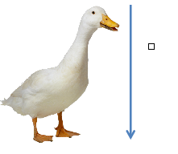Answer 2$\frac{2}{8}$”

4) Convert 5 ft. 3 inches to inches

5 ft. 3 inches
- Multiply the feet by 12 and leave the inches alone 5 x 12 = 60 inches

- Add the remaining inches to that answer you get above 60 inches + 3 inches = 63 inches

5 ft 3 inches is equal to 63 inches

5) Convert 98” inches to feet
98 inches
Figure out how many whole feet you can remove by dividing by 12
98 $÷$ 12 = 8 whole feet
Calculate any remaining inches by multiplying the whole number you get above by 12 and subtracting that from the total amount of inches
8 x 12 = 96 inches
98 inches - 96 inches = 2 inches (remaining)
Therefore 98” is the same as 8’ and 2”

Practice Questions:

1) Identify the measurement indicated by each arrow

2) Use a ruler to draw a line of each length to the nearest ⅛”.

3) Use a ruler to draw a line of each length to the nearest$\frac{1}{16}$”. Write the measurement above the line

4) Calculate the length of each diagram as indicated with the line. Measurements should be rounded to the nearest ⅛”.


a)

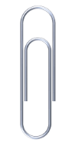
b)

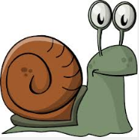

c)

5) Convert each measurement to inches
- 1 ft 6 inches

- 5 ‘ 4”

- 10 ft 2 inches

- 7 ‘ 6”

- 2 ft 3 inches

- 8 ‘ 10”

6) Convert each measurement to feet
- 109”

- 50 inches

- 97”

- 49 inches

- 66”

Strand 2 Lesson 5 Assessment:

1) Identify the measurement indicated by each arrow

2) Use a ruler to draw a line of each length to the nearest ⅛”. Write the measurement above the line

3) Use a ruler to draw a line of each length to the nearest$\frac{1}{16}$”. Write the measurement above the line

4) Calculate the length of each diagram as indicated with the arrows. Measurements should be rounded to the nearest ⅛”.
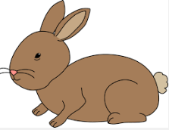


b)

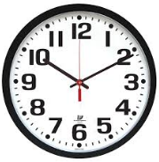
c)

5) Convert each measurement to inches
- 10 ft. 7 inches

- 8’ 7”

- 3 ft. 2 inches

- 9’ 10”

- 7 ft 10 inches

6) Convert each measurement to feet
- 104”

- 99 inches

- 45 “

- 79 inches

- 207”

