Looking At Shapes in Different Ways
Each teacher choose a group of ten students to sit with asking them a variety of number sense and spatial sense questions in an interview style.
The students were asked to look at a picture and see if they could recreate the picture.
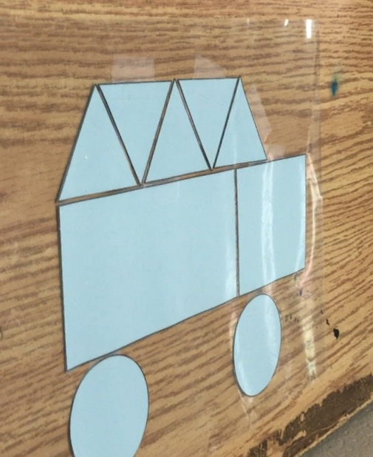
It was not a surprise that the students were able to recreate this picture without any problems. Most would also name the picture a car, truck or vehicle. What was interesting was when we asked the students to look at the picture another way. By turning the picture upside down they had many different answers.
“What do you see?” This time the picture was not as clear to them. Many students answered an upside down car. Some students saw the circles as people’s heads and then they people were sitting in a boat. As teachers we thought that the answer might be a crocodile with sharp teeth. We learned that everyone can see things differently and can also use their own imaginations to create something with the shapes. The next question we asked was; “What can you make with these shapes?” The answers were endless.
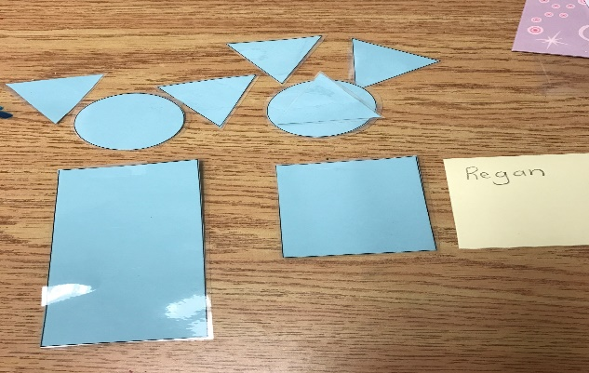
My Dad and brother. The triangles are their ears and this one that is left over can be the nose.
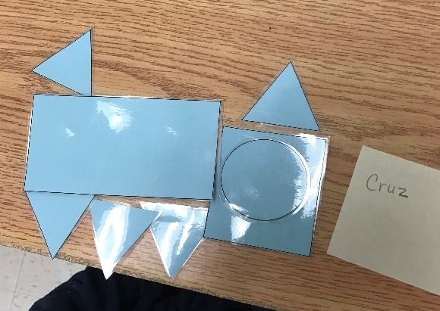

A polar bear.

We also asked the students to sort the shapes. This is when we realized that some students did not have the math language. Even though we had taught sorting at the beginning of the school year, some of the students didn’t know what we were asking of them. This is when the math language became an important focus of this project.

We then began to introduce important math language, like visualizing and subitizing when students were solving the problems of how many dots were on the plate. We gave the students opportunities to explain their thinking and to use the language we had introduced. We notice that the students were applying the skills they were learning during spatial reasoning activities and to problem solving in numeracy.

