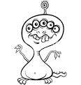MONSTER BODY PARTS
Name: Date:
My monster has:

