Name: Date:

Our February Weather Data

Overcast
Partly Cloudy
Sunny
Rainy 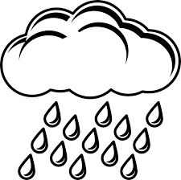
Snowy

What does this graph show?
_________________________________________________________________________________________________________________________________________________________________________________________________________________________________________________________________________________________________________________________________________________________________________________________________________________________________________

