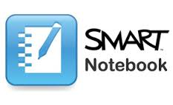
SMART Notebook for iPad Basics
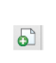
Important Commands
To add a page tap the add page button
Lessons
To access premade lessons go to: exchange.smarttech.com
- Tap the download button on the file that you wish to open
- Tap Open in Notebook to open the file on your iPad

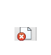
To delete a page tap the delete page button
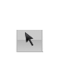
To edit object, you must be on the select key
- To rotate use the green handle
- To move press the object and drag it
- To resize use the white handle

To lock or unlock an object
- Use the select key to select the object
- To lock, tap the white handle and select lock
- To unlock tap the upper right corner (looks like a lock) select unlock
Adding a shape
- Select the shape tool from the toolbar at the bottom
- Select the shape
- Select the line colour
- Select the fill colour
- Tap the screen where you would like your shape to appear
- Drag to create the shape
- You can then use the select tool to move the shape around or resize it
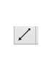
Adding a line
- Select the line tool from the toolbar at the bottom
- Select the line colour
- Select the line style
- Select the start and end of the line
- Tap the screen where you would like your line to appear
- Drag to create the line
- You can then use the select tool to move the line around or resize it

Cutting, copying, pasting and deleting objects
- Using the select key
- Tap and hold the object then tap cut, copy, or delete
- To paste press and hold on the page and tap paste
- You can also order and clone objects using this method

