Listen to the instructions here

Choose one of the two articles to read:

- The Hour - A rant by Rick Mercer
OR
- Homelessness in Canada - An overview

As you are reading the text for the first time, keep track of your understanding by drawing a line down the left hand side of the page. It might look something like this:
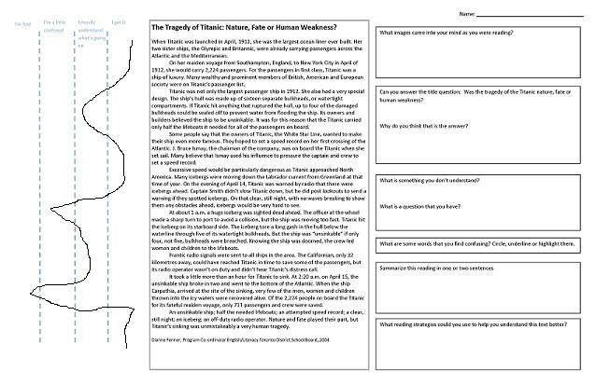
After you have finished reading and drawing the line, then, respond to the questions on the right hand side.

Bring the reading with you to Station 2: Fact vs. Opinion

