Station 3: Speaker’s Corner

We all have strong feelings and ideas about particular issues—and that's totally normal. In a democracy, there's supposed to be enough room for everyone's opinions, even if sometimes we encounter ones we don't like.

Civics is a form of politics. It is important for you to be able to think politically when analysing various civic issues throughout this course and in everyday life.

The expression "Speaker's Corner” comes from a real place in London England!

This was a public place in which they can express their opinion on any topic they wish. Starting in the late 1800's, Hyde Park set aside a designated area where anyone wanting to exercise the right to freedom of speech and freedom of expression could come and make her or his views known to passers-bys.

Your task:
- Pick something that really bothers you in the school, in Ottawa, in Canada, or in the world. It can be anything, but it must be respectful.
- Record your ideas Vocaroo.com and
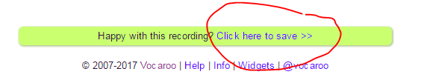
- send it by email to your teacher – at (insert teacher email here)

- Be sure to explain:
  - what is the problem?
  - why does it bother you?
  - do you have any ideas about how it could be fixed?

