Blending Civics: A Mini-Unit on Civic Issues and Engagement

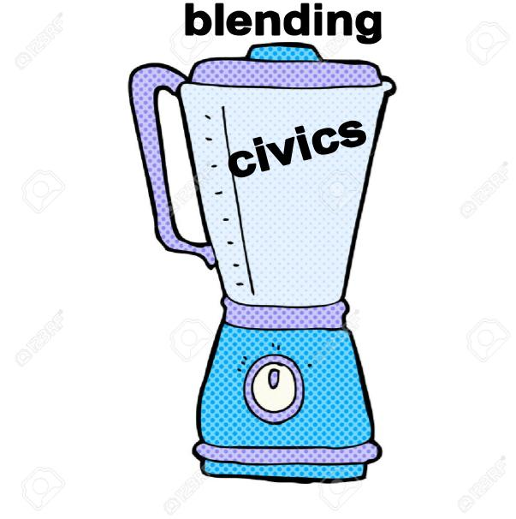
Overview:
This unit is designed to be an student-led investigation on Civic Issues and civic role models. Students work in groups and work through each station in order. This unit can be done during class time or could be assigned as homework through D2L or another platform, like Google Classroom.

We have created test environments that can be used in your own classroom in both Google Classroom and D2L.

Pre-Teaching Ideas Could Include:
- Have students brainstorm around the question about focus question “what is a Civic Issue” - the stations are designed to help students answer this question. The question should be introduced prior so they can have purpose
- Investigation on beliefs systems/values might be helpful for students to better understand their own personal
- Show a Rick Mercer rant - Young Voters is a good one that is relevant to the teenage demographic

Station Rotation Model:
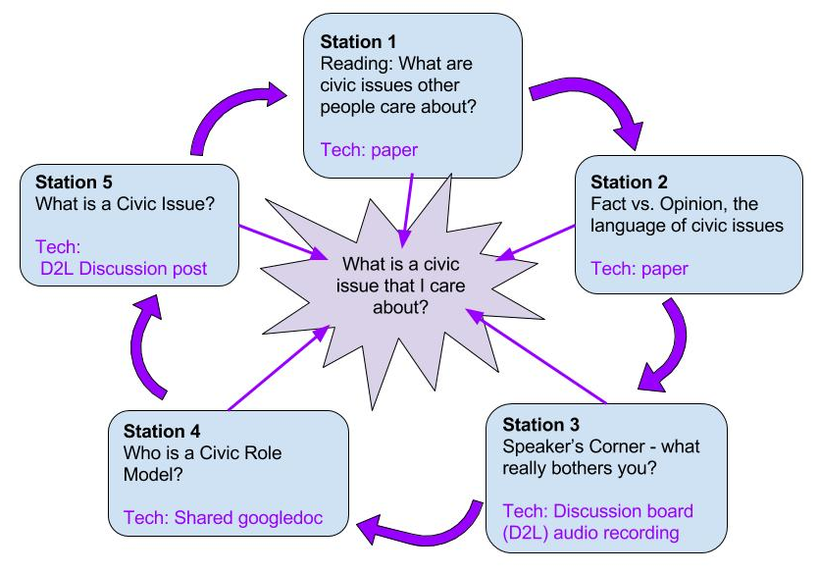

Station Description:
Station 1 | Students are to read from a selection of readings about civic issues. As they are reading the text for the first time, they are to keep track of their understanding by drawing a line down the left hand side of the page. After they have finished reading and drawing the line they will respond to the questions on the right hand side. They will take this information with them to Station 2.
Station 2 | Students are to determine what is fact versus opinion. They will sort the descriptive words in the Word Bank and put them in the appropriate category (fact or opinion). They will then use those words to write sentences to demonstrate their understanding of fact and opinion. They will take the reading from Station 1 and identify the sentences that are fact and the sentences that are opinion.
Station 3 | In this station students will record themselves doing a rant about a civic issue that is important to them. The rant should be approximately 30 seconds long. They will record their rant and submit it to the teacher.
Station 4 | Students will research about the civic contributions of people that they know or that are important to them. They will demonstrate why this person can be considered a civic role model and what their contribution to a civic issue would be.
Station 5 | In their groups, students will come up with 4 issues that are civic related and 4 issues that are not civic related. They are asked to relate these examples to experiences in their personal lives. From the list of examples, students will try to develop a definition to the response of what is a civic issue? Lastly, students are then asked to relate civic and non civic issues into popular media which includes books, films and television shows.

Possible Adaptations:
- Stations can be done on independent days in order to facilitate group work for larger classes.
- Stations can also be done without the use of technology (no Chromebooks, iPads or recording software). In that case teachers would need to have paper copies for students to use for each station and the recording can be done in a written format.
- Student voice can be captured in many different ways - we used iPads to record voices, in addition to using the Vocaroo program on a Chromebook. If using D2L, students can also record their voices in the discussion board by attaching an audio file.
- Students can record their rants at home on their personal time or this can be used as a homework tool.
- Station 1 and 2 can be combined to be one Station. Students would complete the work from Station 1 (reading), and then move to the Fact vs. Opinion work.
- Use different readings for station 1 that might be of more interest/relevance to your students.

