I have included some help text that is highlighted pink. Read through and delete when you are ready to assign this HyperDoc to your students. Enjoy!
What is your #0neWord2018 ?
Have you heard of making a New Year’s Resolution? Have you ever made one?

If you are unsure, a New Year’s Resolution is a promise that you make to yourself to start doing something good or stop doing something bad on the first day of the year. (http://en.wikipedia.org/wiki/New_Year's_Resolution)

Instead of making a list of resolutions this year, pick OneWord that defines your goals, dreams, ambitions and who you want to be in 2018.
Reflect on 2017
Think about it...
What did you accomplish?
What are you proud of?
What did you leave unfinished?
What inspired you?
What do you want to continue in the new year?
What drives you?

Make a bulleted list of your thoughts below:

Get some inspiration!
Three of these are YouTube videos & a playlist. You may need to approve these for your students to watch or you may switch them out for other inspirational materials of your choice.
“A Pep Talk from  Kid President to You”  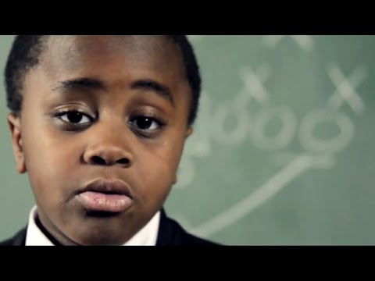  Double Click the image,  then Double Click again to watch the video! | Inspirational Song Playlist  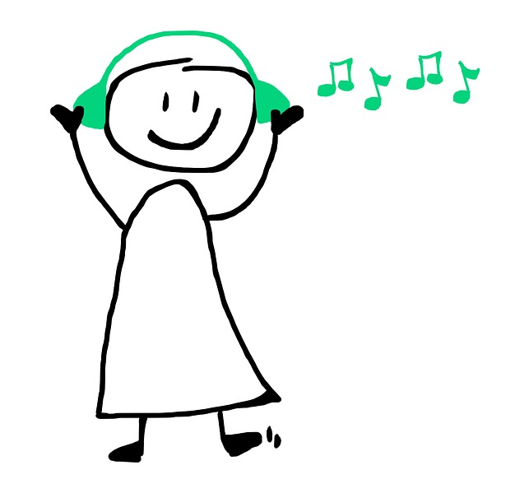  Click Here to explore these songs.  You don’t have to listen to all of them  or listen to a whole song.
Motivational Posters  Click Here and read through these Motivational Posters | “Death Crawl”  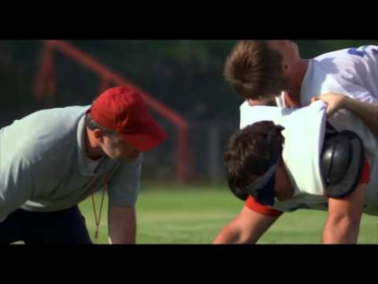  Double Click the image,  then Double Click again to watch the video!

Choose your #OneWord2018
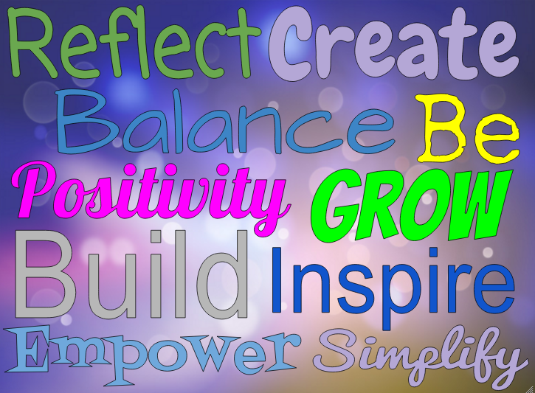
Check out the picture ----------------------->>>
These are all examples of OneWord that people have chosen as their focus in the past. One of these may work for you too!
Think about what your OneWord will be and type it in the box below.
My #OneWord2018 is…

Create your OneWord Graphic!
Now for the fun part!
Read through all directions first and use the hyperlinks to assist you in creating your OneWord, word art.
The links below are GIFs to show students the steps to complete.
Teachers, you may need to make a copy of these and relink into your copy of the hyperdoc, I have noticed that many student accounts will not allow these to be viewed since it is from an account outside of your domain.
- Click and highlight the x below
- Insert a Google Drawing of your word below
- Use color and cool fonts!
- Even insert a background image!
*Hint- Click ctrl + ↓ to move your image to the back
and trl +↑ to move it to the front.

Ready? Let your creativity flow!
X

Teachers feel free to keep these original links to the padlet and flipgrid. Keeping them in will create an incredible global response! However, you may change them to your own if you like or choose another option when having students share their OneWord.
If you keep the original links to the shared padlet and Flipgrid, please monitor your students’ posts. I have elected not to monitor them so if students choose to post something not appropriate it will be visible to all. If you do see something that you feel is not appropriate please reach out to me and I can take care of removing it. Thanks!
Share It
Download your OneWord graphic as a png image. Do this by…
  - Double click the graphic you just created above.
  - Select Actions,
  - Then go to Download as...then select png.
  - Upload this image to your Google Drive & get the shareable link. (Make sure it is anyone w/ link may view)
Choose how you would like to share your #OneWord2018
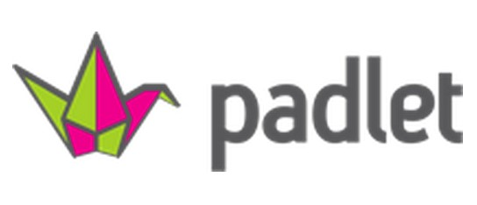 | 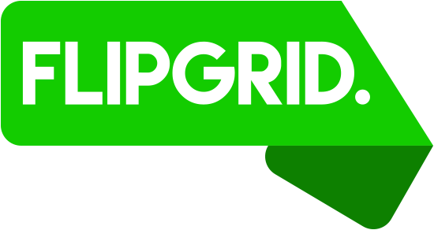
- Click the padlet image above to upload and share your graphic on padlet.  - Once you upload yours, go through and see what other students are choosing as their #OneWord2018  - You may also view responses posted to Flipgrid. | - Click the Flipgrid logo above to share your #OneWord2018.  - Once you add a response, go through and watch other students are choosing as their #OneWord2018  - You may also check out the posts on the Padlet.

Go Further & Write About some ways you can achieve your #OneWord18

This HyperDoc was created by @SeanJFahey Inspired by @KarlyMoura & her OneWord HyperDoc

